Analyzing Interaction between Academic and Professional Writing Practices of Law Undergraduates

Introduction and Objectives.
This project aims to describe and contrast the writing practices of law undergraduates who also work as lawyers at the university and their workplace from a sociocultural perspective of literacy.
The lack of transfer between academic and professional writing practices (or genres) and its effects has been widely studied by Latin American researchers over the past decade. For example, Parodi et. al. (2010) survey and describe the genres encountered in the degrees of Psychology, Social Work, Construction Engineering, and Industrial Chemistry, and in the professional environments in which graduates of these careers work. Among other things, the authors conclude that, in the academic environment, there is a reduced variety of genres in comparison with the diversity and breadth of genres found in the professional environment: that is to say that upon leaving the university, students must produce textual genres that they do not know or were not taught.
Like Parodi and his collaborators, several researchers have been concerned with studying the connection between the literacy practices of the university and those of the workplace to develop teaching materials and adjust the writing tasks required of students throughout their careers (Bhatia, 2008). These studies have been mainly concerned with describing the genres specific to each field. Some of them, with results similar to those of Parodi (for example, Cassany and López Ferrero, 2010), and others, not so much. Regardless of the findings, the underlying understanding of these works is that, if there is specific instruction of professional genres/literacy practices during the university, it can facilitate "the university/company transition and (...) favor the insertion into the workplace by promoting the development of skills that allow them to solve in an adequate, autonomous and self-managing way to the various communicative demands of the professional field" (Natale and Stagnaro, 2013, p. 51).
As well as Parodi et al.'s study, most Latin American research on this topic has been done using a genre description methodology. This means that the main objective of these works has been to describe and contrast the text types encountered. Although studies of literacy that adopt a sociocultural perspective (that claim reading and writing are social practices involving more than linguistic knowledge) have gained preponderance in the region, these studies tend to focus on texts and do not incorporate other methods of data collection that allow to see other aspects of the text production process. An important precedent in Latin America in this regard is the work of Cassany and López Ferrero (2010), who incorporated interviews with participants to data collection, to characterize academic and professional writing practice more comprehensively, emphasizing issues such as the representations they have of academic and professional writing, their learning process, or the functions and identities developed in each context by these literate practices. In the global North, we can find the work done by the Literacies for Learning in Further Education group, led by Roz Ivanic in the UK. The authors analyze the "interaction" between literacy practices students encounter at the university and in their daily lives.
The qualitative approach that focuses not only on the text but on its producer and the process that makes the existence of the text possible is common in studies that seek to understand non-institutional or also called vernacular literacy practices, such as Lankshear and Knobel (2011) or Kalman (2003). These works also highlight and vindicate the knowledge at stake in these practices of literacy, even if they are less prestigious.
For that reason, this research aims to study the interaction between writing practices between university and work. Our goal is double. On the one hand, we will describe this practice to gain knowledge of them and to have thick descriptions of them based on which didactic interventions can be designed. Second, we will contrast them to see if there exists a gap between university and work. To this end, we will adopt a theoretical and methodological perspective that will allow us to describe and contrast not only the differences between the texts produced, but also the various actions that led to the production of the text, the resources deployed in the process (linguistic and non-linguistic), the technologies used, and the knowledge required in the process. Our argument (and hypothesis) is that sometimes perhaps the name of the genre varies, or even superficial issues vary, but, if the skills needed to produce it do not vary that much, then it will not be a challenge for students. The same in reverse: the name may match, but if the process is very different, it may be a complication for the writer.

Objectives.
- Analyzing the writing practices participants encounter in the university and the professional field in the area of Law.
- Identifying if there is interaction between academic and professional writing practices.
- Identifying the type of knowledge involved in university and professional writing practices.
- Studying whether professional writing practices are taught at the university and what impact it has on students as they perform their work.

Research questions
- What writing practices do students encounter in college?
- What writing practices do students encounter in their work environment?
- What do these practices consist of?
- What knowledge do students bring into play in producing these texts?
- To what extent do academic and professional writing practices coincide?
- How did they appropriate them?
- Have academic writing practices constituted a support in the process of appropriating professional writing practices?
- Does not knowing the writing practice undermine students' agency in having to produce a text in their work, does knowing it empower them?
- Does the literacy regime (Blommaert, 2008) change from one environment to another? How?

Methodology.
Data Collection.
The project consists of a qualitative case study in which six law students from different Argentine universities participated. To participate, the subjects had to meet three requirements: 1) be close to finishing their law degree or have recently completed it (in the last year), 2) be working in positions related to the legal profession, and 3) reside in Argentina. We made a call through different media to get volunteers to participate. Finally, of the total number of participants, 50% had already completed their degree and 50% had not. In turn, of the total number of participants, only one had completed her degree at a private university. Before starting the research, participants signed an informed consent form.
The instruments used for data collection were the following: 1) an initial survey and 2) four interviews with the participants.
The first instrument applied was the survey, distributed not only to project participants but also to the general public (only those who met the requirements for participation could answer it). Its objective was to gather demographic information about the participants and, more systematically and quantitatively, about the genres they have had to produce for the university and for the work up to that point. This was designed on the Qualtrics platform and piloted with 8 participants who had the same profile as the case study participants. After the piloting, we designed the final version of the questionnaire. The final questionnaire had 44 questions divided into the following sections: Demographic data, University, and Work.
Since the focus was not only on genres, we included questions focused on what operations they had had to perform in college, as shown below:
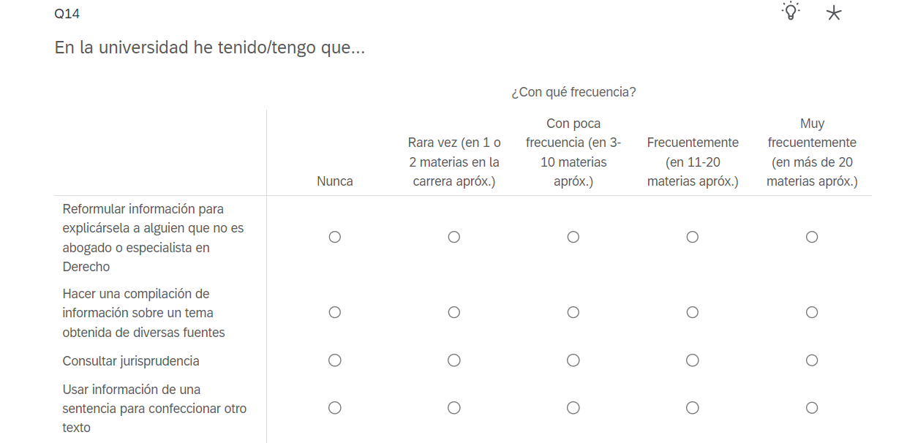
Translation:
Question: At University I have/had to…
Reformulate information to explain it to a non-expert in law.
Compile information on a topic obtained from different sources.
Consult caselaw.
Use information from rulings to make another text.
Option 1: Never
Option 2: Rarely (in 1 or 2 courses)
Option 3: Infrequently (in 3-10 courses)
Option 4: Frequently (in 11-20 courses)
Option 5: Very frequently (in more than 20 courses)

Once the survey questionnaire was completed, we scheduled the interviews with the participants. These interviews were also piloted beforehand with two participants who had also answered the survey and who met the indicated requirements. Based on the piloting, we made the pertinent changes to the design of the script. Each interview addressed a different text; thus, two interviews focused on a professional writing practice and two on an academic one. We first conducted the interviews on work-related texts and then on academic texts. The interviews were conducted by video call through the Zoom platform.
The interviews followed the talk-around-texts model proposed by Lillis (2003), that is, they were semi-structured interviews and, although there was a script, it did not necessarily have to be followed to the letter. The objective of these interviews was to gather information about the processes of text production (participants, stages, tools, among other elements), as well as the participants' perspectives about what is meaningful when writing texts. To this end, we asked participants to send us two texts they had written for the university and two texts they had written for their work. We suggested that they choose the texts based on the following criteria: 1) that it was a text they wrote frequently for the field in question, 2) that it was not excessively brief, and 3) that they had written it relatively recently so that they could remember the information that would be asked. We also suggested that participants choose two texts of the same type for each domain so that we could have a more in-depth description of each genre and also more generalizable.
For the general design of the interview, we took as a guide a categorization built from Blommaert's (2008 and 2013), Lankshear and Knobel's (2011), and Ivanic and Satchwell's (2008) proposal on the elements that constitute literacy practices:
- Artifacts
- Skills and tool use
- Relevant knowledge
- Artifact production aspects
- Discourse affiliations and identities
- Practices and purposes associated
- Literacy performances
- Forms and degrees of collaboration
- Levels of meaning
- Types of member contributions
- Projective/participatory orientation
Ivanic & Satchwell, 2008.

Data Analysis
- participant(s) and relationships
- audience
- purpose(s)
- media
- modes
- artifacts: tools and resources
- activity/processes
- content/topic(s)
- text type(s) / genre(s)
- place/time
- values
- identities
Lankshear & Knobel, 2011.
Our unit of analysis will be the literacy practice, which we defined as the sequence of actions carried out by one or more persons to produce a written text, from the moment the need to produce the text arises until the text is considered "closed" or "delivered". According to our theoretical perspective, this definition includes the text product, but also the activities, artifacts, knowledge, exchanges, etc., carried out and used to move from the need to the text product.
For the analysis of the data, first, we will transcribe the interviews and then identify the writing practices described by the participants and select those that we will characterize. Second, we will perform the linguistic analysis of the texts provided by the students, using the following categories outlined by Bhatia (1993): structural interpretation of the genre and analysis of textualization patterns.
Third, we will focus on making dense descriptions (Geertz, 1973) for each of the writing practices identified, gathering the information obtained from the interviews, self-recording, and linguistic analysis. To describe each of the practices and contrast them, we will define a system of categories.
Finally, we will share the analysis with the participants so that they can give us their opinions and revise aspects of the analysis, if necessary.

Research Progress by Jan. 3 and Some Interesting Findings.
At this time, we have finished the data collection, including the four interviews with participants. We detected a "problem" with the next question in the survey:
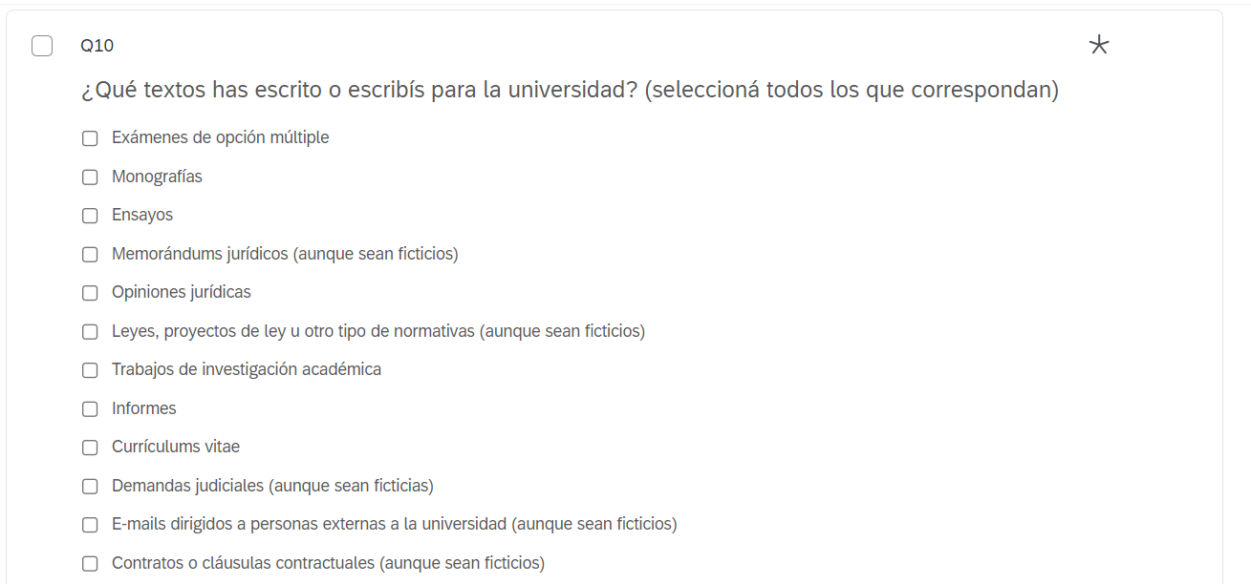

While this question gives an account of what texts they have had to produce in college or at the workplace, they can be misleading for one text could have been asked just once in the whole 6-year-degree program. This makes it difficult to compare the numerical results because it may seem that there is no difference between the type of texts produced in the work and the academic environment, but in truth there is, it is just that the difference is shown by the frequency. This way, we are considering sending an additional question to participants in which they have to rank the texts according to frequency.
We have still had few responses from the general public for the survey; however, as we are considering changing that question, we will wait before making a wider circulation. Some of the results obtained so far are included in the annex.
Lastly, below we will summarize some interesting topics or findings that came up in the interviews:
- Many participants recognize there is a way to “sound like a lawyer” that they use when they write at the workplace.
- Some of them, like participant FG, believe that these conventions are unnecessary and pretentious and, instead, try to be clear and simple when writing. However, their texts get amended when sent to their superiors, who usually add typical legalese words like expressions in Latin.
- Other participants, like AR, develop their own strategies. AR told us she sometimes has trouble understanding the communications sent by judges, so she “translates” them into everyday language. When writing responses, she does the same: she first drafts her texts in "non-lawyer-sounding language" and then "translates" them to legalese. She knows the text would not be accepted otherwise.
- Contrary to our expectations, we found that in many cases transfer was made from work to university, this means, students transferred knowledge gained by writing at the workplace when writing texts at the university. This mainly includes knowledge of formal aspects of the text such as formatting, tone, how to address the judge, or text structure.

Annex I: survey results.
QUESTION: What texts have you written, or do you write for University?

- Answers from participants

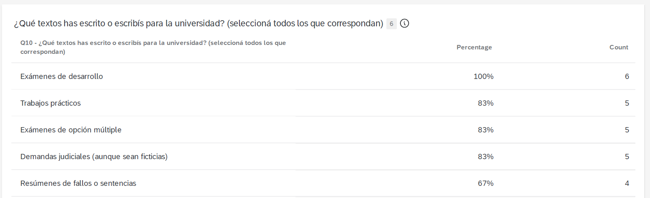

Exams
Q&As
Multiple choice exams
Claims
Summaries of rulings

- Answers from general public

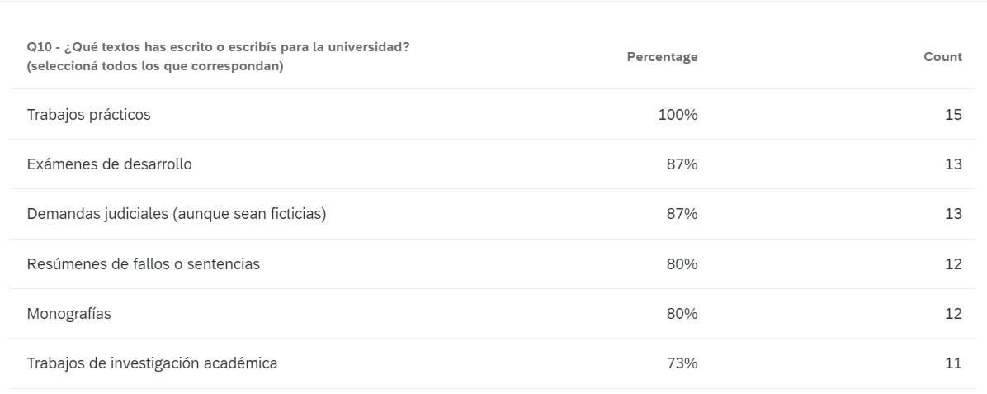
Q&As
Exams
Claims
Ruling summaries
Research essay
Research works

QUESTION: What texts have you written, or do you write for work?

- Answers from participants

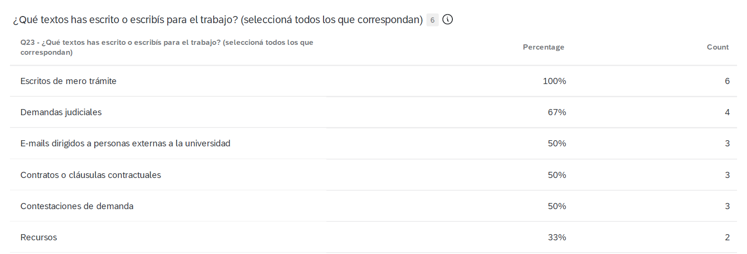
Judicial writs
Claims
Emails
Contracts or contractual clauses
Appeals

- Answers from general public

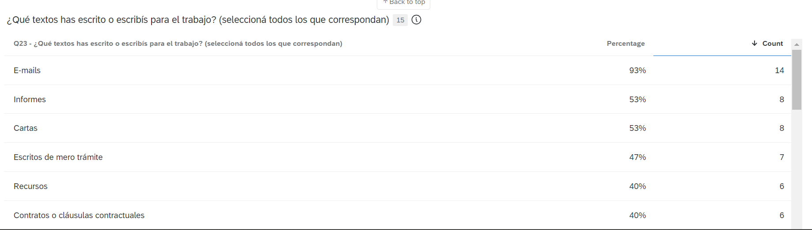
Emails
Reports
Letters
Judicial writs
Appeals
Contracts or contractual clauses

QUESTION: What texts have you read, or do you read at university?

- Answers from participants

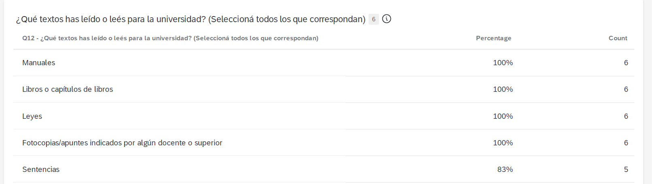

Handbooks.
Books or books chapters
Rules
Texts indicated by the professor
Rulings.

- Answers from general public
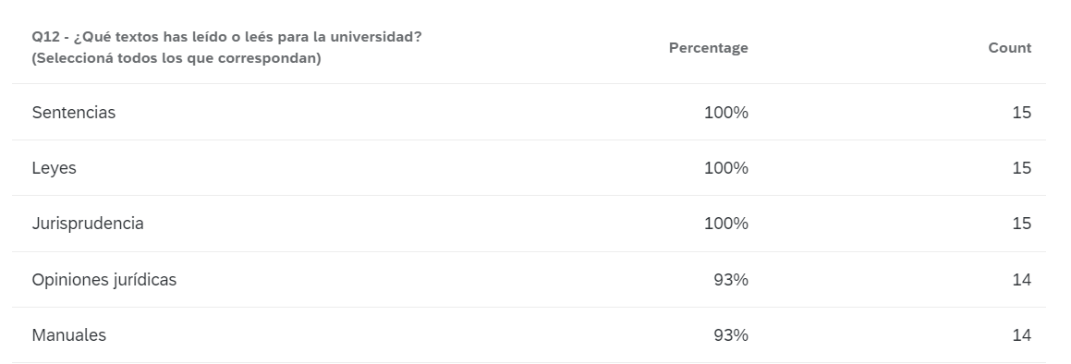
Rulings
Rules
Caselaw
Legal opinions
Handbooks

QUESTION: What texts have you read, or do you read for work?
- Answers from participants
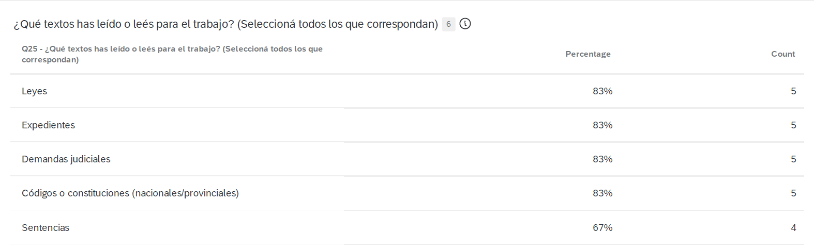

Rules
Files
Claims
Codes
Rulings
- Answers from general public

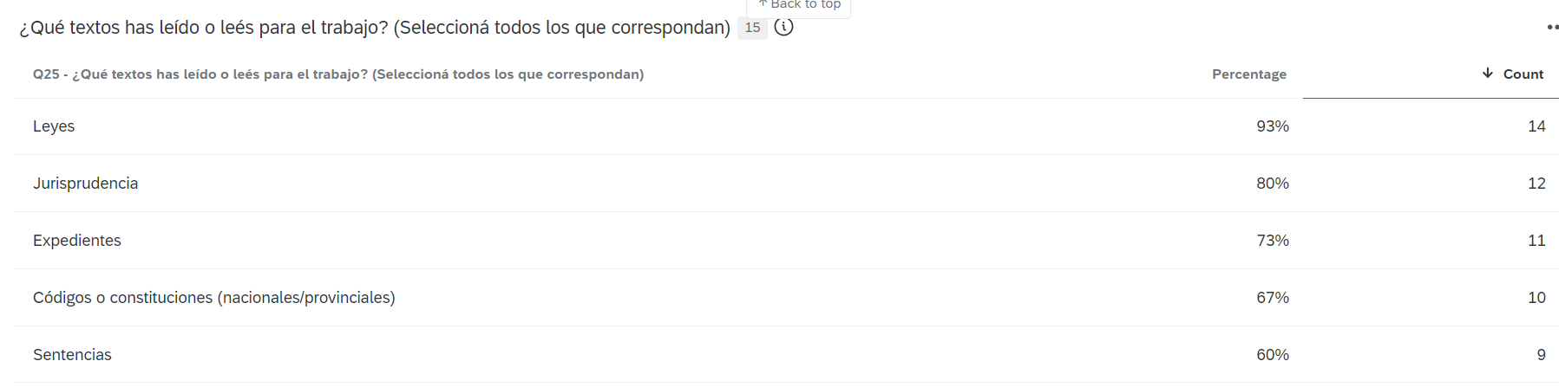
Rules
Caselaw
Files
Codes
Rulings

QUESTION: At university, I had to/have to…

- Answers from participants

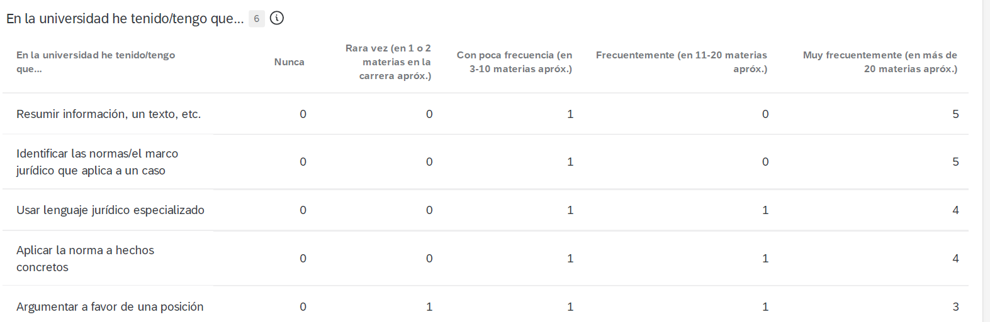
Summarize information
Identify the rules that apply to a case
Use specialized legal language
Apply the rule to concrete facts
Argue in favor of a position

- Answers from general public
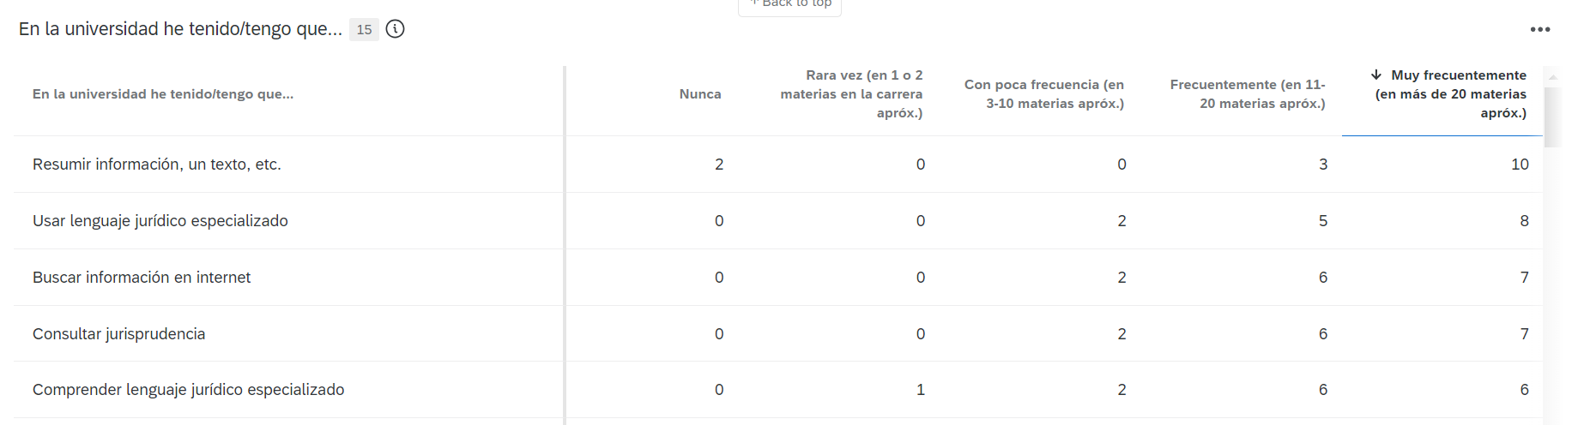
Summarize information, a text, etc.
Use specialized legal language
Look up information on the internet
Consult case law
Understand specialized legal language

QUESTION: In my jobs, I had to/have to…
(We are showing the ones chosen as most frequent)
- Answers from participants

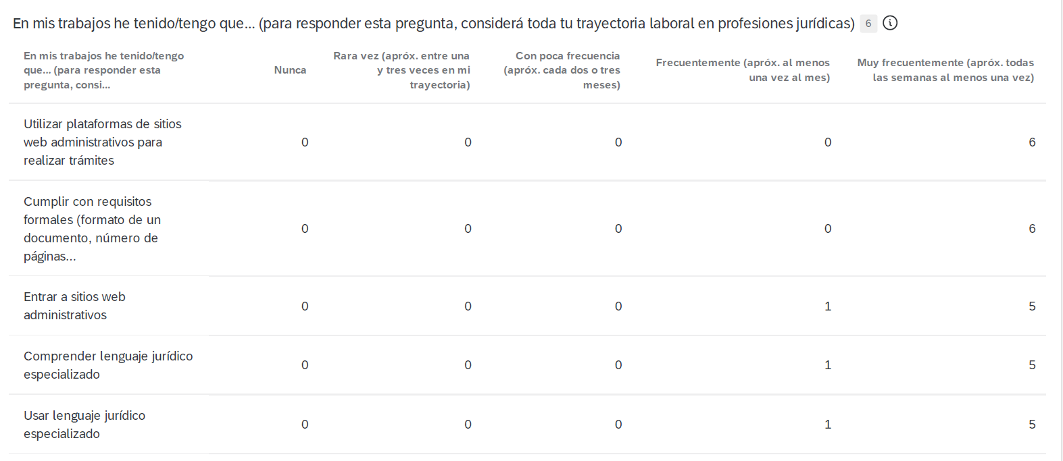
Use administrative website platforms
Comply with formal requirements
Go onto online administration websites
Understand specialized legal language
Use specialized legal language

- Answers from general public

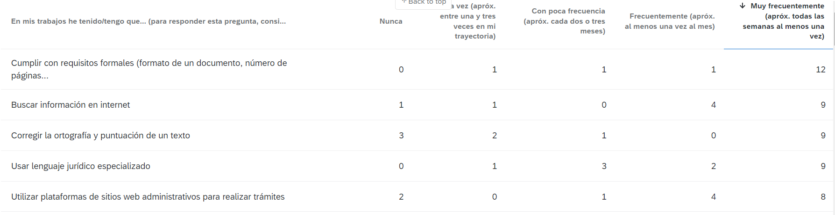
Comply with formal requirements
Look up information on the internet
Correct spelling and punctuation
Use specialized legal language
Use website platforms to carry out administrative procedures

Institutional Description.
The study was conducted with students or graduates from Argentine universities. In Argentina, law is a 5 to 6-year undergraduate degree, i.e., it is not a specialization or a master's degree. Mandatory academic writing workshops are not common in Argentine universities, there is no First Year Composition or anything similar. Some private universities, which tend to copy the American university model, do have specific remedial writing courses, but there is no WAC perspective in designing course programs.
Working and studying at the same time is very common in Argentina, not only for working-class students. Senior students may even have full-time jobs and go to university at night. This is why the profile of the participant we chose is actually representative of the type of student you can encounter at Law School in various universities in Argentina.

Key Theorists.
This research is framed within the New Literacy Studies (NEL) (Gee, 2014), a school of thought that adopts a sociocultural perspective on reading and writing (or literacy) studies. The NEL emerged as part of the social turn of the humanities and constituted an alternative view of reading, writing, and learning to the autonomous model (Street, 1984) predominant up to that time, which understands them as mental processes where individual cognitive activity is predominant (Zavala, 2011).
NEL theorists have criticized and problematized the cognitive approach from a standpoint that deconstructs knowledge and proposes to understand reading and writing as social practices. This way, reading and writing (or linguistic uses in general) are studied, thought, taught, etc., always together with the concrete events in which they arise (i.e., as literacies), rather than as mere skills. The interest of the NELs is the social practices in which literacy plays a role, so the basic unit of the social theory of literacy is "literacy practice" (Barton and Hamilton, 2000), which Barton and Hamilton define as "general, cultural ways of using written language" and add that "in its simplest sense, literate practices are what people do with literacy" (2000, p. 7).
As these units are not limited to a text but also involve values, attitudes, feelings, non-linguistic knowledge, and social relations, these same authors explain that literate practices are more easily observable in events that are mediated by texts. This approach allows us to take the focus away from the text-product and shift it to the process in order to identify key elements of the writing process such as the participants who interact with the texts, the setting in which the texts are produced, the artifacts involved in the interaction, the actions performed by the participants in the literacy event, as well as the textual trajectories (Lillis, 2017).
From this framework, there is neither one literacy nor a single way of being literate. Rather there are multiple literacies, each associated with different domains of life (Barton and Hamilton, 2000; Kalman, 2003). This explains why certain students entering college "cannot read or write" academic texts. The same is true for any individual who enters a new domain that demands specific ways of using specific written language. Thus, the NELs provided a theoretical and conceptual framework from which to redefine and reinterpret the experiences of alleged student failures. From this perspective, what lies behind "poor performance" (or part of it) is, in reality, a lack of knowledge of literacy practices that are specific to another domain (which does not detract from the fact that other factors may also be at play).
This perspective on the teaching of writing and reading has several didactic implications. Two of them we wish to highlight for the purposes of this project. The first is that teaching reading and writing is not solely the province of the elementary or secondary school. Although reading and writing processes such as encoding and decoding should be mastered from early stages, as we enter new environments (such as the university or the academy), new ways of reading and writing are required of us, which merit instruction.
The second implication is that learning to read and write not only requires individual technical skills and knowledge of historically constructed structures and formats, but that, to use reading and writing, it is also necessary to have knowledge about the uses of written language in context and specific situations, about how the language we use comes into play in the establishment of social relations, and about the value of using written language, among other things (Kalman, 2003). This knowledge, called "social knowledge" by Kalman (2003), but mentioned by several theorists such as Bhatia (2008), refers to the knowledge about language, linguistic use, culture, the disciplinary field, etc., that we must possess to produce a "well-written" text or "make a correct reading" of a text. In many cases, this knowledge is implicit, and even possessed by people who do not necessarily know how to read and write. In any case, this knowledge should be part of a class that intends to teach text production or reading.

Glossary.

- Interaction (Ivanic & Satchwell, 2007): in their work from 2007, the authors examine how academic literacies interact with literacy practices in other domains of students’ lives. They break down the unit "literacy" practice into twelve elements that conform them. They use the term "interacting" to shift the focus from the text as a whole to how these different elements interface and interrelate among practices.

