International Researchers Consortium Workshop at WRAB 2023, Trondheim, Norway

Draft title of a potential paper: Working at the interface of academic and professional concerns: identifying 'critical moments' in social work writing

Theresa Lillis, Professor Emerita, The Open University, UK

1.Setting the context for these notes and the discussion at IRC
In the first instance my interest is not so much in the production of a single/particular paper as sharing a discussion about an issue of ongoing concern. The notes here are therefore not structured as a draft paper but in a way which I hope sets out clearly the questions of concern to me. In the longer term the reflections and discussions might lead to an academic paper so it would be interesting to hear whether colleagues think the concerns raised could be of wider interest. My own position is that I am the lead researcher on a project on writing in professional social work WiSP, Writing in Professional Social Work Practice https://www.writinginsocialwork.com/: we have completed data collection, published some articles and we are continuing to analyse data and prepare several interrelated papers on voice in social work writing. At the same time, I am a member of a multi-agency professional team (including professionals from social work, health, education, police) concerned with ‘developing ways of writing about children, young people and adults so that their voices are more strongly heard, and they can exercise their rights in their records’ https://www.aberdeencity.gov.uk/Aberdeen-Protects/improving-childrens-futures/write-right-about-me-aberdeens-multi-agency-records-improvement-work. My concern around what constitutes a ‘critical moment’ emerges from my involvement in both academia-facing and practice-facing initiatives.

2.The key questions I am interested in exploring with colleagues
In the discussion around the notes provided here, I would welcome any comments, reflections and questions but in particular thoughts on the following two questions:
- What are/count as 'critical moments’ in professional writing- the focus in this instance- professional social work writing? Who decides? How are such decisions reached? (eg. by researchers and or professionals and/or policy makers)
- What are the implications of such decisions for research design, findings and for use in contexts of practice- in this instance higher education courses towards social work qualification, ongoing professional development, policy initiatives?

3.Why might this be of interest to other researchers?
Many of those of us engaged in writing research are concerned with the potential usefulness of the research to practitioners and policy makers. However, as we know there are significant challenges in trying to engage in the generation of research, that is robust, empirically grounded, theoretically insightful and engages in conversations (involving specific discourses) that are of interest to academic domains, and at the same time research which speaks to the concerns of research participants (whether as ‘participants’ or ‘co-investigators’) and potential 'end-users', that is practitioners and professionals who have not been involved in the research.

4.Methodology of the WiSP project
The research adopts an overarching ethnographic orientation using multiple methods of data collection including interviews, texts, observation, diaries. The data is analysed using a range of textually and contextually oriented methods and languages of description including: genre, keywords (corpus linguistics), discourse- professional, formal, vernacular- voice, addressivity, verbal, semiotic resource (e.g. templates) centring institutions, chronotope (after Bakhtin 1935; Blommaert 2018).

Table: WiSP research questions, empirical focus and data generated
Research questions | Key empirical focus | Data collected
- What are the institutional writing demands in contemporary social work?  - What are the writing practices and perspectives of professional social workers?  - What are the challenges faced and solutions found?  - How are writing demands and practices shaping the nature of professional social work? | written texts, key textual functionalities and genres | 4608 texts that also constitute a 1-million-word corpus
 | the text work constituting social work practice | 10 weeks of researcher observations  42 ‘Text clusters’ (text-oriented ethnographies of 42 specific social work cases)
 | perspectives of social workers | 81 transcribed interviews with 71 social workers

5. The notion of ‘critical moments’
The idea that we should focus our attention on critical or crucial moments in practice as a way of gaining some deeper insight into the nature of a particular phenomenon is a long-standing tradition across a number of social science disciplines, e.g. education (e.g. Myhill and Warren 2005) and the health professions (e.g. Vachon and LeBlanc 2011). Candlin uses both crucial and critical to argue for where our attention as researchers of language and communication should be directed (bold emphases added):

[W]e should address our talents as explorers and explainers to those texts which evidence crucial moments in discourse where participants may be placed at social risk during communication. (Candlin 1989: viii)
and
Critical moments [are] where personal and community matters of concern are critically evidenced and in play, typically matters surrounding issues of rights, powers, claims and responsibilities […]. Critical moments [are] where discursive (in)competence is at a premium. (Candlin 1997: )

There is lots we could discuss here about risk (to whom) and what we mean by ‘(in)competence’ but overall I understand the focus on ‘critical or ‘crucial’ to mean that there are moments of high significance in (and about) communication and that (as researchers) we can work to identify through careful focus and analysis, and in so doing contribute to the development of understandings and solutions to communication/writing ‘problems’. In seeking to identify such moments I have aimed to focus on those moments explicitly signalled as ‘troublesome’ in some way by the research participants and also by professionals not participating in the research.

6.Issues and data to illustrate the key issue being raised- how/who are critical moments identified

6.1 Example of a research case study and critical moments as identified by the researcher
What follows is an extract focusing on a series of ‘critical moments’ in the writing of an assessment. The critical moments are marked as such by the writers- the social worker and family support worker- and by me, the researcher-writer. The extracts are from a paper accepted for publication focusing professional voice/ing (Lillis 2021b).

Critical moments in the production of written discourse

There are a number of critical moments in producing the PAs. [A parental assessment (PA) is a document which aims to assess a parent’s capacity to look after his/her child/ren and is used in family courts to consider how a child’s needs can best be met]. A key challenge throughout Melanie and Joan’s 4 hour (observed) discussion is agreeing factual information and how this can be represented textually. They repeatedly check with each other, with Melanie often reading from her draft, “Let me know if this bit is right” and Joan reading her notebook, “That’s right isn’t it?”. One example of what might be considered the documenting of a relatively straightforward procedural issue, was the question of the adults’ views on whether their (observed) contact time with the children should be together or separate. Melanie and Joan checked and discussed notes and finally agreed that neither of the adults had a consistent view. This lack of consistency was finally encapsulated in the statement:

Over the following two months Mr Brown and Ms Smith changed their position regarding wishing for the contact sessions with the children and parenting assessment sessions to be separate or together.[10 Text]

Another challenge of more fundamental importance is clarifying whether in fact the adults see themselves as continuing to be in a relationship or not. Joan says:

How can I say that on same day that he said they were separated he bought her a pair of boots. (Joan) [11 Field notes]

The final textual account of this was as follows:

Both Mr Brown and Ms Smith are clear with the Local Authority that their view is to remain separated as they can identify the difficulties within their relationship however it is of concern that the couple have a history of ending and resuming their relationship and the status of their relationship throughout the assessment has been unclear. For example, the couple report that they were separated and had a dispute around Christmas however Ms Smith informed professionals that Mr Brown had bought her a pair of boots. [12 Text]

As extracts 11 and 12 indicate, language work is involved in shifting from spoken to a written discourse of a more formal register, through lexis and impersonal constructions (e.g. a history of ending and resuming their relationship, it is of concern). Throughout there is explicit discussion about wording and (implicitly) how to move from understandings articulated in oral discourse to written, for example:

How can I say she goes from one to another very quickly? (Melanie) [13 Field notes]

In the final version of the text becomes

She appears unable to remain single for lengthy periods of time, entering from one relationship to another within close succession. [14 Text]
And

What word can I say that she’s always cheated in her relationships? (Melanie) [15 Field notes]

in the text becomes

has entered into several different relationships which all show a pattern of domestic violence, instability and infidelity.[16 Text]

A specific challenge Melanie and Joan discuss throughout is how to represent the network of people each adult has been involved with sexually and/or emotionally, with each other and others (together or separately), and the extent to which violence and or drug and alcohol use have been part of routine behaviours. In attempting to produce an accurate written account of their networks (in the case of the man involving at least 14 other adults, and in the case of the woman, 28) Melanie and Joan struggle to impose a meaningful/recognisable textual structure on complex lives. After discussing the details of the adults’ networks, there is a long silence. Finally, Melanie thinks a chronological textual structure is the best way forward, although difficult:

I’ll try to do it in chronological order but it’s very hard- I’m hoping they will see that. [17 Field notes]

with ‘they’ here left vague but understood as ‘the court’ hearing the case.

In representing the adults’ lives, a particularly troublesome word throughout Melanie and Joan’s’ discussion and drafting is relationship. Relationship is part of the institutionally given-discourse, used in templated section headings and subheadings and therefore is a key ‘categorisation’ (Sarangi and Candlin 2011) that the social worker is expected to use, in her analysis and textual account. In some instances, whilst struggling to accurately document, the adults’ involvement with others, Melanie and Joan seem comfortable with using the word as part of their discourse (see also Extract 12 above):

I don’t know how I’m going to summarise her relationships- when in one relationship, she sleeps with others, some relationships are all about domestic violence. (Melanie)[18 Field notes]

as well as using relationship as a way of recontextualising adults’ vernacular accounts. For example, Jane, talking of the man, reading her handwritten notes, says:

He says alcohol doesn’t make him violent, it makes him “horny”---He doesn’t really get that, that it’s all about their relationship, the violence in their relationship.[19 Field notes]

In the final reports, relationship/s is used substantially: 85 times in the woman’s PA, and 52 times in the man’s PA to refer primarily to people they interacted with sexually, some of whom they also lived with. However, in other instances of drafting the PAs, Melanie and Jane worry about the word relationship, viewing it as being inadequate as a descriptive term to capture the adults’ experiences and practices.

How can you say ‘she slept with them both’? ‘Sexual relationship? But it wasn’t a relationship. (Melanie) [20 Field notes]

They also debate which descriptors they can use to qualify and categorise the nature of the ‘relationship’:

how can I say their relationship is dysfunctional? Will the court have me on the stand challenging me on that? (Melanie: my emphasis) [21 Field notes]

The social worker is questioning her right to use the specific term dysfunctional, signalling that the court has specific views about which expert categories and discourse she can legitimately use. In the final version, relationship is qualified through adjectives such as significant, positive and abusive and also used as a complex noun in domestic violence relationship, domestic abusive relationships. Melanie also opts for the word disputes (both as a noun and a verb) to signal disagreements/problems with the behaviour between the adults, for example, referring to

Disputes in the relationship [22 Text]

Verbal disputes between [23 Text]

X fully disputes this allegation [24 Text]

The lexeme dispute is used as a way of characterising behaviours between the adults at specific moments which- set alongside descriptions of the violence between them and the repeated breaks-ups - contributes to forming a warrant for an evaluative metacomment in the written text, as exemplified in the extract below:

There have been continued verbal disputes between Mr Brown and Ms Smith via the telephone, within Ms Smith's home---. There therefore continues to be an unstable and volatile relationship between the couple.[25 Text My emphasis ]

Providing descriptions of specific events and behaviours is core to their writing as these descriptions constate the warrants for evaluative metacomments on which the recommendation will be assessed. But a key challenge throughout is deciding how much description is necessary. Commenting on one of the PAs:

We’re already at 68 pages [26 Field notes]

At the end of their 4 hour discussion and drafting, Melanie and Jane reported feeling

Drained, extremely drained [27 Interview].

Comment: The moments were identified as ‘critical’ both by the participants (e.g. how can you say?) and the researcher. I feel convinced as a researcher that this case study illustrates several important dimensions to the nature and challenges of social work writing. These include: providing insights into some of the (often invisible) discourse challenges social workers are grappling with; the complexity of the addressivity involved; the contested nature of professional social work discourse. However, I think the discussion and findings are potentially of interest to academics interested in professional discourse and literacy studies and less (immediately) to professionals

6.2 Example of a professional debate and critical moments as developed by professionals and engaged with by the researcher

What follows is a brief summary including three slides focusing on a ‘critical moment’ from a workshop with the multi-agency team about the need to develop ways of including the voices of children and young people in records/texts written about them. A key focus was on whether certain words should be proscribed, either because they were deemed to be ‘jargon’ and/or because young people have expressed unhappiness about their use. One word we explored in discussion was ‘care’. Interviews with young people has indicated that this was not a word that they liked:

we are not always keen on the word ‘care’ as this can mean anything due to ‘care’ having a wide definition

with some workshop participants raising the questions of whether ‘care’ should be prohibited. By drawing on the corpus of texts from the WiSP project I talked about the need to focus on the contexts/histories of use of words to understand why young people may not like certain words to describe their experience, but why ‘care’, a word which should facilitate expression of warmth towards the young people, should not be proscribed.

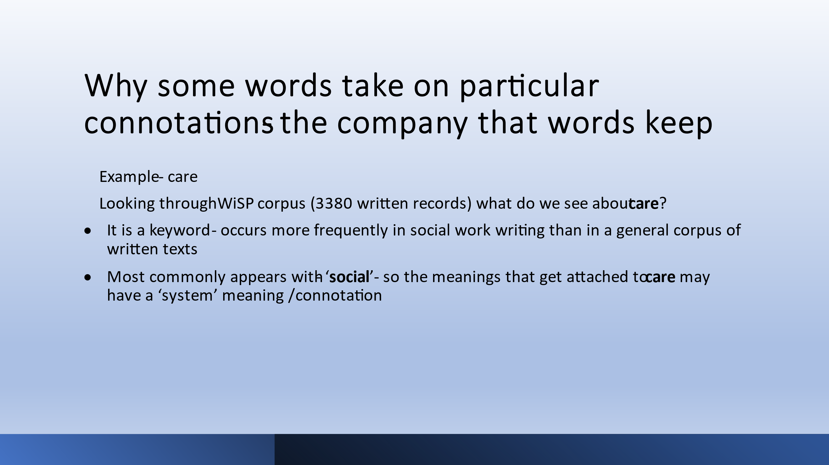
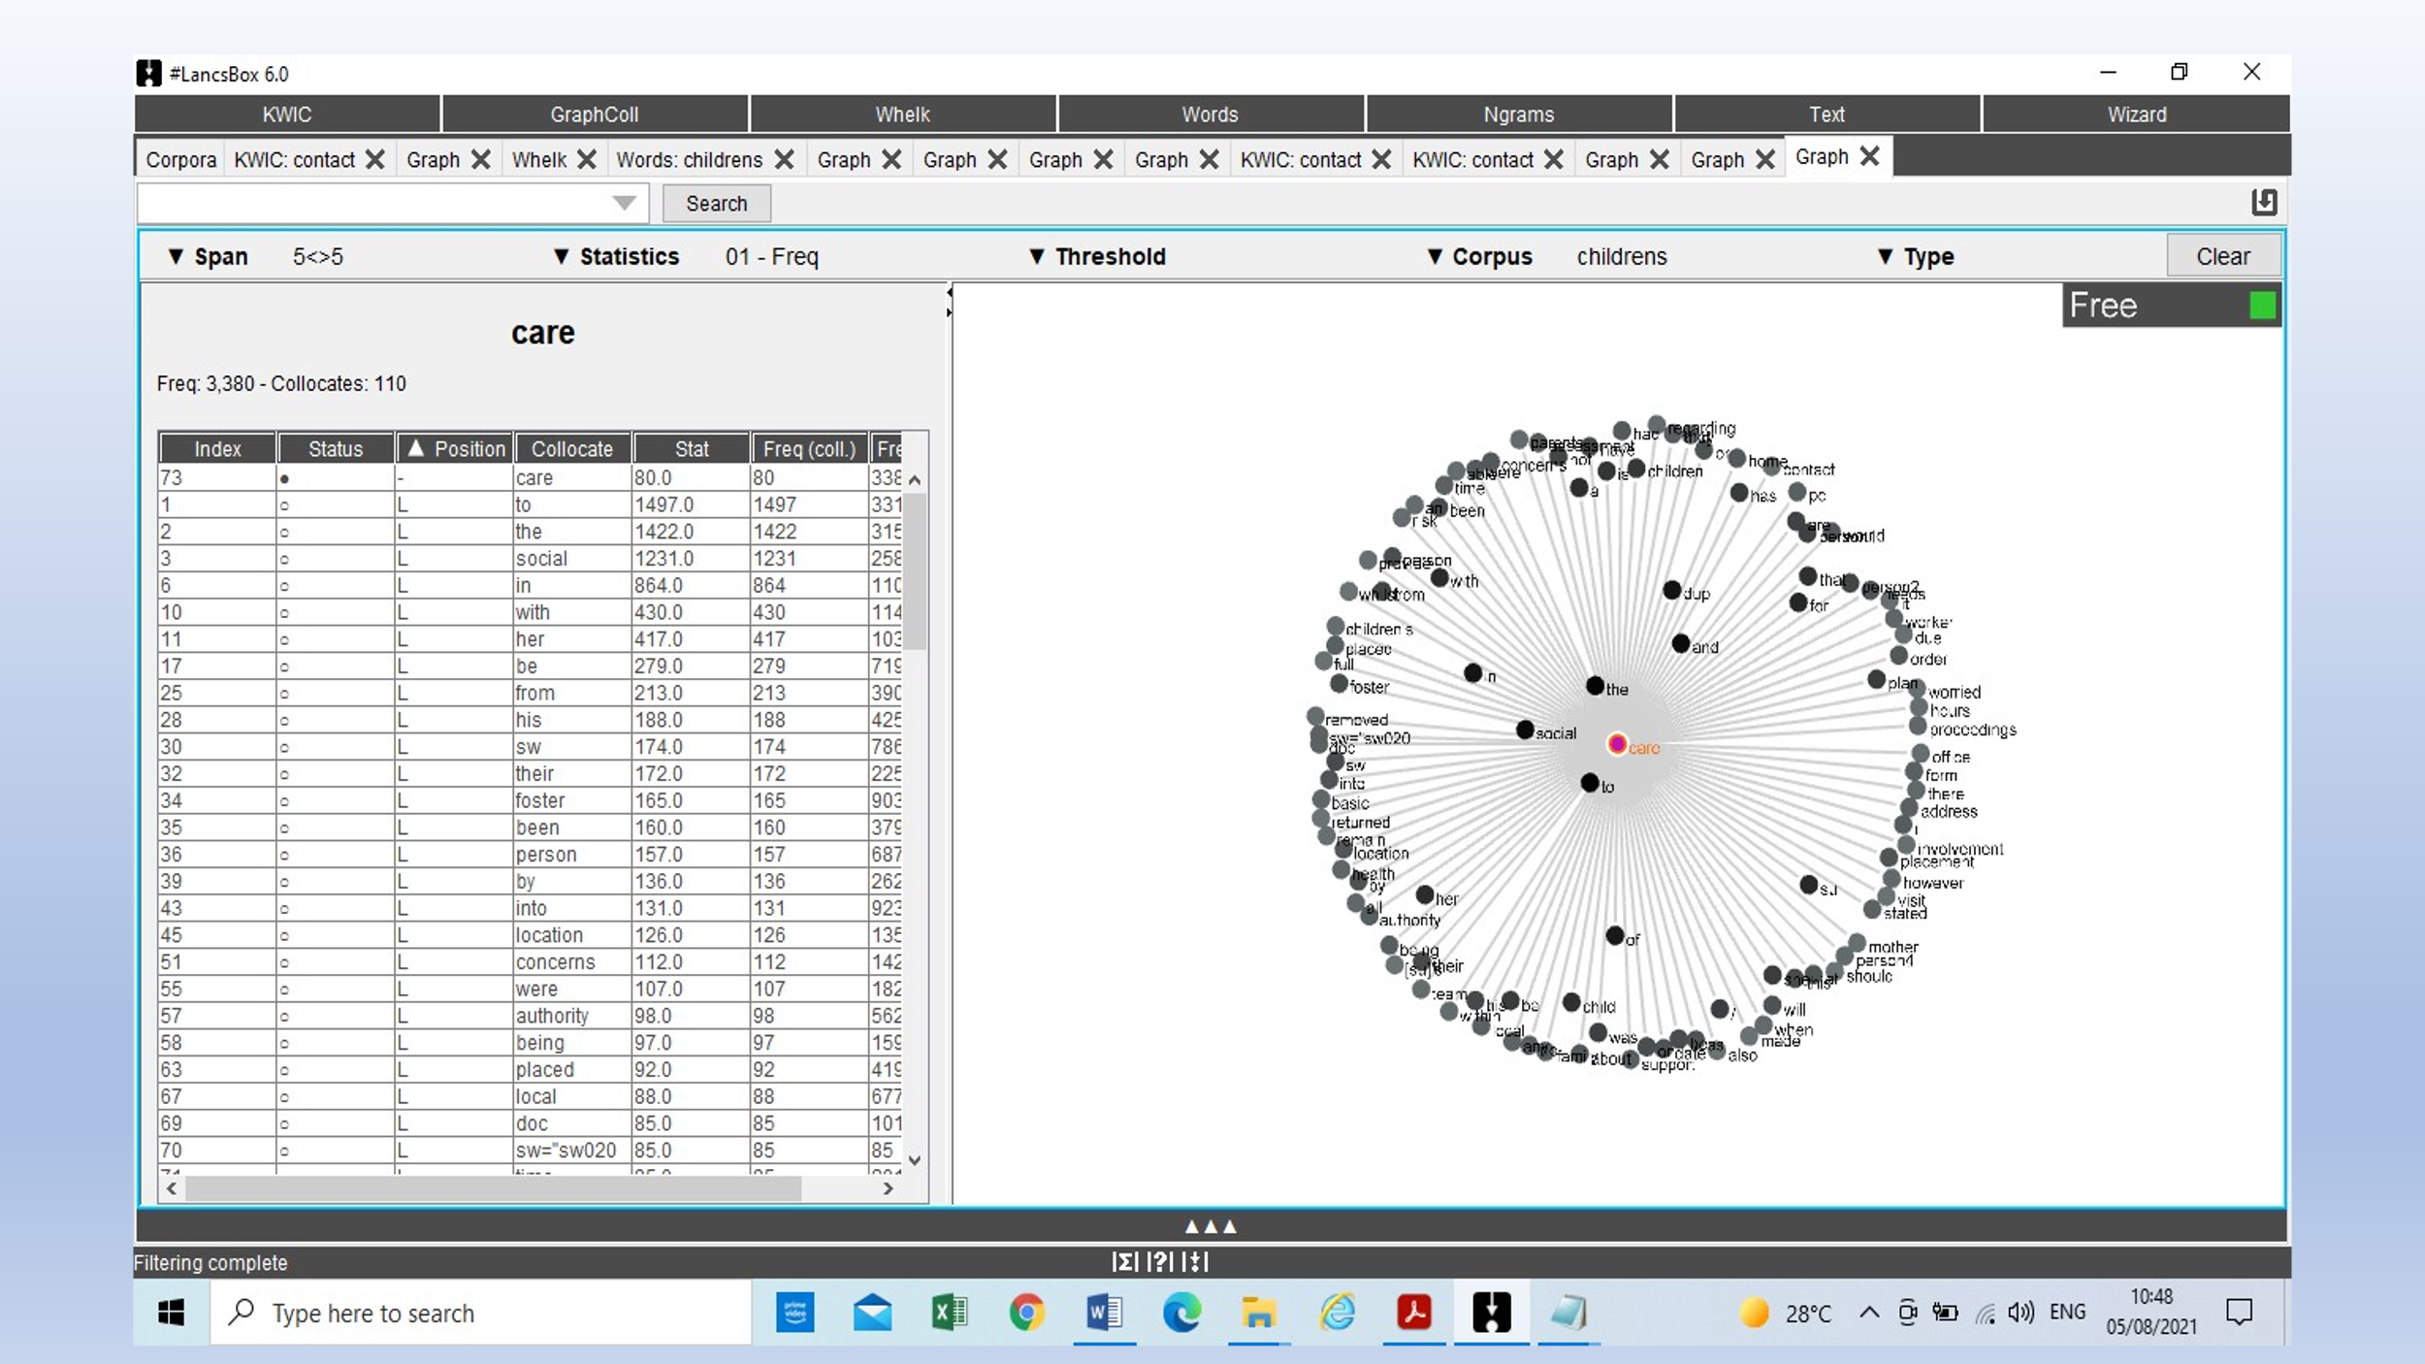

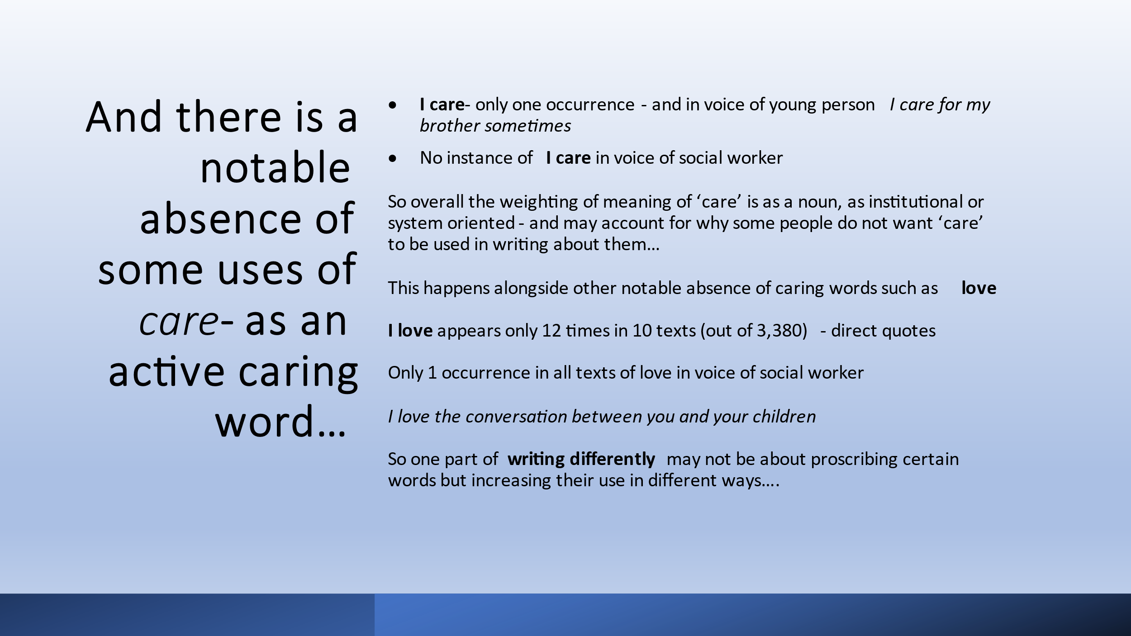

Comment: The ‘critical moment’ here was identified as such by young people and subsequently discussed by professionals. I don’t think I as researcher would have identified ‘care’ as a troublesome discourse in voicing on the basis of the analysis we carried out. However, the text data from the WiSP project enabled me to bring a perspective on the use of ‘care’- and a key distinction between it being used as a noun and thus indexing ‘system/organisation’ to young people rather than as a verb which- if used as a verb- might index the kind of warmth towards the young person that many of the professionals are interested in expressing. Reaching some conclusion about whether the word ‘care’ should or should not be used in records is of immediate interest to professionals.

7. Conclusions??
- At one level the decision around which specific aspect of research data/potential findings to focus on is a practical problem- it is not possible to do everything we would like to do with limited time, energy and resources. However we need to recognise that higher education ‘regimes of evaluation’ (I’ve discussed this in Lillis 2018, based on Blommaert’s ‘language of evaluation’ ) may skew decisions about what to focus on, towards ‘academic’ conversations which may be interesting to the field but not necessarily of interest to practitioners- raising questions about the extent to which we can produce usable/useful research.
- ‘Critical moments’ are not autonomous from context and orientations: specific academic conversations may orient us towards the identification of particular moments, perhaps to engage with data and generate findings which are robust and valued by academic communities. At the same time, specific professional conversations may orient us to moments of immediate concern, reaching conclusions which may be of more immediate usefulness/usability.
- We as researchers cannot know what is of interest to professionals and therefore which data/insights from our research constitute ‘critical moments’ from their perspective- there is therefore a need for ongoing cyclical research focusing between researchers and potential end-users of research.

References
Bakhtin, M. (1981 [1935]). The dialogic imagination (C. Emerson & M. Holquist, Trans.).
University of Texas Press.
Blommaert, J. (2018)). Are chronotopes useful? Working Papers in Urban Language and
Literacies, Paper 243. University of Tilburg
Candlin, Christopher N. (1989) Preface. In Norman Fairclough (ed.) Language and Power, vii viii. London: Longman..
Candlin, Christopher N. (1997) General editor’s preface. In Britt Louise Gunnarsson, Per Linell and Bengt Nordberg (eds) The Construction of Professional Discourse, viii–xiv. London: Longman.
Lillis, T. (2018) Resistir regímenes de evaluación en el estudio del escribir: hacia un imaginario enriquecido, Signo y pensamiento, 36 (71): 66-81.
Lillis, T. (2021a) Writing as a critical moment in professional discourse, Journal of Applied Linguistics and Professional Practice, 15.3: 334-363.
Lillis, T. (2021b, available online) Professional written voice ‘in flux’: the case of social work, Applied Linguistics Review, https://www.degruyter.com/document/doi/10.1515/applirev-2021-0055/html
Myhill, Debra and Pauline Warren (2005) Scaffolds or straitjackets? Critical moments in classroom discourse. Educational Review 57 (1): 55–69.
Vachon, Brigitte and Jeannette LeBlanc (2011) Effectiveness of past and current critical incident analysis on reflective learning and practice change. Medical Education 45 (9): 894–904.

Institutional Description: The research centres on professional social work writing and involves five local authorities in the U.K., 71 social worker participants, working in the three key domains of social care: children’s, adults, mental health. The research seeks to characterize the nature of contemporary social work writing, by documenting the institutional writing demands and requirements, tracking everyday social worker practices, and exploring the perspectives of professional social workers

Key Theorists: Methodologically the research draws on ethnographic orientations towards writing, with multiple types of data generated and analysed in order to shed light on the particular phenomenon of social work writing. Key theorists include Street, Blommaert, Snell et al., 2015. Notions of “thick participation” (Sarangi, 2006) and “thick description” (Geertz, 1973) are used. Data are explored using both realist and interpretive lenses (Lillis, 2008; see Lather, 1991).

Glossary: I think the key notion is ‘critical moment’ which is outlined in the draft notes. Underpinning and central notions are notions of writing/literacy as a social practice, after Street and Bakhtin’s notions of voice, utterance and addressivity.

References
Bakhtin, M. (1981 [1935]). The dialogic imagination (C. Emerson & M. Holquist, Trans.).
University of Texas Press.
Blommaert, J. (2006). Ethnography as counter-hegemony: Remarks on epistemology and method (Working Papers in Urban Language and Literacies Paper 34). Institute of Education.
Brandt, D. (2005). Writing for a living: Literacy and the knowledge economy. Written Communication, 22, 166–197.
Geertz, C. (1973). The interpretation of cultures. Basic Books
Lather, P. (1991). Getting smart: Feminist research and pedagogy with/in the postmodern. Routledge.
Lillis, T. (2008)‘Ethnography as method, methodology and ‘deep theorising’: closing the gap between text and context in academic writing research’. Written Communication, 25, 3: 353- 388.
Sarangi, S. (2006). The conditions and consequences of professional discourse studies. In R. Kiely, P. Rea-Dickins, H. Woodfield, & G. Clibbon (Eds.), Language, culture and identity in applied linguistics (pp. 199–220). Equinox
Snell, J., Shaw, S., & Coupland, F. (Eds.). (2015). Linguistic ethnography. Palgrave Macmillan.
Street, B. (1984). Literacy in theory and practice. Cambridge University Press.

