Writing Engagement and Formative Feedback in the ELA Classroom
Introduction
Lit Review
Formative assessment of language learning
"As soon as others want the results of learning more than the learner, the game is over" opined James Moffett in his 1992 book on language learning assessment, Detecting Growth in Language. Arguing that summative assessments were largely political ("National assessment exists to embarrass schools into improvement by comparing scores"), Moffett contended that assessment should only be conducted in situ by the teacher and for the teacher. Moffett's central belief was that assessment should be formative; that is, assessment should only be used to provide information which teachers can use to adjust instruction and support learning.
In what remains the largest research review of assessment and classroom learning to date, Black and Wiliam (1998) reviewed more than two-hundred and fifty studies and found that students whose teachers used formative assessment made significant gains in their learning. In fact, the gains which Black & Wiliam found among formative assessment interventions were some of the largest ever reported for educational interventions (effect size went from 0.4 to 0.7, a massive increase). They described formative assessment as a “process in which assessment-elicited evidence of students’ status is used by teachers to adjust their ongoing instructional procedures or by students to adjust their current learning tactics” (p. 6). And formative assessment isn't just valuable for teachers, but also teachers in training. Beck et al. (2018) contended that "formative assessment holds promise as a place for preservice teachers to gain a better understanding of students’ unique struggles as writers and of writing as a complex, challenging skill" (XX).
As Glasswell & Parr comment in their 2009 Language Arts article, "thinking about what to teach next is a long-standing and worthwhile tradition" about which teachers are always thinking (XX). They felt, much as Moffett did, that formative assessment is more than reading and giving feedback on a students' writing; it involves looking "beyond the text to the context" of the learner's development (XX). In particular, Glasswell & Parr believe that formative feedback is a powerful classroom tool which helps to "transfer responsibility for evaluating performance over to the student" (XX). Crumpler (2010), however, has noted that "in many assessment practices… students are often not positioned as active designers of their own social futures" (XX).
One important approach to integrating students' perspective into formative assessment practices is student self assessment (Black & Wiliam, 1998; Andrade et al., 2010). Many studies have demonstrated a positive association between self-assessment, learning, and achievement (see Brown & Harris, 2014, for a review), as well as contending that self assessment can increase self-regulated learning strategies (Kostons et al., 2012), enhance students’ self-efficacy (Ramdass & Zimmerman, 2008), and empower students in the assessment process (Tan, 2012; Taras, 2010). All of this research points to the potential value of self-assessment for the purposes of formative assessment, which Turner & Brannon contended "can help [teachers] to make sense of student feedback and to identify the ecological forces that may be impacting engagement" (XX).

Writing engagement

While learning engagement broadly, and literacy and reading engagement specifically, have been researched extensively and both shown to have a positive impact on student performance (Fredericks et al., 2004; Parsons et al. 2018), research on writing engagement is much rarer, and often conflated with writing motivation (see Camacho et al., 2021 for an authoritative review of Writing Motivation). The studies of writing engagement which do exist all conceive of writing engagement as a multidimensional construct, typically conceived of as including affective (Boscolo & Hidi, 2007), behavioral (Cho, 2019; Liu et al., 2018), cognitive (Kitsantas & Zimmerman, 2006), and social components (Farizka & Cahyono, 2021).
In a recent study (Rogers et al., 2022), we developed a student self-assessment tool, the Writing Engagement Scale (WES), based on our own four-factor model of writing engagement. This tool was designed as a formative classroom assessment in which students self-assessed their experience with a recently submitted writing assignment in order to provide teachers with actionable information with which to formatively adjust their practice and instruction thereafter. Our results demonstrated that the WES was psychometrically valid; that it provided valid and reliable scores of upper elementary student writing engagement. Teachers' perceptions of the usefulness of the WES further supported its validity (XX). .
In this study, we intend to delve further into the results of a teacher survey we sent to participating WES teachers in order to investigate the following questions:
- What are teacher perceptions of the usefulness of the WES for formative assessment?
- How do teachers view the dimensions of writing engagement?
- How do they respond (formatively) to the information from the WES in their efforts to increase engagement?

Methods
After each participating teacher administered the WES to students in their classroom, we compiled the data and results and sent them a short report which showed both the overall class trends and averages as well as the raw individual student data. We then asked them to answer an eight-question survey, the questions of which were:
- In what ways, if any, are the overall, class-wide WES results useful for you in providing feedback to your students?
- Which items in the WES offer the most useful information in terms of providing feedback? Pick two.
- After selecting one student’s WES results and looking at their accompanying text, in what ways, if any, does the scorecard provide meaningful insight into the student’s writing activity?
- Please provide (e.g. copy and paste) the prompt for the assignment for which your students completed the WES.
- How do the overall class scores on this assignment help you to think about how you might adjust or adapt your instruction for your next writing assignment?
- Please elaborate on any other ways in which the WES results provide useful information for you as a teacher.
- Is there anything you would change or add to the WES to make it more helpful?
- What advice or ideas might you offer to a teacher who asked you how they might support their students as engaged writers?
We asked Questions 1, 2, 6, and 7 in order to help us as researchers better understand the dimensions of the WES that provide the most value to teachers. In other words, what did teachers want to know about writing engagement and why? Question 3 encouraged teachers to focus on the data for individual students. Question 4 sought to understand better the types of texts students were writing, which also provided important data for us insofar as the relationship to the analysis of student texts for quality, and in better understanding the relationship of genre to writing engagement (we plan to investigate the relationship between engagement and text quality in a future study). Question 5 invited teachers to consider the results at the whole class level. Finally, question 8 provided us with an understanding of the practical ways in which teachers think about writing engagement, given that they are experts on what's happening in their classrooms and professionals who bring the wisdom of practice to conversations about writing engagement.
Seventeen teachers responded to the survey, and we transferred that data into a workbook where we began the process of coding these streams of language. In keeping with Geisler and Swarts (2019), we approached the systematic analysis of this data using a mixed-methods approach. In one pass of our coding we conducted a straightforward content analysis of the survey results, reviewing the answers the teachers gave to the survey questions as self-report data at face value, and considering their responses as reflections of their attitudes, values, and beliefs.
More importantly, however, for the purposes of our inquiry, while the data itself is qualitative, we approached the analysis quantitatively in order to ask "precise questions and make judicious selections of data that [were] sensible" within our chosen analytic frame (Geisler & Swarts 29). In this regard, we first broke out the data at the sentence level independent of coding (69). We chose to segment at the sentence level so that each segment would fit into one and only category of our coding scheme (70). We ended up with 308 total "units of language" (73) , hereafter referred to as "discourse items."
We then began development of a codebook using multiple dimensions with which to "symbolize, summarize, or otherwise capture some attribute" of the discourse items (113). We chose to begin with mutually exclusive, non-inferential categories to not only contribute to the reliability of our coding but familiarize ourselves with the data as we coded (116). Our first coding dimension was Tense, and we coded each of the discourse items based on the tense in which they were speaking (Past, Future, or No Code). We then recoded the data across a second dimension, Focus, which sought to characterize the object of interest for each discourse item (Teacher, Student, or No Code). We then devised a nested dimension wherein we took all of the discourse items coded as Student and recoded them as either Whole Class or Individual depending on which level of specificity the discourse item was utilizing. Throughout these coding sessions, we took notes, discussed coding dimension definitions and tentative trends which surfaced, and developed a codebook with definitions and examples (See Appendix X). After we finished coding across the first two dimensions, Tense and Focus, we decided to devise a third and fourth dimension to capture some of the phenomenon which had emerged.
As our project was based on a four-factor model of engagement which included affective, cognitive, behavioral, and social elements (Rogers et al. 2022), and as we noticed that the teachers themselves were at times speaking in terms of engagement in their own survey answers, we then recoded all of the discourse across a third dimension, Writing Engagement, which sought to differentiate the types of engagement with which teachers thought about and expressed their thoughts regarding their students' engagement with the writing task and finished products.
Coding Category | Definition | Cases | Examples
Affective | Code as Affective any sentences which reflect attention to student interest and enjoyment in the writing activity. | a. refers to student enjoyment, interest, or joy about their writing efforts | - The results are useful for discovering how students feel about writing and perceive their writing assignment.  - When it said, “I was interested in what I was writing” and he chose I strongly agree.
Behavioral | Code as Behavioral any sentence which reflect student participation, effort, and persistence. | a. refers to student efforts to complete writing activities | - I was surprised by the effort students are putting into their writing, and they are aware of putting forth effort.  - This was a tough writing piece as it including researching one of the 21 CA missions (not the most interesting reading), but my students persevered and did well
Cognitive | Code as Cognitive affective any sentences which reflect student strategy use and self-regulation. | a. refers to students use of strategies and self-regulation to complete writing activities | - We need more time to talk about writing and the writing process.
Social | Code as Social any sentences which reflect the degree to which students collaborate and interact with others during writing. | a. refers to students interacting or working with others to complete writing activities | - They learned how to work with others, those who are easy to collaborate with and those that require more grace and compromise.  - The results about wanting to share their writing with their peers, and talking about their writing with other students are really useful to share with students.
Table X - Coding Dimension 3: Engagement
Finally, we made one other observation while coding through all of the data; sometimes teachers expressed surprise at the results or student comments. We decided to devise a fourth and final dimension, which we called the Expectation Gap, that sought to capture teacher comments which demonstrated that the WES provided data of which they were otherwise unaware. We recoded all of the data a final time across this fourth dimension as either Expected or Unexpected. Once we had coded all 308 discourse items across these four dimensions, we began to analyze the trends which emerged. In the following section, we share our results.
Results
A quick snapshot
Our overall results demonstrate that teachers mostly talked in the past tense about the whole class in terms of affective engagement; how students felt about the writing or how much they enjoyed writing. Only 8.6% of comments were coded as Unexpected. Teachers valued the Cognitive items most, followed by Affective, Behavioral, and then Social. Teacher advice about writing engagement mostly revolved around student choice, but included some other interesting suggestions. We were able to collect the writing prompts and genres for slightly more than half of the participating teachers, but what we collected showed that teachers were mostly using personal genres such as personal letters, personal narratives, and personal essays.
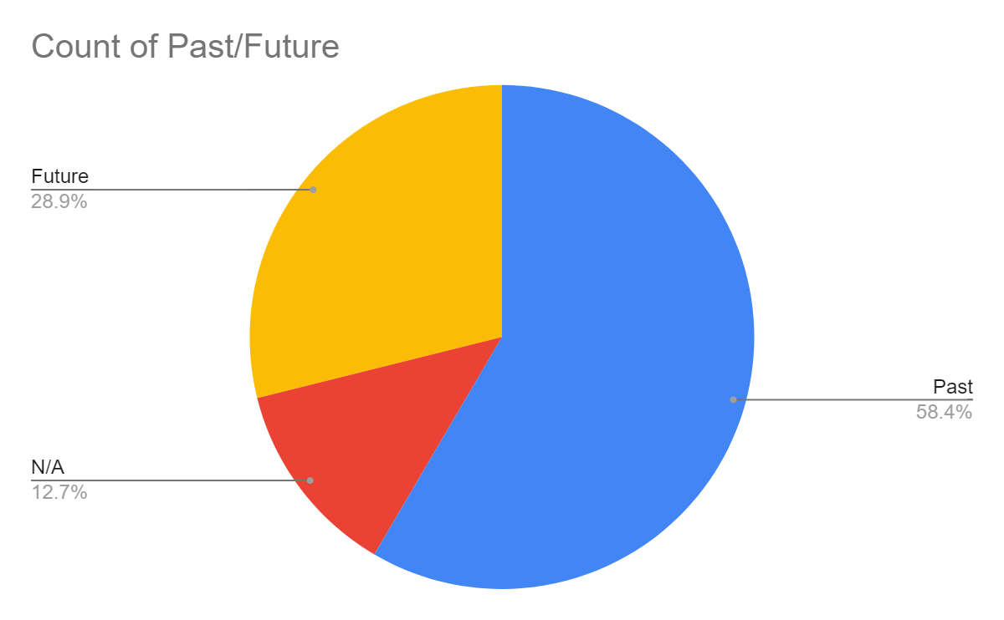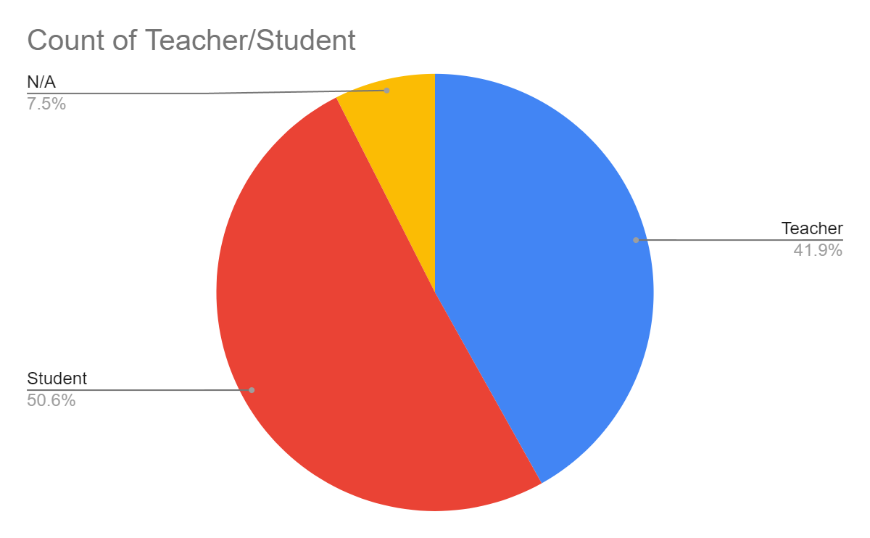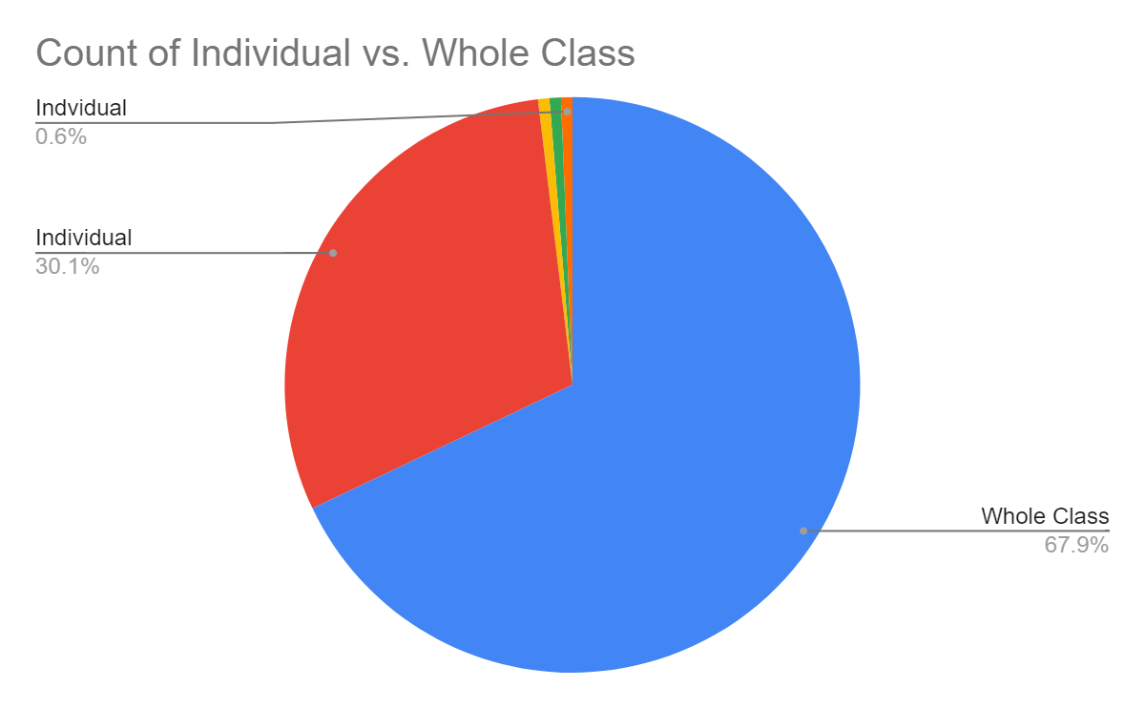
Figure X - Overall Results
Perhaps the most interesting trend we were able to discern with regards to the overall data was that while teachers often talked in the past about students at the whole class level centered on affective engagement, their future tense comments were mostly about themselves or students and centered on social engagement. That is to say, while reflecting on what had already occurred, teachers were mostly interested in how students felt or if they enjoyed the writing, but when they looked at what they might do next or differently because of these results, they mostly focused on increasing students' opportunities for social engagement with their peers. In the following sections, we share more details about each of these findings.
Advice for fellow teachers to support engagement with writing
The majority of teachers contended that offering students choices about what and how they write was the most useful way to support engagement with writing. Representative comments ranged from short and direct ("Give students choice.") to more elaborate answers suggesting choice of writing assignment, within writing assignments, and when and how to write (multiple informal writing sessions during class vs. prewriting as homework, etc.). Second to student choice was structure and guidance; for example, teachers suggested modeling, guiding questions, and sentence frames. Thereafter, journaling and opportunities for social and dialectic interaction were perceived as the most useful. A significant proportion of teachers suggested encouragement of daily practice writing, often in journals, thinkbooks, or other related formats. A few teachers recommended engaging in activities related to audience awareness and physical activity prior to the act of writing ("Start with the work of the hand i.e. sculpting, building 3-D models, painting, stitching books, marble painting").

Most useful item

As shared above, teachers mostly favored cognitive items when asked to choose the two items from the WES survey which they thought were most useful.

Engagement | Percentages | Number | Totals
Cognitive | 24% | 18/74 | When writing this piece, I reread to see if I could make it better.
Affective | 16% | 12/74 | When writing this piece, I was interested in what I was writing.
Cognitive | 15% | 11/74 | When writing this piece, I created a plan before I started writing.
Social | 12% | 9/74 | When writing this piece, I talked with my peers about my writing.
Affective | 9% | 7/74 | I enjoyed working on this piece of writing.
Behavioral | 9% | 7/74 | I was focused on my writing while completing this assignment.
Behavioral | 8% | 6/74 | When writing this piece, I put my best effort into my writing.
Social | 4% | 3/74 | When writing this piece, I talked with my teacher about my writing.

Table X - Results of the "Most Useful WES Item" Survey Question
These results demonstrate that teacher's perceptions of the usefulness of the WES began with the value of knowing whether or not students used strategies like planning and rereading while completing the writing task. Further still, teacher's saw value in understanding whether or not students were interested in and enjoyed writing. Teachers also found useful hearing from students about whether they had talked with their peers about their writing. Behavioral items were perceived as less useful by teachers, as well as the social item asking if students had talked with their teachers about their writing, foreseeably because teachers would already be aware of this information prior to or without the WES. These results are particularly interesting because while teacher's valued the cognitive items, our coding results demonstrate that they rarely talked in terms of cognitive writing engagement in their own comments.
Dimensions of writing engagement
It is worth pointing out that a significant proportion of the teacher comments, or discourse items, which we coded did not speak to or about writing engagement and were thus coded as N/A; 82 out of the 308 total items were coded with one of the dimensions of writing engagement. Those remaining 82 items demonstrate that among the four elements of writing engagement in our model, teachers most often spoke in Affective terms (32.4%), followed by Social (28.7%), then Cognitive (22.1%), and finally Behavioral (16.9%). For all of the items in each of these coding categories, items were mostly coded as Past, Student, and Whole Class.
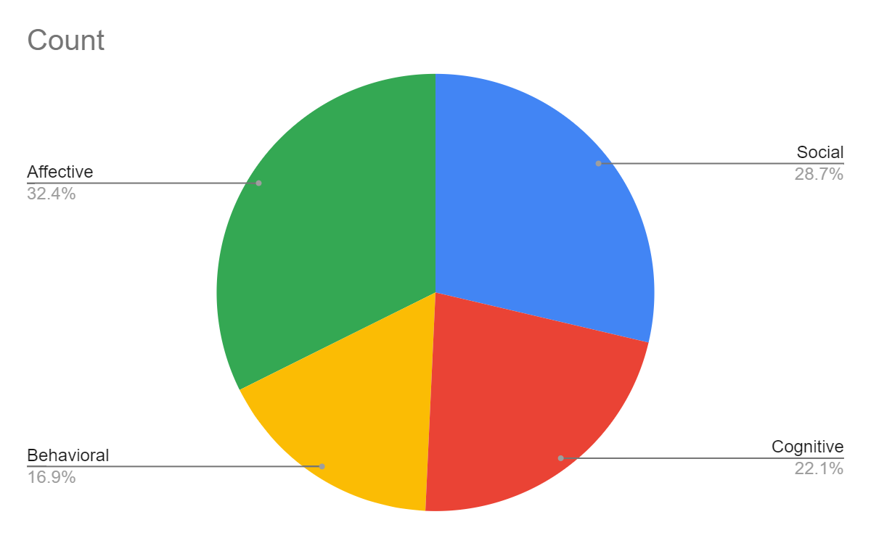
Figure X - Percentage of Discourse Items Coded for the Elements of Writing Engagement
Affective engagement
44 total items were coded as Affective, 81.8% of which were coded for Past tense, and 86.4% of which were coded for Student. Among Student comments, 55.3% of discourse items were coded for Whole Class.. Only 2 items (4.5%) were coded as Unexpected. The most frequently used terms used by teachers in affective items (besides "writing" and "student") were "engaged," "enjoyed," "interesting," "feel," and "felt." Two representative affective discourse items were:
- "The students who felt more engaged scored higher and produced more thoughtful pieces of writing."
- "I liked to see if my students were actually engaged or just doing the assignment to get the grade."
Behavioral engagement
24 total items were coded as Behavioral, 82.6% of which were coded for Past tense, and 82.6% of which were coded for Student. Among Student comments, 68.4% of discourse items were coded for Whole Class. 4 items (16.6%) were coded as Unexpected. The most frequently used terms used by teachers in affective items (besides "writing" and "student") were "effort," "think," "reread," and "hard." One representative affective discourse item was:
- "I think it's relevant to see that there was a correlation between students' interest in the writing, and their desire to improve their writing through revisions"
Cognitive engagement
30 total items were coded as Cognitive, 73.3% of which were coded for Past tense, and 80% of which were coded for Student. Among Student comments, 83.3% of discourse items were coded for Whole Class. No cognitive items were coded as Unexpected. The most frequently used terms used by teachers in cognitive items (besides "writing" and "student") were "process," "think," and "confused." One representative affective discourse item was:
- "They had to think about their process and the steps they took to achieve their end goal."

Social engagement
39 total items were coded as Social, 61.5% of which were coded for Past tense, and 71.8% of which were coded for Student. Among Student comments, 71.4% of discourse items were coded for Whole Class. 7 social items (18%) were coded as Unexpected. The most frequently used terms used by teachers in social items (besides "writing" and "student") were "peers," "share," "work," "conferences," and "feedback." One representative affective discourse item was:
- "Many students approached me after reading it aloud to their peers that they noticed minor errors and changes they wished they would have made."

Unexpected discourse items

Only 20 total items (8.9%) were coded for Unexpected, 45% of which were coded for Student, and 55% of which were coded for teacher, which was much more teacher focused than the other coding categories. Unexpected items were also more focused on individual students, with 45% of Unexpected items coded as Individual and 55% coded as Whole Class. These items were also mostly coded as Social (43.6%). The Unexpected + Social items largely centered on helping teachers to understand which of their students were hesitant to share their work with their peers as well as how students perceived or felt about"sharing" their work in general.

Discussion
A formative assessment tool like the WES is a step forward for teachers and researchers interested in a student centered view of assessment. Self-assessment tools, like the WES, allow for students to have a say in the results of their own learning in the same way for which Moffett argued. Further in line with Moffett's thoughts on language assessment, it also positions assessment as a part of the naturally occurring every day activities of the classroom and as a tool which can provide useful information for teachers to monitor the learning and development occurring in their classrooms. Much as Glasswell and Parr put it, the analysis of WES results by participating teachers was a “process in which assessment-elicited evidence of students’ status [that was] used by teachers to adjust their ongoing instructional procedures” (p. 6).
In this regard, in the answers to teacher survey question number six ("How do the overall class scores on this assignment help you to think about how you might adjust or adapt your instruction for your next writing assignment?") one teacher remarked that the WES scores "help[ed] me to understand how I can tweak the prompt to make it more engaging for more students." And many other teachers commented on small changes or tweaks they might make in their future instruction as a result of reviewing the results of the WES: "next time, I will have my students practice reading their drafts aloud" and "in the future, I will provide more partner feedback time," are two representative examples. Overall, the teacher comments demonstrated "the WES scores can provide meaningful information" with which to monitor and adjust ongoing instructional practices for teachers of the language arts in K-12 contexts.
The WES also positioned teachers to look "beyond the text to the context" of learners' development (XX) much as it positioned students, as Crumpler suggested, as "active designers of their own social futures" (XX). By involving students in the assessment of their own writing, they got to play a part in shaping not only the perception of their own work, but also have a say in what's done about it; how teachers augment instruction thereafter to address student comments and perceptions of their own writing. Much as Turner & Brannon have outlined, the WES results positioned teachers "to make sense of student feedback and to identify the ecological forces that may be impacting engagement" (XX). Having discussed teachers' perceptions of the usefulness of the WES for formative assessment, it's worth considering for a moment how teachers view the dimensions of writing engagement.
The most curious element without our results on teacher perceptions of writing engagement was undoubtedly the cognitive dimension. Note that teachers rated the cognitive items as two of the top three most useful items on the WES. And yet, teachers themselves seldom talked in cognitive engagement terms. Teachers were mostly interested in affective engagement; how their students felt and whether they had enjoyed the assignment, activities which surrounded and supported the writing task, and the writing itself. It's worth thinking for a moment through what other avenues a teacher might access this information, and so too how putting students on the spot about whether they enjoyed something might unwittingly pressure them in their answers.
SImply put, a self-assessment, like the WES, provides access to information which teachers might otherwise find difficult to access, especially from the entire class; namely, how students felt about the work. In this way, the WES demonstrates quite aptly how powerful self-assessment tools can be for formatively adjusting and differentiating instruction. By accounting for student perceptions in curriculum design and implementation, teachers can more adroitly shape their pedagogical practices to fit not only their own desired learning outcomes, but student's perceptions of what is or is not useful, productive, and enjoyable.
Finally, in answering how teachers respond to the information from the WES in their efforts to increase engagement. Teachers mostly expressed that they planned to increase opportunities for social writing engagement; for soliciting feedback from their peers, for teacher conferences, and for encouraging them to share their work with their parents and other adults in their lives outside of school. Two representative comments in this regard were, "students seem to really want to talk about their writing" and "it is important to provide space for reluctant writers to share their thoughts." This desire to increase opportunities for social engagement was also accompanied, in the answers to survey question number eight ("What advice or ideas might you offer to a teacher who asked you how they might support their students as engaged writers?") with suggestions about the import of student choice over how and what students work on or write about in efforts to drive writing engagement in the classroom "Give them choices within a writing prompt" read one representative comment. Secondly, and no less important to these teachers, was the idea of authentic writing tasks for authentic audiences; "kids are motivated when…. they are provided an authentic audience," remarked one teacher.
We see immense value in teacher's insights into how to increase engagement with writing in the classroom; namely, by centering on students. For, much as Moffett contended in the quote which began this essay, "as soon as others want the results of learning more than the learner, the game is over" (XX). Including students as "active designers of their own social futures'' includes involving them in decisions about what and how they write, whom they write to, and to what end much as it hinges on the social and dialectical connections which incarnate the myriad types of communications they meaningfully encounter in their own lives, and will have to master throughout their time in school (XX). Teachers, researchers, and administrators would do well to give their serious, renewed attention to formative assessment practices in the language arts classroom which can in turn help to drive engagement with writing.
Limitations & Future Directions
This study has several limitations, foremost among them the lack of a longitudinal follow-up to investigate the impact of these formative plans on the part of teachers to adjust and augment instruction in the wake of the WES results. While the statistical validity of the WES is affirmed, and while teachers perceive of it as useful, it still remains to be seen if the formative information generated by the WES and the plans to adjust and differentiate instruction which teachers gleaned from its results lead to more engagement in the classroom, much as Black and Wiliam found in 1998 that students whose teachers who used formative assessment made significant gains in their learning. Future studies of the WES should seek to investigate its implementation over time and multiple writing assignments to see if it leads to better, more engaged writing. Lastly, the potential of formative assessment for supporting the development of preservice teachers is another promising future direction, extending Beck et al.'s 2018 work which contended that "formative assessment holds promise as a place for preservice teachers to gain a better understanding of students’ unique struggles as writers and of writing as a complex, challenging skill" (XX).
Conclusion
Supporting Information
Institutional Description:
I am a writing teacher and PhD student at George Mason University, a large research institution in the midatlantic United States. I am also a part of a larger research team which includes several senior researchers both here at Mason, and at the University of California, Santa Barbara. Because our research focused on K-12 contexts, we collected data through pre-existing professional and academic partnerships and through the California Writing Project (CWP), a regional association within the National Writing Project (a large, teacher led volunteer organization dedicated to professional development of and for writing and language arts teachers).
Our research was IRB approved through GMU and UCSB and the last round of data collection (on which the attached research paper is based) was funded through the CWP. Accordingly, there are a myriad of institutional contexts to navigate in the implementation of this research. We are currently partnering with other researchers to implement the WES in new sites and working on grant proposals for federal funding through the National Center for Education Research (NCER) and the Institute of Education Sciences (IES).

Key Theorists:
James Moffett was a ground-breaking teacher, author, and theorist of language learning who had a profound impact on the fields of English education, composition, and educational psychology in the mid-to-late 20th century. Moffett’s teaching practice, his student-centered theory of instruction, and his account of language development in relationship to discourse types—most of it articulated in the late 1960s—remain powerfully influential today in the most advanced contemporary models for learning assessment, in shaping the writing curriculum of modern schools and college writing programs, and in what are widely regarded as best practices for the teaching of writing and the teaching of reading (or literature) across grade levels and across the curriculum. Moffett remains the only figure in Writing Studies and English education writ large to offer a fully developed learning theory for education and all the language arts—a theory for practice focused first on learners, but then also on the intellectual structures and content of what is to be learned, all of it serving as the rationale for a principled methodology, field-tested and validated by a long history of praxis and research.
Cheryl Geisler and Jason Swarts are two well-established experts in the methodology of coding both verbal and written streams of language. Using a complex, systematic mixed method, they advocate for combining context-based inquiry with quantitative tools for examining big picture patterns that acknowledges the complexity of language use.
Kathleen Blake Yancey & Brian Huot are two independent scholars that have both advocated for assessment efforts which go beyond concerns of validity and reliability and towards the end goal of producing assessments with practical instructional value.
Gavin Brown and Lois Harris are two scholars who have advocated for formative assessment practices which value and include student self-assessment of work products and processes.
Glossary:
I do not at this point see any potentially context or culture specific terms in need of explanation. If any arise, I am happy to contribute working definitions.

