Rewriting Gender Identities
Xiqiao Wang, Ke Xu
Research on literacy mobility has yielded useful theoretical and methodological tools to examine language learning and literacy practices at the intersection of advancing digital technologies and global processes of migration. With such research focusing on transnational migrants who move across geographic, linguistic and cultural borders, literacy researchers have examined how migrants leverage old and new literacy practices to sustain social networks, send financial and social remittances, and navigate transnational bureaucracies of immigration. Such research has not only examined how digital literacies provide transnational youth with opportunities to negotiate multiple identities, languages, and networks embedded in online and offline spaces (Barton & Lee, 2011, Black, 2005; Lam, 2009; Yi, 2009), but also argued for the central role of literacy in enabling migrants’ navigation of institutionally sponsored spaces that controls and regulates individual mobility (Leonard-Lorimer, 2013; Vieira, 2016). Such scholarship has positioned literacy as an important dimension of transnational migration, as those on the move learn new ways of reading and writing in anticipation of their geographic mobility, economic solvency, and emotional intimacy. In important ways, multilingual writers constantly reconfigure their language repertoire in reaction to social, bureaucratic, and ideological structures that privilege languages of the powerful and render the languages and narratives of the vulnerable as deficient and invisible (Fraiberg, Wang, & You, 2017; Leonard-Lorimer, 2017).
Whereas current research has often celebrated transnational migration for enabling the fluid movements of financial, learning, and identity resources across international borders, such a celebratory stance has often risked at creating “contemporary silences about internal migration,” or ways in which migratory experiences are powerfully shaped by nation states and narratives of national identities (Schiller & Salazar, 2013).
It is in this spirit that we turn to China as a site to examine how various acts of physical, imaginary, and linguistic border crossing shape multilingual writing. With China’s rapid economic growth and urbanization, its population of migrants moving from rural areas to urban centers has increased from 70 to 247 million in the past three decades, accounting for 16.5% of its total population. More recently, China’s expansionist agenda has been accompanied by outward labor migration and new forms of immigration through geopolitical initiatives such as Belt and Road (Haugen, 2012; Lee, 2017). The intertwinement of such internal and outbound labor movements has created opportunities for social mobility, shifted social structure, and displaced families (Lee, 1998; Naughton, 2007). Scholars of China studies have further noted for the increasing intertwinement of censorship, propaganda, and grassroot digital practices in inculcating and spreading nationalistic discourse (The Economist, 2016; Fang and Repnikova, 2018), which often silences the voice of the vulnerable, deprives those left behind of agency and dignity, and creates obstacles for disrupting official narratives and social hierarchy (Meng, 2011; Gong & Yang, 2010; Yang, 2016). It is therefore important to examine experiences and imaginaries of migration under the influence of social policies and cultural narratives at both national and transnational scales. Attending to Chinese university students’ literacy as dynamically connected to mobility, this chapter is an attempt to invite “deeper and broader questioning of contextual work, political influence, heterogeneous national contexts, dominant models, interdisciplinarity, and diverse research methods” (Donahue, 2009, p.214).
Scales as an Analytical Tool
Scale is a concept borrowed from social geography to capture the complex stratification of spaces, which are power-invested structures that exist in hierarchical relationship to one another. Hence, spatial scale includes a horizontal dimension, referring to the geographical orchestration of spaces at local, translocal, national and transnational scales (such as street, neighborhood, city, state, country and continent). It also operates vertically to account for the asymmetrical manner in which the mobility of people, texts, and semiotic resources are conducted. Vertical scales allow us to observe the different power differentials that enable global centers (e.g. world-renowned universities, powerful nations, global lingua franca) to exploit the resources on the peripheral (e.g. regional college, marginalized countries, non-dominant vernaculars). In spatial terms, scale helps to position literacy as simultaneously mediated by local, translocal, and global forces and multiple centers of valuation.
Scale allows us to trace semiotic resources and normative values as historically formulated and translocally mobilized. Scholars (Blommaert, 2015; Prior & Shipka, 2013) have theorized scale as semiotized space/time in a fashion comparable to Mikhail Bakhtin’s conception of chronotope (1981), which is an “invokable [chunk] of history that provide meaning-attributing resources [and] historically configured and ordered tropes” (p. 111). Scale therefore provides a means of trace the invocation of historically developed semiotic resources in local, fleeting activities through the circulation of artifacts, such as a samurai sword used in feudal Japan to revenge family honor (Lemke, 2000).
Scholars have used scale to theorize meaning making in the context of transnational immigration (Lam & Warriner, 2012; Pahl, 2007) and to describe how power asymmetries can unfold in practices to disadvantage particular groups and their multilingual repertoire as well as creating exigencies for negotiation (Dong & Blommaert, 2016; Kell, 2011; Stornaiuolo & LeBlanc, 2016). Together, such research situates the mobile potential of literacy as mediated by and negotiated with historical meanings embodied by semiotic resources, artifacts, and networks. While such research has directed our attention to contentious labor of producing texts as layered by scaled resources, there has been little understanding of multilingual students’ active and strategic working and reworking of such resources or how such work is intersected in everyday literacy activities.
In this chapter, we consider Yi’s multilingual repertoire in connection to transnational and national migratory processes, which are inflected in her own physical, imaginary, and linguistic movements. Operating with the concept of scale, this chapter examines multilingualism as a site of innovative performance of literacy practices and semiotic resources located at multiple scales. The following questions guide the present study: What narratives of multilingualism are enacted and circulated through national policies, institutional practices, and personal narratives? How are young women’s lived experience with multilingualism shaped by geographical, professional, literacy, and imaginary forms of mobility at intersecting scales?
Methodology
Institutional Context
The research was conducted in Hainan University (HNU), which is the only university with 211 and Double World-Class Discipline designations (indicators used in a national ranking system) in the island province of Hainan, China. Located at the southernmost point of China and facing the South China Sea, the island is an important node of “Maritime Silk Road” under the Belt and Road Initiative. The province is China’s largest special economic zone and is under development into a globally-influential, high-level Free Trade Port (FTP) by the middle of the century. As a key player in the national initiative, HNU is expected to lead research efforts and prepare young professionals in areas of tourism, agriculture, and technology. Currently enrolling 38,000 students from 34 provinces in China and an increasing population of international students, the university is under pressure to develop new forms of global collaboration, which manifests in its plan to attract students and talents internationally, collaborate with elite research centers, and develop joint international colleges.
This study was conducted with a cohort of sophomore English majors from the College of Foreign Languages (hereafter referred to as College), which welcomes undergraduate students with diverse linguistic and cultural profiles. At the center of the College’s mission is the need to help students “draw on multiple languages to discover, analyze, and solve problems embedded in everyday, workplace, and international contexts” and “to craft and communicate significant stories across languages and cultures” (“Learning Outcomes”). The English department helped students reach such goals through intensive courses in English Pronunciation, Speaking and Listening, Reading and Writing.
Pedagogical Intervention
In the summer of 2018, we offered a six-week pedagogical intervention, sponsored by a Fulbright Specialist assignment, to explore ways of integrating translingual theory (Horner, Lu, Royster, & Trimbur, 2011) into an existing curriculum in the department. Enacting principles of translingual theories, which recognize languages as varied, fluctuating, and negotiated in relation to each other, the pedagogical intervention connects to English Reading and Writing, which was taught by the second author to offer students opportunities to practice descriptive, narrative, argumentative and expositive writing.
A translingual view departs from a monolingual approach that positions linguistic irregularities manifested in multilingual students’ writing as deficits based on a view of languages as hierarchically ordered and discrete structures tied to geographical territories, nation states, and speech communities (Horner, NeCamp, & Donahue, 2011). More specifically, we draw on recent theorizations of translation as a site for embodied and mediated rhetorical practice (Gonzales, 2018; Horner & Tetreault, 2016; Pennycook, 2008; Wang, 2020) to design assignments that invite students’ practice, discussion, and reflection of their own moves in translating life experiences across spaces, languages, modes, and genres. The program consists of three assignments:
- Translation Narrative, which invites students to practice and reflect on their own practices translating a cultural text from their home language into English (Kiernan, Meier, & Wang, 2017);
- Writing Theory Cartoons, which invites students to theorize and visually represent language and cultural differences when they compose across multiple languages and modes (Wang, 2017);
- I am From Poetry, which invites students to describe places, persons, and objects embedded in their home culture and literacy practices (Stewart & Hansen-Thomas, 2016).
The pedagogical design positions students’ multilingual repertoire and traversal as assets for learning, sites of inquiry, and subject of analysis. By inviting students to perform, name, and strategy their own translingual practices, we aim to support students’ development of a disposition towards open inquiry into language differences as well as strategies for dynamic negotiation and shuttling between fluid, hybrid codes, communities, and cultures (Canagarajah, 2006).
Data Collection & Analysis
Twice a week, we in a workshop format introduce the assignments and facilitate ongoing brainstorming, drafting, reviewing, revision, and sharing of projects. Literacy artifacts, including written narratives, poems, cartoon drawings, and multimodal components, were collected. Two semi-structured interviews were conducted with each participant to explore students’ literacy histories and practices (first interview) and to gather student narratives about their literacy and mobility trajectories through the prompt of Where I am From poems and artifacts students brought (second interview).

Table 1: Mobility Across Scales
Mobility | Description
Geographic | Movements of physical bodies across multiple geographic locations at local (villages), regional (province), national (within nation state), international (between nation states), and global (fluidly across national states) scales.
Linguistic | Movements of life experiences, life worlds, and meanings across languages, through writing, translation, adaptation, and remix
Imaginary | Imaginary movements of peoples, ideas, financial resources, technologies as laid out in strategies plans, visions, narratives, and discourse.
Disciplinary/Professional | Movements of expertise, strategies, and knowledge across disciplinary and professional fields to enable the accumulation of academic and professional credentials.
Social/Class | Movements across social and class strata, often connected geographic movements in search of work, remittance of technologies, money, and literacy artifacts, and consequent accumulation of family wealth

Data analysis was recursively organized throughout the study to identify various forms of mobilities that mediate participants’ experiences with multilingualism and mobility. In light of the theoretical frames that guided this study, our first pass at data analysis focused on various forms of mobility (see Table 1) that give shape to lived experiences and imaginaries of how and why people move or stay. Our second move was to identify scales of mobility, including international, national, provincial, and local. Scaled movements manifested in ways such as a parent working in an Africa country under Belt and Road Initiative, family home being demolished to force people’s relocation, or travelling alone by train to join parents in a different province. Triangulated reading of interviews, narratives, and multimodal artifacts allowed us to identify broader scalar mobilities that mediate students’ literacy practices. In this chapter, we focus on Yi’s physical and imaginary mobilities as important exigencies for her efforts in developing a robust multilingual repertoire.
Negotiating Scripted Gender Identities
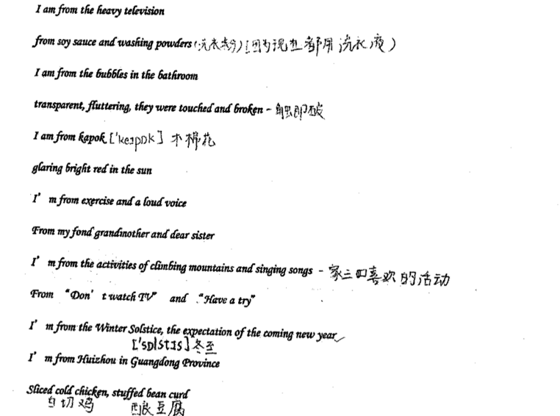 | 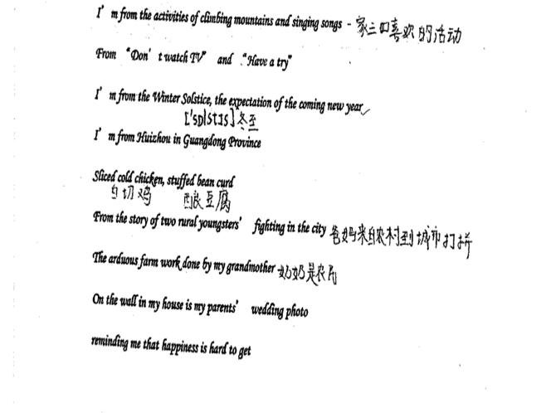
Spongy’s I am from poem.
Spongy, a 21-year old sophomore majoring in English literature, was from Meizhou, Guangdong. The geographic proximity of the small town to Dongguan, in the heart of the Pearl River Delta economic zone of south China, is transformed from a city of migrants into a city of ghosts, led to massive migration of young workers leaving Meizhou to join the workforce of “the world’s factory” due to its prosperous manufacturing industry, with some 75% of its 8.34m population migrant workers drawn from nearby towns in the Pearl River Delta economic zone of south China. From the mid-1980s, Dongguan was China’s leading export and manufacturing base, a hothouse for churning out cheap clothes, toys and shoes bearing the ubiquitous “Made in China” label. The city was hit hard when exports dried up in the wake of the global financial crisis in 2008, and suffered a slump. Today, with the help of economic input from various levels of government, it is transitioning into a smart manufacturing base focused on producing hi-tech robotics and automated equipment.
Spongy bore witness to such labor mobility, with most young people in her extended family having left their hometown to work a migrant workers in nearby economic hubs, such as Dong Guan, Shen Zhen, and Guang Zhou. Older members of the family, on theher hand, were left behind to not engage in traditional farming, but to care for the grandchildren left behind by migrant workers.
“就比如说我表哥表姐他们在外面闯荡，然后可能就得自己的就自己的小孩在托管在大伯家，就寄托在自己的爸爸妈妈那里，然后爸妈可能在老家生活，所以就平常就带小小孩。”
Spongy, who says “most of my cousins work in Dong Guan, starting off by performing manual labor on assembly lines, with the possibility to be promoted to a mid-level manager or a unit head, therefore enhancing the earning potential. Such work pays very well.毕竟他们可能刚开始可能只是生产一线，那可能当他们变成管理人员就或者说那个小组的组长，一个小头头对你的工资升迁的这种机会也有。而且本来给的给的工资也挺高”
Spongy’s own parents, who both received professional training in a local vocational school, earning degrees equivalent to a Graduate Equivalency Degree, with specializations in music education and art. To achieve geographic and social mobility, both parents left their agrarian hometown to work as high school teachers. Facing the poor economic outlook of the profession and expanding opportunities in the manufacturing industries, Spongy’s mother leveraged local connections to launch a new career in a local hospital, and her feather quit his job as an art teacher to start his own small business dealing with all profitable commodities. In comparison to the stable income her mother makes, her dad’s business experiences ebbs and flows with the rise and fall of the economy in regional and national contexts. The valuations of literacy and professional skills play out against the background of cultural scripts of gender identity deeply rooted in a regional, clan-based culture. According to Spongy, her hometown, Hui Zhou, has a large concentration of Hakka people, Han Chinese who had historically been migrants who moved to coastal areas from economically under-developed inland areas to seek better lives. 客家，literally translated as “guest families”,” and less literally as newcomers and settlers, are Han Chinese with ancestral homes in chiefly northern parts of China. Unlike other Chinese Han people, the Hakkas are not named after a geographical region because of historical mobilities.
Historical mobility manifested in Walled Village
The Hakkas are thought to have originated from the lands bordering the Yellow River (the modern northern Chinese provinces of Shanxi, Henan, and Hubei).[5] In a series of migrations, the Hakkas moved and settled in their present areas in Southern China, and from there, substantial numbers migrated overseas to various countries throughout the world. The Hakkas moved from northern China into southern China at a time when the Han Chinese people who already lived there had developed distinctive cultural identities and languages from their northern Han Chinese counterparts. (wikipedia). To fend off attacks from hostile locals and animals, such migrant families were often tightly bounded together both in material forms and symbolic forms. From the 17th century onwards, population pressures drove them more and more into conflict with their local neighbours. As rivalry for resources turned to armed warfare, leading to the building of communal living structures designed to be easily defensible. Hakka walled village, emerged as a unique architectural achievement, which a large multi-family communal living structure that was often round in shape and internally divided into many compartments for food storage, living quarters, ancestral temple, and armory.
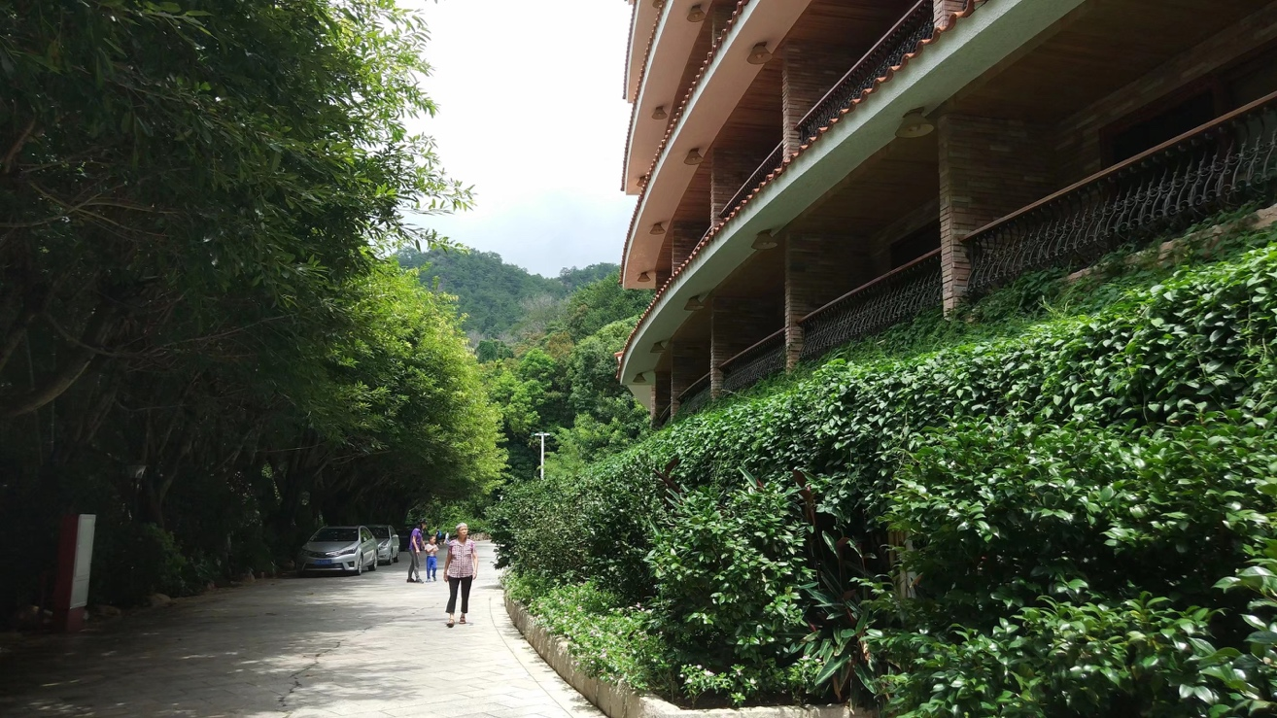
Photo of Walled Village from Spongy’s Mobility Journal
The need to bound together to fend off enemies also led to much emphasis on clan lineage in organizing social structures and preference for boys rather than girls at birth. In addition to social economic circumstances that favor men for their physical strength, the need to fend off enemines and gaining social status has played a big role in Hakka’s preference for boys. From a young age, Spongy has struggled with her identity as the only child, and a girl, in the household of her father, who is also the oldest son of his generation, who is, in theory, in charge of carrying on the family name through a male offspring. When she was born, her faternal grandmother refused to acknowledge her as the first-born of the family and pushed for her parents to have another baby. While the one-child policy in China at the time prohibited her parents from having another baby, implemented through penalty measures that might lead to the termination of her mother’s job at the hospital, has not appeased her grandmother, who then reluctantly accepted her but kept on preaching about how she was supposed to be a boy.
“I remember when I was young, grandma would often bath me, as she sat by the bath, murmuring ‘Why aren’t you a boy?’ over and over again. Even how, when I call her, she would preach to me ‘Your grandfather only had one son, your dad, and he only had you, a daughter, which was why we had always raised you as a son, giving you education and wanZBNting you to succeed. Now you have to remember to go home very year for the Ancestral Worship Ceremony so that you remember that you are a member of the clan. Go back to the old house, where everyone living there carries our family name.” 然后我奶奶现在给我打电话的时候她就说，她还会跟我强调，就是其实我觉得我因为我是从小在惠州长大，然后我其实很少，就是老家的生活其实很小很小一部分可能真的只占百分之几而已，对我来讲所以我受的影响更多的是在惠州这边的读书生活啊，所以我个人我其实对家族的血缘我没有说特别特别的就是看重，所以我这方面的意识也不太强，但是我奶奶就一直跟我强调，就是我爷爷只传了我爸爸一个儿子，然后把只传了我一个女儿，所以就把你当儿子养也把你当女儿一样，所以你以后一定要记得回老家看看，你记得每年都要去祭祖要记得你还有一个老家，就我们那个刚好叫x屋吧，对，刚好一系，就那一块都是姓x的都是
while Spongy grew up in a household of young professionals and in a town that was geographically and culturally distant from the old family house, these values travelled with her, constantly reminding her of her cultural root, her identity as a girl in the clan, and her obligation to achieve literacy and professional goals in honor of the family name.
Linguistic play during ancestral worship
This gender identity script is also embodied in an important cultural practice that is performed annually in celebration of the birth of male offspring.
“Hui Zhou (where spongy current lives) is two-and-half-hours drive from the old house, and the most important occasion for everyone to return is the annual Lantern Festival. In classical Chinese, a boy is a “丁（ding）” if you have a boy, you are adding a 丁 to your family. In Hakka, 赏灯（shang deng, translated as watching the lanterns）sounds like 双丁（shuang ding, translated as two sons). It is a lucky saying, meaning that this year you are adding two sons to your clan. The 13th day of Lunar New year, we have a Lantern Festival. If you have a boy, you get to hang a lantern in front of your house and another one at the Ancestral Temple to let everyone in the village know. Like in my own extended family with a shared family name, if there are five boys born, you get to hang one lantern with five decorative strings attached to it. In the past, you could add a side lantern，but now most people don’t even put up a lantern for a girl. This is the most important ritual of the year, even more important than the lunar new year. Celebrating the continuation of the family’s incense is so important that most of us who left for work or school need to make every effort to return.”
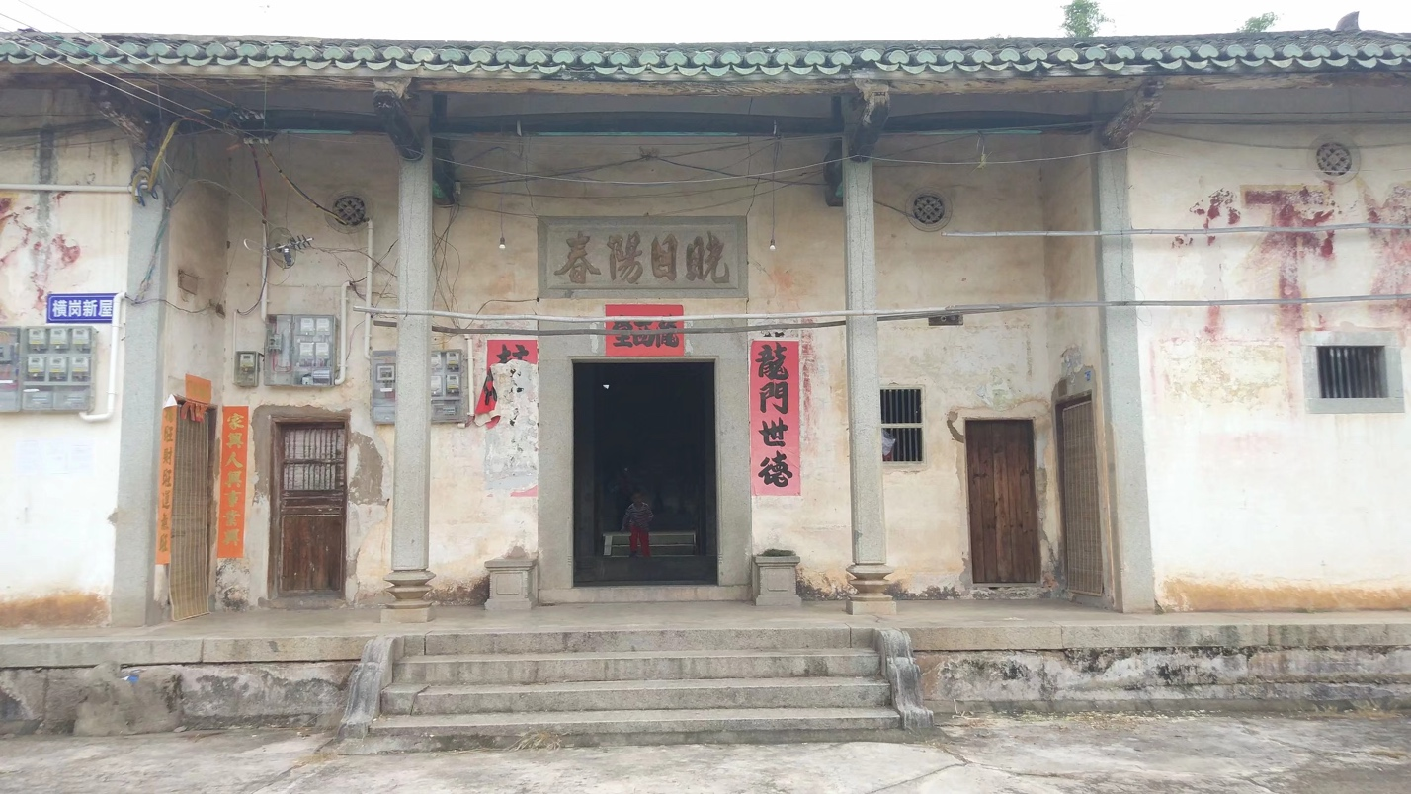
Photo of an Ancestral Temple from Spongy’s Mobile Journla
The notion of boys as continuation of a family’s bloodline is important. The metaphoric relationship between incense and the male offspring is important here. Incense is an important practice for Ancestor worshipping, which is performed not to ask for favors, but to fulfill filial duties. The act is a way to respect, honor and look after ancestors in their afterlives guaranteeing the ancestors’ well-being and positive disposition towards the living, as well as possibly seeking the ancestors’ wisdom, guidance or assistance for their living descendants. Traditionally, only males have the right to light and place incense in front of the ancestor shrine to honor one’s ancestors. The absence of a male offspring is emblematic of the discontinuation of the bloodline as no one will be able to light and offer incense.
Linguistic policing and regional identity
Another way to consolidate member’s clan identity is through linguistic policing. That is, clan identity is very much attached to a shared linguistic identity that is maintained through daily practice and monitoring. Spongy, who speaks Mandarin, Cantonese, and Hakka, often juggles the multiple languages when communicating across familial, romantic, and professional spaces. To this, Spongy has this to say,
“Although I don’t have any siblings, I have many cousins still living in the old house. In that space, speaking Hakka is a given. Even though I don’t live there anymore, the fact that grandma has been living with us meant that I had to speak Hakka, not Mandarin at home. So I switch codes all the time. At school, we all speak Mandarin, but as I switch immediately to Hakka when speaking with grandma or chatting with my cousins. Because I have been living on the “ouside” for too long, sometimes I forget. One time when I was visiting the old house, a few Mandarin words slipped out at family dinner and some of my Hakka words were pronounced with an accent, my cousins teased ‘You can’s speak Hakka anymore? Are you still a member of the clan?’ Yeah, you get dissed for not behaving like a member of the clan. Hakka is part of the bloodline.”
Entangled here is the simultaneous fluidity and fixity of gender identity scripts, which are mobilized across geographic, generational, and historical contexts to limit the possibilities for young women to achieve academic and professional mobility. The limiting effects of such a gender script has very real material and symbolic consequences.
“My dad is a typical Hakka male. He has quite some machismo and feels very strongly about his position as the owner and head of the family. Everyone needs to follow his lead despite economic disparities. It doesn’t matter if my mom makes more money than he does. And he puts a lot of emphasis on blood relatives over everyone else. If a close friend of his gets into a conflict with his blood relative, he will definitely side with his blood. Similarly, if my mother gets into an argument with my grandma, he will definitely side with grandma. also, relatives on my mother’s side are all considered as outside relatives while his own blook relatives are considered inside relatives. This is something I don’t like. 然后对自己家然后这方面的血缘的那种亲戚特别看重，因为就我家的人就这种区别对待有一些明显，就比如，毕竟妈妈那边可能对他来说可能就是个亲戚而已，说不好听点我得加一个“外”字，我当然不喜欢这样形容，因为我同学跟我闺蜜和我都是独生.”
Such identity scripts, performed in everyday lives, but are reinforced during religious practices of the clan. They have important implications on how her languages and literacies are valuated.
The Chinese New Year holiday marks the start of the biggest annual human migration on the planet. During the Spring Festival travel rush – or Chunyunin Mandarin – which runs from 1 February to 12 March 2018, it’s estimated that Chinese returning to their hometowns for family reunions will make 2.98 billion trips. According to China’s National Development and Reform Commission, in total, 2.48 billion road trips, 390 million rail trips, 65 million air trips and 46 million boat trips are expected to be made over the 40-day period. Nowhere is this large-scale migration likely to be more evident than in Dongguan, an industrial city in central Guangdong province.
Dongguan is sometimes called “the world’s factory” due to its prosperous manufacturing industry, and some who return home during the festive period, leaving the city nearly deserted. According to Qihoo 360 Technology, a big data and software giant, last year Dongguan was the country’s most empty city during the holiday. The company’s “ghost city index”, compiled by tracking the locations of its users during the Chinese New Year travel rush, saw Dongguan ranked first, as almost 70% of its population left town during the holiday.
Conclusion
Literacy mobility, manifested in one’s attempt to move meaning across languages, is entangled with other forms of mobility, such as the daily imaginary movements between Chinese and Japanese culture through digitally mediated fandom spaces. It also creates exigencies for physical mobility (e.g. travelling to various physical locations bearing the literacy footprints of celebrities) and professional mobility (her plan to study advertising in Japan). A view towards intersecting mobilities lends to an understanding of opportunities through which students develop a disposition of open inquiry into language and cultural differences (Canagarajah, 2006), while providing a glimpse into linguistic, cultural, and disciplinary border-crossing as an important dimension of students’ rhetorical repertoire, with specific attention to the innovative ways in which language users fashion fluid semiotic resources to specific ends (Lorimer Leonard, 2013).
From this account, we are observing how students’ languages and multilingual repertoires are constantly valued and revalued in accordance to national policies, institutional responses, and personal aspirations. While such an account seems to portray a top-down reverberation of economic incentives and political priorities in dictating how literacies and languages move, these accounts also point to the incredible ways in which individuals take up, resist, and reconfigure such values in their attempt to reconfigure their multilingual repertoire. While she recognizes the value of English in enabling further academic and professional pursuits, Yi has chosen to pursue her graduate studies in business in Japan because of the influence of an inspirational idol, who graduated with a degree in language and literature from Waseda University.
Although the portrait presented here seems to focus on the fluid manner in which life experiences, writing-related knowledge, and ideas for writing travel seamlessly across ever-loosening borders and boundaries (digital, linguistic, and national), we are constantly reminded of the fact that literacies and languages are differently valued, with relations of power rendering certain repertoires and literacies invisible and irrelevant (Leonard-Lorimer, 2017). For instance, YI’s literacies, creatively leveraged in the writing extracurricular, rarely traveled into the academic sphere, where grades are the basis for awards, scholarships, and internships. Even as she prepared her application for graduate schools in Japan, a TOEFL score was required. Her work as a student liaison was barely compensated in financial terms. Multilingual writers work with and against power-invested linguistic, cultural, and rhetorical differences embedded in social, political, and institutional structures. We argue that an understanding of the geographic, affective, and embodied crossings is not complete without attention to these moments of frictions—the difficult task of positioning personal aspirations within powerful hierarchical structures.

Works Cited
Bakhtin, Mikhail Mikhailovich. (1981). The dialogic imagination: Four essays by M.M. Bakhtin (Caryl Emerson & Michael Holquist, Trans.): University of Texas Press.
Barton, D., & Lee, C. (2011). Constructing glocal identities through multilingual writing practices on Flickr.com. International Journal of Multilingual Research Journal, 5, 39-59.
Black, R. W. (2005). Access and affiliation: The literacy and composition practices of English-language learners in an online fan fiction community. Journal of Adolescent and Adult Literacy, 49(2), 118-128.
Blommaert, J., Collins, J., & Slembrouch, S. (2005). Polycentricity and interactional regimes in "global neighborhoods". Ethnography, 6(2), 205-235.
Canagarajah, S. (2006). Toward a writing pedagogy of shuttling between languages: Learning from multilingual writers. College English (68)6, 589-604.
Donahue, C. (2009). Internationalization and composition studies: Re-orienting the discourse.” College Communication and Composition, 61(2), 212–43.
Dong, J., & Blommaert, J. (2016). Global informal learning environments and the making of Chinese middle class. Linguistics and Education, 34, 33-46.
Fang, K., & Repnikova, M. (2018).Demystifying “Little Pink”: The creation and evolution of a gendered label for nationalistic activists in China. New Media & Society (20)6, p. 2162-2185.
Fraiberg, S., Wang, X., & You, X. (2017). Inventing the world grant university: Chinese international students’ mobilities, literacies and identities. Logan: Utah State University Press.
Gere, A. R. (1994). Kitchen tables and rented rooms: The extracurriculum of composition. CCC, 45(1), 75-91.
Gonzales, L. (2018). Sites of translation: What multilinguals can teach us about digital writing and rhetoric. Ann Arbor: University of Michigan Press.
Horner, B., & Tetreault, L. (2016). Translation as (global) writing. Composition Studies, 44(1), 13-30.
Horner, B., Lu, M., Royster, J. J., & Trimbur, J. (2011). Opinions: Language difference in writing: Toward a translingual approach. College English, 73(3), 303-321.
Horner, B., NeCamp, S., & Donahue, C. (2011). Toward a multilingual composition scholarship, From English only to a translingual norm. CCC 63(2), 269-300.
Ismangil, M. (2019). Subversive nationalism through memes: A Dota 2 case study. Studies in Ethnicity and Nationalism, (19)2, p. 227-245.
Jiménez, R. T., David, S., Fagan, K., Risko, V. J., Pacheco, M., Pray, L., & Gonzales, M. (2015). Using translation to drive conceptual development for students becoming literate in English as an additional language. Research in the Teaching of English, 49, 248–272.
Kell, C. (2015). “Making people happen”: Materiality and movement in meaning-making trajectories. Social Semiotics, 25, 423–445.
Kiernan, J., Meier, J., & Wang, X. (2016). Negotiating languages and cultures: Enacting translingualism through a translation assignment. Composition Studies, 44(1), 89–107.
Lam, W. S. E. (2009). Multiliteracies on instant messaging in negotiating local, translocal, and transnational affiliations: A case of an adolescent immigrant. Reading Research Quarterly, 44(4), 377-397.
Lam, W. S. E., & Warriner, D. S. (2012). Transnationalism and literacy: Investigating the mobility of people, languages, texts, and practices in contexts of migration. Reading Research Quarterly, 47(2), 191-215.
Lemke, J. L. (2000). Across the scales of time: Artifacts, activities and meanings in ecosocial systems. Mind, Culture, and Activity, 7(4), 273-290.
Lorimer Leonard, R. (2013). Travelling literacies: Multilingual writing on the move. Research in the Teaching of English, 48, 13–39.
Lorimer Leonard, R. (2017). Writing on the move: Migrant women and the value of literacy. Pittsburgh, PA: University of Pittsburgh Press.
Pahl, K. (2004). Narratives, artifacts and cultural identities: An ethnographic study of communicative practices in homes. Linguistics and Education, 15, 339–358.
Pennycook, A. (2008). English as a language always in translation. European Journal of English Studies, 12(1), 33-47.
Prior, Paul., & Shipka, Jody. (2003). Chronotopic lamination: Tracing the contours of literate activity. In C. Bazerman & D. Russell (Eds.), Writing selves, writing societies: Research from activity perspectives (pp. 180-238). Fort Collins, CO.
Schiller, N. G. & Salazar, N. N. (2012). Regime of mobility across the globe. Journal of Ethnic and Migration Studies, 39, 183-200.
Stewart, M., Hansen-Thomas, H. (2016). Sanctioning a space for translanguaging in the secondary English classroom: A case of a transnational youth. Research in the Teaching of English,50(4), 450-472.
Stornaiuolo, Amy, & LeBlanc, Robert. Jean. (2016). Scaling as a literacy activity: Mobility and educational inequality in an age of global connectivity. Research in the Teaching of English, 50(3), 263-287.
Szablewicz, M. (2014). The ‘losers’ of China’s Internet: Meme as ‘Structures of feeling’ for disillusioned young netizens. China Information, (28)2, p. 259-275.
Stewart, M., Hansen-Thomas, Vieira, K. (2016). Writing remittances: Migration-driven learning in a Brazilian homeland. Research in the Teaching of English, 50(4), 422-449.
Wang, X. (2020). Becoming multilingual writers through translation. Research in the Teaching of English, 54(3), 206-230.
Wang, X. (2017). Developing Translingual disposition through a writing theory cartoon assignment. Journal of Basic Writing, 36(1), 56-86.
Vieira, K. (2019). Writing for love and money-How migration drives literacy learning in transnational families. Oxford University Press.
Yi, Y. (2009). Adolescent literacy and identity construction among 1.5 generation students from a transnational perspective. Journal of Asian Pacific Communication, 19(1), 100-129.

Institutional Context
The research was conducted in Hainan University (HNU), which is the only university with 211 and Double World-Class Discipline designations (indicators used in a national ranking system) in the island province of Hainan, China. Located at the southernmost point of China and facing the South China Sea, the island is an important node of “Maritime Silk Road” under the Belt and Road Initiative. The province is China’s largest special economic zone and is under development into a globally-influential, high-level Free Trade Port (FTP) by the middle of the century. As a key player in the national initiative, HNU is expected to lead research efforts and prepare young professionals in areas of tourism, agriculture, and technology. Currently enrolling 38,000 students from 34 provinces in China and an increasing population of international students, the university is under pressure to develop new forms of global collaboration, which manifests in its plan to attract students and talents internationally, collaborate with elite research centers, and develop joint international colleges.
Key Theorists

I draw on a body of work that has theorized multilingual practices and semiotic repertoires as tied to the physical, imaginary, and intellectual movements of bodies, languages, and ideas across geographical, linguistic, and virtual borders. I draw on the work of scholars such as Rebecca Leonard-Lorimer, Anna Tsing, Kate Vieira to explore how movements create opportunities for encountering and negotiating differences through unpredictable encounters on one hand, and constrain the movement of semiotic repertoires and literacy practices through the working of border-enforcing institutional structures.

Glossary

Hakka: An ethnic minoritized group in China that has historically moved from northern to the southern part of China and then overseas. Globally it has an estimated population of 60 million people. The name Hakka is derived from the Cantonese pronunciation of the word Kejia (guest people), which speaks to a set ofcultural and linguistic practices tied to the historical mobility of the people

Double World-Class Discipline Designation: A tertiary education development initiative launched by the Chinese government in 2015 to construct world-class universities and first-class disciplines (Double First-Class Initiative) to adapt to changes in the educational environment at home and abroad. It aims to develop elite Chinese universities and world-class disciplines by 2050. It represents a new way of ranking Chinese universities, with impact for funding distribution.

Literacy mobility: the movements of meaning and ideas from one language, person, mode, rhetorical tradition, and cultural context to another.

Mobility: physical, imaginary, and symbolic movement across linguistic, physical, political, economic, class, and virtual borders.

Scale: Semiotized space-time relationship, with historically formulated meanings and norms that can be mobilized. It can be used as a horizontal way of rendering spaces in hierarchical relationship to each other and in vertical way by differently valuing semiotic resources and tropes at different scales.

Semiotic Resources: An assemblage of resources or tools that people use when they communicate (such as speech, image, text, gesture, sign, gaze, facial expression, posture, objects and so on) that can be reconfigured in synergetic ways in fulfillment of communicative purposes.

