Using text history analysis to visually represent publication trajectories
This article describes the development of graphical manuscript trajectories to examine processes underlying academic knowledge production. Existing graphical representations tend to use idealized text trajectories (Burrough-Boenisch, 2003; Weller, 2001) rather than empirical data. To address this, text histories for three manuscripts were used to develop graphics representing their trajectories, with a focus on the brokers and processes acting on them. These include the number of times manuscripts were submitted to and evaluated by journals along with the other “brokers” (Lillis & Curry, 2006, p. 4) interacting with the authors and their texts. Empirical findings provide insights concerning languages of production and evaluation, time to publication, the volume of revision and evaluation work, as well as how manuscripts may be submitted to and evaluated by more than one journal. Methodological findings speak to the importance of examining full trajectories and not only sets of texts from discrete stages in manuscript trajectories, as examining text trajectories holistically facilitates connecting evaluations to uptake in published manuscripts. The graphic’s potential to explore other text production processes is discussed, particularly concerning its ability to reveal hidden textual production processes.
Key words: text history, text trajectory graphic, writing for publication, text brokering, knowledge production
- Introduction to visually representing Japan-based language teachers’ manuscript publication trajectories
This article describes graphical representations of manuscript trajectories as a research tool, arguing for their efficacy in facilitating examination of the processes underlying academic knowledge production. Existing graphical representations tend to use idealized text trajectories (Burrough-Boenisch, 2003; Weller, 2001) rather than incorporating empirical data from published manuscripts’ actual trajectories. To address this, the text histories of three manuscripts published by Japan-based English-language teachers across three different types of publication were used to develop graphics to represent their trajectories. These manuscripts were selected from a larger investigation into the publishing practices of Japan-based authors involving 23 authors and 29 manuscripts (Muller, 2018). The concept of text trajectories is based on Lillis and Curry’s “text histories” (2006, p. 8), which involves analyzing manuscript histories, including different versions and cycles of submission and revision, to examine how they change. The findings presented concern the insights text trajectory graphics offer to understanding the processes underlying textual production in writing for academic publication and are both empirical and methodological. Key empirical findings concern languages of production and evaluation, time to publication, the volume of revision work, as well as how manuscripts may be submitted to and evaluated by more than one journal. Key methodological findings speak to the importance of examining texts’ full trajectories rather than sets of texts from discrete stages in manuscript trajectories, such as sets of reviewer evaluations, as examining full text trajectories facilitates connecting evaluations to uptake. This is because understanding how manuscript texts are shaped by the processes of their production requires investigating manuscript trajectories rather than sets of texts (such as reviews). The potential of these graphics as a tool to explore other text production processes is also discussed.
- Literature review of investigations into academic publishing processes
Interest in investigating processes underlying writing for academic publication are well-established (Hyland, 2016; Lillis & Curry, 2010), as are methods of examining the characteristics of texts produced through such writing. These include genre analyses of manuscripts (Loi, 2010; Sheldon, 2011; Swales, 1990), reviewers’ evaluations of manuscripts (Kourilova, 1998; Fortanet, 2008), and authors’ and editors’ letters of correspondence (Flowerdew & Dudley-Evans, 2002; Swales, 1987). Such studies investigate the texts of published manuscripts and texts comprising “cycles of inquiry, submission, review, revision, editing and so forth” (Swales, 1993, p. 693).
Such research describes the characteristics of texts important to writing for academic publication. However, criticisms have been raised that concentrating on textual characteristics detracts from the importance of processes of textual production in writing for academic publication (Lillis & Curry, 2010, 2015). Specifically, how evaluations lead to changes in manuscripts and the co-constructed nature of such changes (the relationship between evaluation and revision) is difficult to interpret through analysis of sets of texts in isolation. This is in part because such analyses tend to de-couple evaluations, such as reviews, from the manuscripts evaluated to analyze textual features, such as Kourilova’s (1998) description of the characteristics of reviews. Yet evaluative texts such as reviews are presumably written with the intention of effecting specific changes to specific manuscripts. Research into how such texts instigate changes requires analyzing not only their genre characteristics but also how manuscripts change in response to reviews, or “uptake” (Lillis & Curry, 2015, p. 132). Such investigations into processes of academic production (as opposed to sets of types of texts) highlight the influences academic brokers have on textual revisions (Lillis and Curry, 2010), including:
- refocusing articles around “the most attractive point” (Lillis and Curry, 2010, p. 102),
- reformulating conclusions “from contrast to confirmation” (p. 105),
- handling “conflicting reviews” (p. 107), and
- authors “resisting the call to simplify” (p. 110) the language of manuscripts.
While Lillis and Curry (2010, 2015) identify important ways in which authors’ texts are shaped in their publication trajectories, where in their larger trajectories changes are instigated and the overall trajectories of the texts they examine remain unelucidated.
One way to examine the overall trajectories of texts is through graphic representations, which have previously been given some attention (Burrough-Boenisch, 2003; Weller, 2001). Writing from the perspective of a journal editor, Weller (2001)’s representation, reproduced in Figure 1, examines the processes manuscripts may go through at a journal, along with some of the possible decisions that may be made. Weller emphasizes the decision processes of journals evaluating submissions, foregrounding broker options and what their implications are to manuscript trajectories. The brokers or evaluators involved are not the focus of attention, and the brokers that authors may enlist outside of formal journal review and evaluation are not represented.
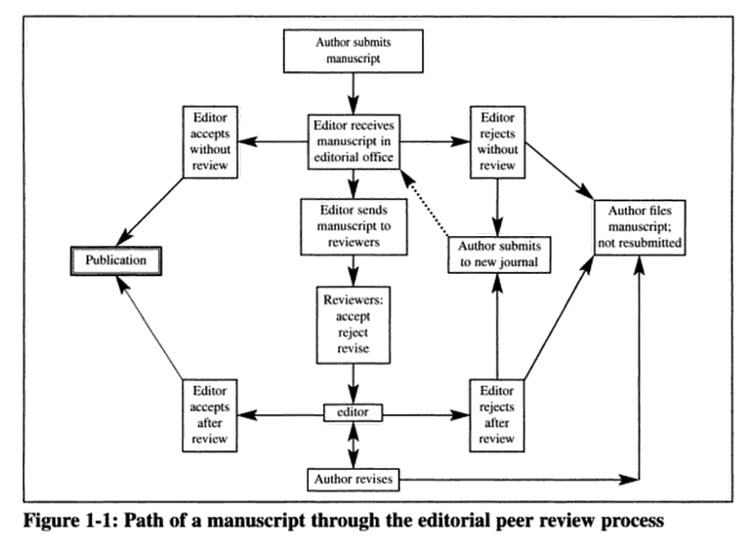
Figure 1. Weller’s (2001) “Path of a manuscript through the editorial review process” (p. 2)
Burrough-Boenisch (2003), writing about the role “professional editors” play in revising manuscripts pre-review, uses a graphic to represent the different “shapers” of a hypothetical “NNS-authored” (p. 223) manuscript (Figure 2). In this graphic, the brokers in the trajectory are foregrounded while how they shape and evaluate the manuscript is backgrounded.
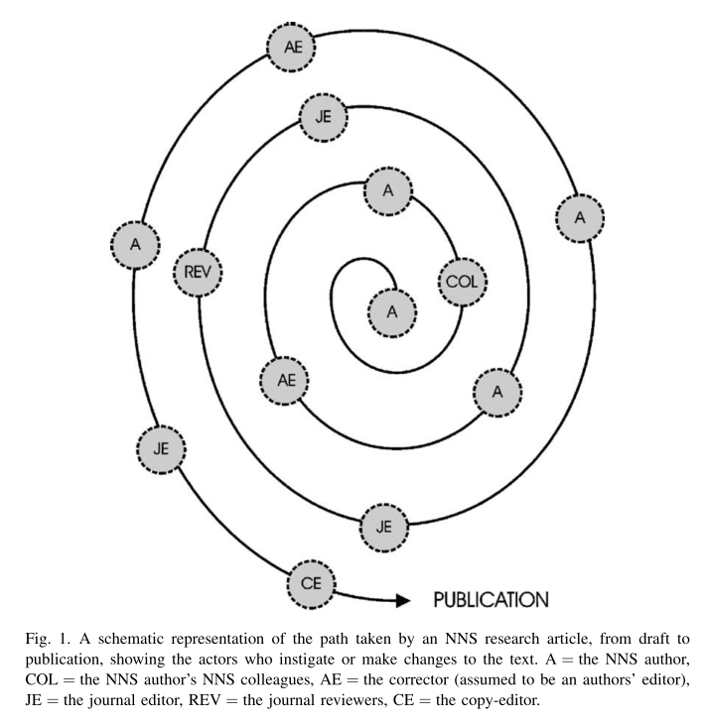
Figure 2. Burrough-Boenisch’s (2003) “Representation of the path taken by an NNS research article” (p. 226)
Finally, Lillis and Curry (2006), the only example used based on analysis of empirical data, represent the brokers involved in text production along with their orientations toward manuscript revisions (Figure 3). They examine different broker types and the kinds of changes they make to manuscripts. In their representation different brokers and the manuscript changes they initiate are foregrounded while where these changes occur in manuscript trajectories is not the focus of attention.
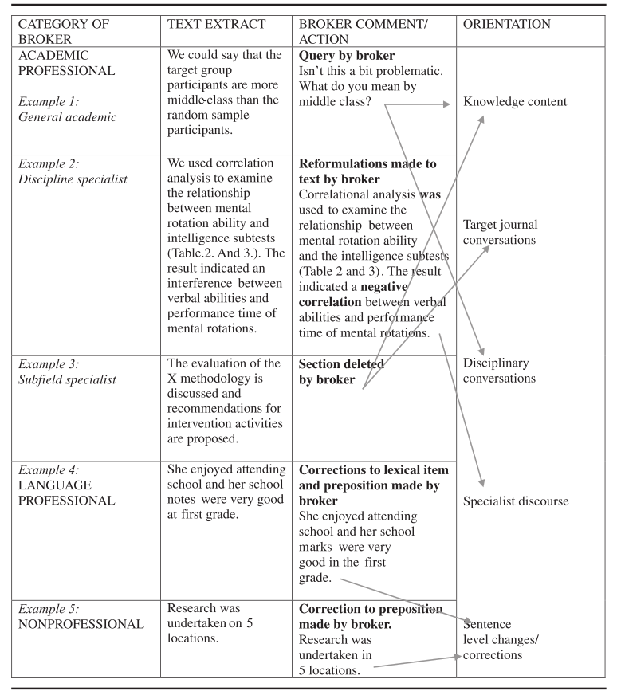
Figure 3. Lillis and Curry’s (2006) “Representation of brokers involved in academic text production” (p. 15)
While the graphics presented in Figures 1-3 do illustrate some aspects of manuscript trajectories, they capture only narrow aspects of these trajectories and make potentially problematic assumptions. For example, Weller (2001) notes three possible reviewer evaluation options; “accept”, “reject”, and “revise” (Figure 1, center). However, it is not clear whether these evaluations are clearly and unambiguously communicated to authors in actual manuscript trajectories. Burrough-Boenisch (2003) appears to assume that the title a given broker has, such as “author’s editor,” “reviewer,” and “copy-editor” (Figure 2) explains how they interact with the author and shape a manuscript and its trajectory. However, different “journal editors” (Figure 2) may interact with authors and their texts in different ways. Therefore, the title an individual broker holds should not necessarily be used to make assumptions about how they shape a given manuscript and its trajectory. Lillis and Curry’s (2006) representation is the most comprehensive of the three examples and the only one based on analysis of empirical data. They include the “category of broker”, a “text extract” from the manuscript, some “broker comment/action”, and the “orientation” taken in the changes made (Figure 3). Nevertheless, an overall picture of where in the manuscript’s history the evaluations and changes are made is not represented, leaving an overall image of the manuscripts’ trajectories unclear. This is where this research makes its contribution by developing a more comprehensive representation of manuscript trajectories, including the brokers involved, changes made, evaluations received, and publication timelines.
- Methods
The three manuscripts’ text history graphics discussed here were developed as part of a larger investigation into the publishing practices of Japan-based authors in the field of English language teaching that involved 23 authors and 29 manuscripts (Muller, 2018). The larger investigation explored the authors’ academic writing and writing for academic publication literacy histories, including why they wrote and how their writing was received and evaluated professionally and institutionally. It also examined specific manuscript trajectories identified as important to the authors to develop text histories based on different versions of the manuscripts and the correspondence associated with them. Perhaps unsurprisingly, and consistent with challenges that typically face qualitative researchers (Silverman, 2011), rather quickly the difficulty of organizing, analyzing, and explaining this complex data became evident. For each manuscript history analyzed here there were between 4 and 7 distinct versions, 1 and 5 sets of broker feedback, 2 and 14 additional documents, such as journal author submission guidelines, 1 and 2 interviews with the authors, and 2 and 6 follow-up emails with authors discussing key sets of analysis and findings. The complexity of the data complicated understanding the manuscripts’ trajectories and how they changed. As I organized these different sources of information, it became apparent that a graphical representation of the manuscript trajectories would assist my analysis. Such a graphic would serve three purposes. First, it would facilitate explaining the complexity of the texts’ trajectories, mapping what work was done when and by who. Second, it would inform analysis, facilitating “dialectical tacking between the most local of local detail and the most global of global structure in such a way as to bring both into view simultaneously” (Geertz, 1974, p. 43), an objective of this kind of ethnographically informed investigation (Rampton, et al., 2004). Finally, it would serve as a frame for further analysis and discussion, as it would facilitate contextualizing manuscript version and correspondence data within a given text’s trajectory. The graphic ultimately developed draws on empirical data to represent the manuscripts’ trajectories while at the same time offering a global view of the overall path of each manuscript.
  - The manuscripts and their authors
The manuscripts developed into graphical text trajectories focused on here include three journal manuscripts, representing an indexed journal published outside Japan, a non-indexed journal published outside Japan, and a non-indexed journal published in Japan. The indexed journal published outside Japan manuscript is the only one from the larger study successfully submitted to and published in an outside-Japan indexed journal. There are two authors, Jason (all author names are pseudonyms) and Alan, both from North America and long-term residents of Japan (more than 20 years). This was the first outside-Japan indexed journal publication for both authors. The non-indexed journal published outside Japan manuscript was written by David, a North American who has lived in Japan since 2002. This paper is his first publication outside Japan and his first reviewed paper publication. The non-indexed journal paper published in Japan was written by Junpei, a Japanese PhD student. This paper began as Junpei’s English medium undergraduate graduation thesis, which he developed into a joint Japan conference presentation with his undergraduate thesis supervisor, who was a named coauthor of version 1 of the manuscript (Figure 6). The paper was ultimately published with Junpei as sole author.
  - Creating the text trajectory graphic tool
Chronology was used to organize the information presented (an element not included in Figures 1-3), as it facilitated mapping data across a given text’s trajectory. Different manuscript versions were added to represent the different parts of the trajectories. Next, the different brokers, processes, and evaluations from the manuscript trajectories were included. Finally, the different versions of the manuscripts were compared to give an approximate picture of how much the manuscripts changed during their trajectories. Thus, the text history analysis graphic developed tracks the trajectories of the texts analyzed, focusing on the process, the brokers, their evaluations, and the number of changes made across versions.
As this investigation examines manuscript versions and correspondence provided by the authors for analysis, the actual text trajectories are likely much more complicated than what is depicted here. As Lillis and Curry (2006) point out, “scholars vary enormously in their practices of keeping drafts and correspondence about specific texts” and “in the extent to which they report the involvement of others in their text production,” conceding “no text history is ever fully complete, in that frequently, drafts are discarded and written exchanges destroyed” (p. 8). Nevertheless, the text history graphic as an analytical tool offers a rich visual representation of complex trajectories that can help illuminate the processes manuscripts go through.
- Results: The Text History Graphics
All the text history graphics have the same overall structure (Figures 4-6). At the top is the timeline of the text history, with each date representing submission of a manuscript to a broker or return of an evaluation. The second arrow from the top tracks the changes from the earliest available version of the manuscript to the final available version, summarizing total changes made. The text immediately under this arrow tracks changes from version to version. Changes were calculated using Microsoft Word’s compare function, which performs an automated analysis comparing two different files, presenting the number of insertions, deletions, and moves (text moved from one location to another).
The solid rectangular boxes in the middle of the graphics summarize key manuscript versions, usually submitted to brokers or publications, including information about manuscript length (in words) and where the manuscript was submitted to or received from. The offset rectangular boxes summarize the evaluations returned. There is some information about the extent of the comments made such as by quantifying evaluation length (in words or characters) or the number of changes or comments made with quotations from the data where possible. The arrows at the bottom of the graphics track relevant changes in the lives of the authors, such as in work or study circumstances. These partially illustrate authors are not exclusively working on their writing for academic publication during the periods represented but are rather engaged in other pursuits in addition to writing for academic publication.
  - Outside-Japan Indexed Journal: Jason and Alan’s Text History Graphic
Jason and Alan began their research collaboration as full-time colleagues at the same university. After completing limited term contracts they moved to different universities in the spring of 2013 (bottom arrow in Figure 4), although they continued to collaborate, including on the manuscript analyzed here. The journal was suggested by Alan for its reputation for accepting practice-based language teaching research, as Alan was interested in publishing “a journal publication and international – outside Japan” (Alan Interview 1). Their investigation was planned and conducted with this journal in mind, beginning in spring 2011. They gave a presentation at a Japan-based conference in November that same year (the entry for 2011.11 in Figure 4). Jason explained this research presentation was integral to the completion of the project, as it provided an impetus to organize and analyze their data. Jason encountered a friend through his master’s studies at the conference who was on the Editorial Board of the journal and who offered to read the manuscript prior to submission. After their presentation, Jason and Alan spent more than a year preparing Version 1 of the manuscript, which they sent to Jason’s editorial board member friend for comment in the spring of 2013. This contact read and commented on Versions 1 and 2 of the manuscript (Figure 4) before submission of Version 3 to the target journal in October 2013 (Figure 4) which completed the pre-submission part of the manuscript’s trajectory.

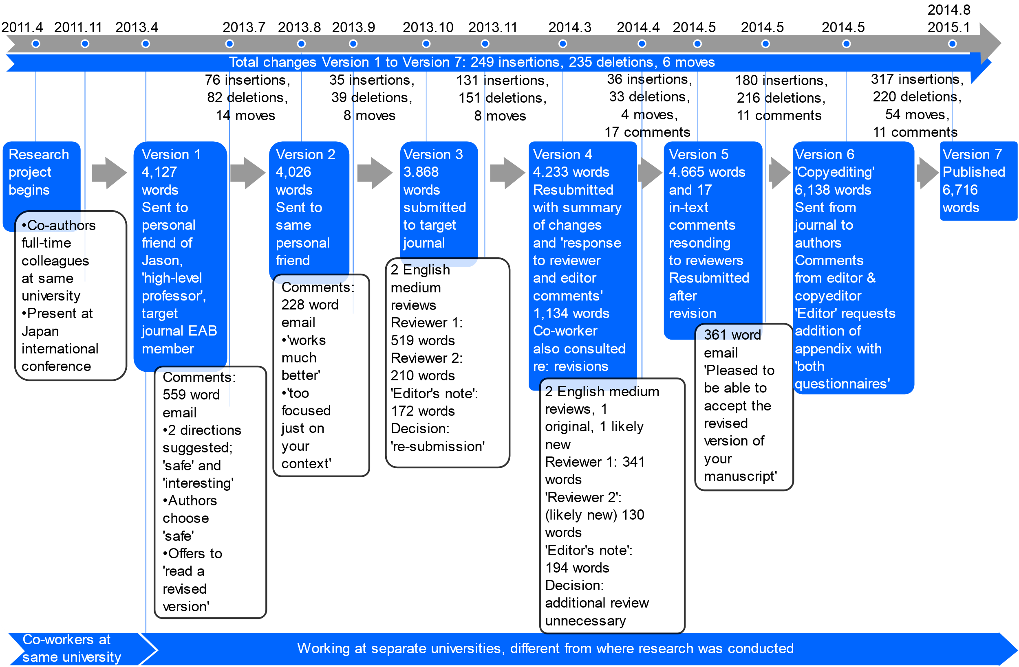
Figure 4. Publication Trajectory of Jason and Alan’s Outside-Japan Indexed Journal Manuscript

Version 3 was submitted to the target journal with the editor responding, including reviewers’ comments and an ‘Editor’s note’ (Figure 4) with additional explanation of the revisions required. Between Versions 3 and 4, as the authors worked to address the issues raised, Jason and Alan consulted a colleague with experience of academic publishing about how to revise their manuscript. This colleague’s advice to expand their data analysis led to Version 4 of the manuscript, sent as a resubmission, which received a decision that additional review would not be necessary (Version 4 in Figure 4).
Next Jason and Alan used the evaluations of Version 4 to revise their manuscript, submitting Version 5 May 2014 (Figure 4), initiating “copyediting” (Figure 4) and contacts concerning additional changes (Version 6, Figure 4). The manuscript’s appendix was expanded at the Editor’s request, resulting in the large increase in word count between Versions 5 and 6 (Figure 4). Between Version 6 and 7 there were several formatting changes applied by the journal copyeditor, accounting for the changes tracked in Figure 4, as the text of the manuscript was not changed significantly, but there was a considerable amount of formulaic text added when the Microsoft Word manuscript document was converted into the journal’s published PDF format, including a running header, journal issue and volume numbers, DOI information, and page numbers.
  - Outside-Japan Journal: David’s Text History Graphic
This publication opportunity came to David after giving a presentation for an outside-Japan conference, when the language teacher association that organizes the conference sent an email inviting him to contribute a paper based on his presentation to its journal, with a deadline of less than a week to submit for consideration for its earliest issue. David prepared and submitted the manuscript by the deadline (Version 1 in Figure 5). Receipt was acknowledged by Editor 2 then a consolidated review document, contributed to by an unspecified number of reviewers, was returned with instructions for David to “make some editorial changes and resubmit” (dated 2013-6 in Figure 5). David revised his manuscript and resubmitted Version 2. David was then contacted by Editor 3, who interacted with David for the remainder of the paper’s trajectory. This message from Editor 3 is the first indication in the correspondence that the manuscript is likely to be published, with the Editor writing, “There are no major changes to content to be made at this stage” (dated 2013-7 in Figure 5), implying the manuscript has (at least tentatively) been accepted for publication. Until this point in the journal’s evaluation process it was unclear from the correspondence whether the manuscript was going to be accepted, particularly as prior correspondence from the journal included explicit mention of the possibility of rejection. David made additional revisions in Versions 3, 4, and 5. From Version 6 Editor 3 mentions a “copy editing process” (Figure 5) with changes made by the journal staff that conclude with Version 7 (Figure 5). The journal staff also appear to have made changes between the version David saw for final approval, Version 7, and the final published version of the manuscript, Version 8 (Figure 5). Unfortunately, not all the versions of the manuscript were available for analysis, so the versions used for this analysis include the first submitted version (Version 1 in Figure 5), the last three prepublication versions (Versions 5, 6, & 7 in Figure 5) and the final published version (Version 8 in Figure 5), along with 19 emails between David and the three Editors and the reviews of Version 1 (Figure 5).

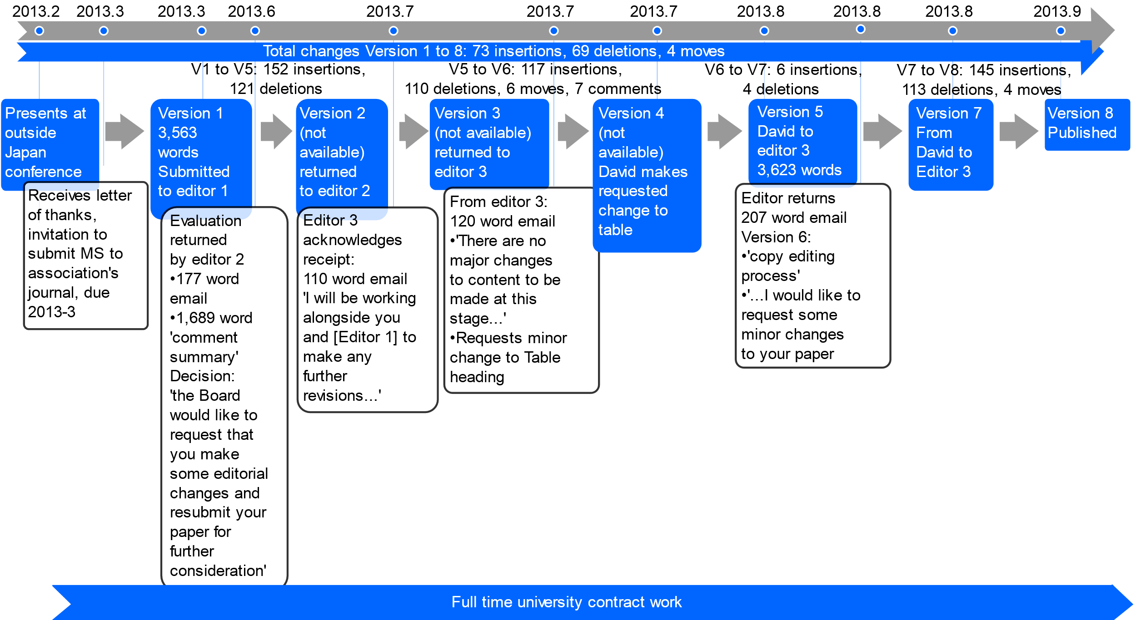
Figure 5. Publication Trajectory of David’s Outside-Japan Journal Manuscript

  - Japan Journal: Junpei’s Text History Analysis
For this manuscript Junpei developed data from his English medium undergraduate graduation thesis at a private Japan-based university into a joint Japan-based conference presentation with his undergraduate thesis supervisor. Junpei initially included his supervisor as a named coauthor in Version 1 (Figure 6). The publication trajectory analyzed here spans about two years, from initial submission of Version 1 to the first journal to acceptance of Version 5 for publication at the third journal (Figure 6). Version 1 was initially submitted during Junpei’s first year as a master’s student in language education at a Japanese national university (different from his private undergraduate university) and was accepted for publication during his first year of PhD study at the same university (the bottommost arrow in Figure 6).
Version 1 was reviewed by three Reviewers at the first (English language medium) Japan journal and rejected (Figure 6). His undergraduate supervisor encouraged Junpei to submit the manuscript to a “more prestigious journal,” but after reading a revised version of the manuscript (not available for analysis and therefore not tracked in Figure 6) his supervisor decided it was “not the quality for [an] international journal” (Junpei Interview 2). This led Junpei to submit Version 2 as a single author to an outside Japan indexed journal (Figure 6). Figure 6 tracks Junpei’s undergraduate thesis supervisor as a coauthor through Version 1 of the manuscript followed by Junpei as the sole author after Version 1 in the third arrow from the bottom. Junpei revised Version 1 into Version 2 largely independently, although he mentioned consulting an Australian colleague for language checks, which were not available for analysis. Version 2 was reviewed by one Reviewer, with Junpei receiving a decision letter stating, “we cannot proceed any further with your submission” (dated 2012-9 in Figure 6). Following this, Junpei revised the manuscript into Version 3, submitted to a third, mixed language medium (English and Japanese) journal where faculty on his master’s and PhD courses were editors and reviewers (Figure 6). This third journal returned a decision of “re-examine” (再審査する) along with three reviews, two Japanese and one English (dated 2013-6 in Figure 6). Junpei revised the manuscript and submitted Version 4 for another evaluation, which included comments from one reviewer (dated 2011-9 in Figure 6), returning a decision accepting the manuscript as a “Research Note” (採択（リサーチ・ノートとして）) (MS3Doc4). Following this, Junpei further revised his manuscript into Version 5, which was accepted as a Research Note for publication (dated 2013 in Figure 6).

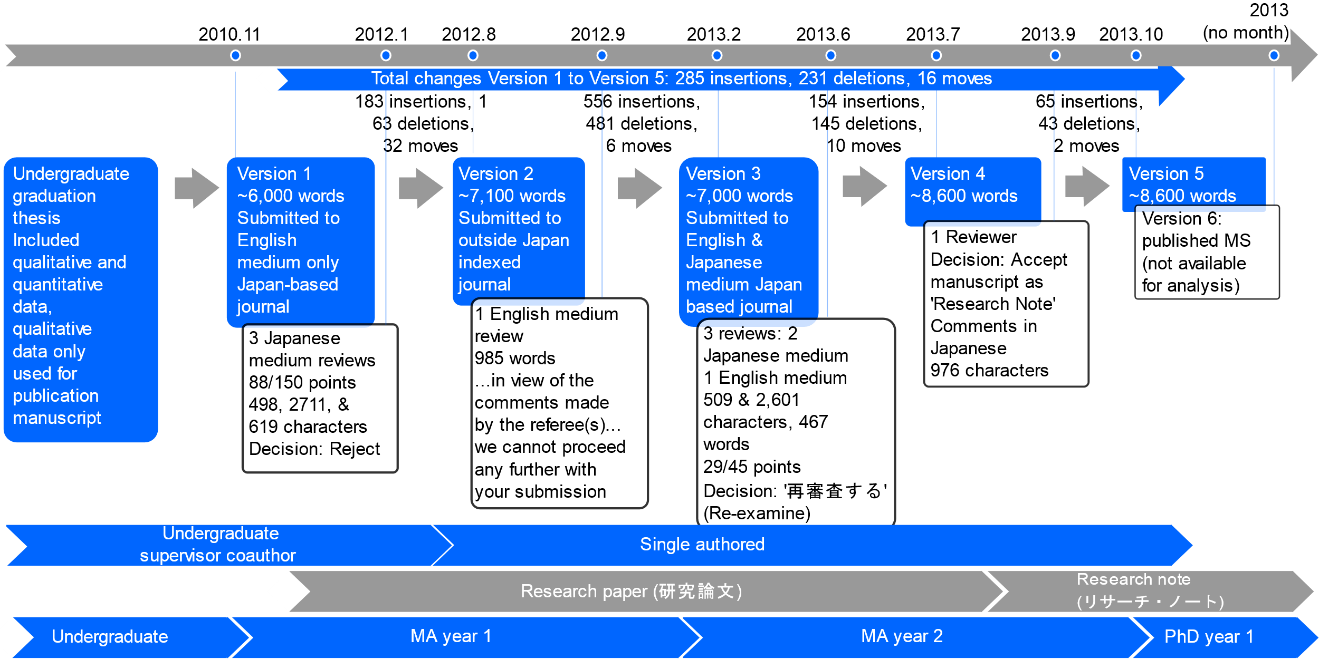
Figure 6. Publication Trajectory of Junpei’s Japan Journal Manuscript

- Findings
  - Empirical Findings
The empirical findings highlighted here include insights about languages of production and evaluation, time to publication, the volume of revision and evaluation work, as well as how manuscripts may be submitted to and evaluated by more than one journal. Concerning languages of production and evaluation, while all the manuscripts were published in English, the language of evaluation the two Japan journals used in Junpei’s case included Japanese language medium reviews (Figure 6), signaling the importance of translanguaging (Canagarajah, 2018) in that trajectory. This suggests that the language medium of publication may not correspond to the language medium of correspondence and evaluation in at least some cases, a phenomenon likely of interest to translanguaging researchers. Concerning time to publication, the trajectories examined range from about six months in the case of David’s outside Japan journal manuscript (Figure 5) to more than three years in the case of Jason and Alan’s outside Japan indexed manuscript (Figure 4). One related issue that authors identified as problematic is institutions’ tendency to evaluate publication “outputs” (Daizen, 2015, p. 151) annually despite publishing potentially taking years, as evidenced in two of the text histories analyzed here (Figures 4 & 6).
Concerning the volume of revision and evaluation work, counting the number of versions of manuscripts across the trajectories, the fewest was five in the case of Junpei’s Japan journal manuscript (Figure 6). However, this is partly because some versions of interim manuscripts that Junpei spoke of were not available for analysis. The largest number of manuscript versions was nine in the case of Jason and Alan’s outside Japan indexed journal manuscript (Figure 4). While one topic of considerable discussion in the literature is how authors respond to reviewer evaluations through revising their manuscripts (Gosden, 2001, 2003; Li, 2006), examining the texts’ trajectories analyzed here, they are changed extensively throughout their trajectories. This includes following review, but also following decisions to accept manuscripts for publication. For example, Jason and Alan’s manuscript, following a decision “to accept” (Figure 4), gains nearly 1,500 words in length between Versions 5 and 6 (more than 30 percent of Version 5’s word count) following receipt of the decision notification. Junpei and David’s manuscripts also show changes being made following decisions to publish (Figures 5 & 6). Thus, Weller’s representation of a single arrow going from “Editor accepts after review” to “Publication” (Figure 1) appears to be masking a considerable amount of revision work when empirical text history data is analyzed.
Regarding this revision work, in contrast to Weller’s (2001) unambiguous representation of journal decision options, in many cases whether a manuscript was accepted or subject to another round of review was not always obvious. For example, David was asked to “resubmit” (Figure 5) his manuscript after the first round of review, but the resubmitted version was further reworked between David and Editor 3; there does not appear to have been a second round of review. The volume of additions made to Jason and Alan’s manuscript following the decision “to accept”; 180 insertions, 216 deletions, and 11 comments (between Versions 5 and 6 in Figure 4) also speaks to how Weller’s representation may be problematic. Similarly, Burrough-Boenisch (2003) shows a manuscript going from “journal editor” to “copy-editor” to “publication” without further involvement from the author (Figure 2). However, this was not the case in the two manuscripts involving a copyeditor examined here; in both Jason and Alan’s and David’s cases, copyediting involved the authors being asked to respond to change requests. Finally, as in Belcher’s (2007) investigation, one way that researchers have organized manuscripts for analysis is through examining versions journals have on hand that were submitted by authors. However, Junpei’s manuscript history (Figure 5) shows how manuscripts can move between journals, suggesting that the versions available to a single journal may not represent a complete trajectory for a given text. This has been noted by researchers examining the social construction of science (Myers, 1985), but is a potentially important limitation for researchers who only have access to journal submission archives to keep in mind when describing findings.
There are other findings of potential interest that can be gleaned from the graphics presented here, such as the brokers who interact with and shape the authors’ texts (Muller, 2018). There are even further findings that can be examined through a closer analysis of correspondence surrounding the manuscripts, such as how the ambiguity of journal publication decisions may serve to elicit further manuscript work from authors in the hopes of publishing their papers (Muller, 2018). Nevertheless, the insights highlighted here illustrate the facility of these text history graphics as a tool for analyzing texts’ histories.
  - Methodological Findings
The kind of examination presented here, a text history analysis focusing on individual manuscripts’ trajectories, expands and elaborates in important ways on genre-focused examinations of sets of types of texts. For example, examinations of review comments on manuscripts tend to use sets of reviews gathered independently from the manuscripts they evaluate (Kourilova, 1998). However, the manuscript trajectories examined here show that while review is an important part of the manuscripts’ trajectories, it is not the only place where manuscript texts are evaluated and revised. This helps to demonstrate the importance of considering processes of textual production when examining writing for academic publication. While not a new finding, as Lillis and Curry (2010, 2015) make a similar argument, it is important to point out how the current study further evidences this.
Next, I turn to the methodological contribution represented by the text trajectory graphic as an analytical tool. While there have been efforts to graphically represent manuscript trajectories, these have tended to employ hypothetical trajectories (Burrough-Boenisch, 2003; Weller, 2001) or to examine specific aspects of textual brokering or manuscript changes (Lillis & Curry, 2006). Expanding on these earlier representations, the text trajectory graphic presented here involved considerable effort to develop a suitably nuanced representation of the complexity of the text histories analyzed. The text history graphic developed offers an improvement on earlier representations of text trajectories as it captures several important elements of manuscripts’ publication trajectories. It represents:
- A time-oriented perspective, tracking when versions were submitted and feedback received,
- Information about the various versions submitted to and returned from brokers,
- Information about the quantity of changes between versions and between first available and final published versions,
- Information about how many and what kinds of brokers interacted with the authors and their manuscripts, and
- Information about the evaluations authors received, including how many reviews, how many reviewers, length of reviews, and other brokers the authors interacted with.
The graphic developed concisely shows a variety of different elements of a text’s trajectory that have not previously been made explicit. It also serves as a ready frame on which to build further analysis, such as how manuscripts change and the exchange structures of the correspondence (Muller, 2018).
While this graphical representation of text trajectories has demonstrated its utility for the text histories examined here, it also has considerable potential as a methodological tool to facilitate further future research. This potential includes comparing text trajectories within and between fields and publication types. The three text trajectories analyzed here show the graphic was successfully applied to journal manuscript trajectories in the field of English language teaching. Comparing text trajectories in fields outside English language teaching, within multiple texts of the same publication type, and across multiple texts for a single author are some potential further applications of the tool. More broadly, examining manuscript trajectories outside of writing for academic publication, such as university assignment work, is another potential application of the graphic (Muller & Tsuruoka, 2020).
- Conclusion
This paper explained the development and application of a text history graphic tool to analysis of three manuscript trajectories written by Japan-based authors in the field of language teaching published in an outside Japan indexed journal, an outside Japan journal, and a Japan journal. It contributes to investigations of processes of writing for academic publication literature, such as that pursued by Lillis and Curry (2010, 2015) by further demonstrating the importance of examining textual production processes as opposed to sets of types of texts. It also methodologically expands such investigations by presenting a tool for graphically representing manuscripts’ overall trajectories. Doing so allows for further insights into the processes manuscripts go through in their trajectories, including timelines for publication, the volume of evaluation and revision work manuscripts are subjected to, and the journals manuscripts are submitted to. While the research presented here applies the graphic as a tool to three specific text histories, there is considerable potential for the application of the text history graphic to broader sets of data. Applying the text history graphic more broadly would help to further illuminate the complexity of texts’ histories, the revisions texts undergo, and the brokers involved in instigating those revisions (Muller, 2018).

References
Author. (Year). [2 citations removed for anonymity of peer review]
Belcher, D. (2007). Seeking acceptance in an English-only research world. Journal of Second Language Writing, 16(1), 1–22. http://doi.org/10.1016/j.jslw.2006.12.001
Burrough-Boenisch, J. (2003). Shapers of published NNS research articles. Journal of Second Language Writing, 12(3), 223–243. http://doi.org/10.1016/S1060- 3743(03)00037-7
Canagarajah, A. S. (1996). “Nondiscursive” Requirements in Academic Publishing, Material Resources of Periphery Scholars, and the Politics of Knowledge Production. Written Communication, 13(4), 435–472. http://doi.org/10.1177/0741088396013004001
Canagarajah, S. (2018). Translingual Practice as Spatial Repertoires: Expanding the Paradigm beyond Structuralist Orientations. Applied Linguistics, 39(1), 31–54. https://doi.org/10.1093/applin/amx041
Daizen, T. (2015). Research productivity. In A. Arimoto, W. K. Cummings, F. Huang, & J. C. Shin (Eds.), The Changing Academic Profession in Japan (pp. 149-168). New York: Springer.
Englander, K. (2009). Transformation of the identities of nonnative English-speaking scientists as a consequence of the social construction of revision. Journal of Language, Identity & Education, 8(1), 35–53. http://doi.org/10.1080/15348450802619979
Flowerdew, J., & Dudley-Evans, T. (2002). Genre Analysis of Editorial Letters to International Journal Contributors. Applied Linguistics, 23(4), 463–489. http://doi.org/10.1093/applin/23.4.463
Fortanet, I. (2008). Evaluative language in peer review referee reports. Journal of English for Academic Purposes, 7, 27-37.
Geertz, C. (1974). “From the Native’s Point of View”: On the Nature of Anthropological Understanding. Bulletin of the American Academy of Arts and Sciences, 28(1), 26–45.
Gosden, H. (2001). “Thank you for your critical comments and helpful suggestions”: compliance and conflict in authors’ replies to referees’ comments in peer reviews of scientific research papers. Ibérica, 3, 3–17.
Gosden, H. (2003). ‘Why not give us the full story?’: functions of referees’ comments in peer reviews of scientific research papers. Journal of English for Academic Purposes, 2, 87-101.
Hyland, K. (2016). Academic publishing and the myth of linguistic injustice. Journal of Second Language Writing, 31, 58–69. http://doi.org/10.1016/j.jslw.2016.01.005
Kourilova, M. (1998). Communicative characteristics of reviews of scientific papers written by non-native users of English. Endocrine Regulations, 32(2), 107–114.
Li, Y. (2006). A doctoral student of physics writing for publication: A sociopolitically- oriented case study. English for Specific Purposes, 25(4), 456–478. http://doi.org/10.1016/j.esp.2005.12.002
Lillis, T. M., & Curry, M. J. (2006). Professional academic writing by multilingual scholars: Interactions with literacy brokers in the production of English-medium texts. Written Communication, 23(3), 3–35. http://doi.org/10.1177/0741088305283754
Lillis, T. M., & Curry, M. J. (2010). Academic writing in a global context. London: Routledge.
Lillis, T., & Curry, M. J. (2015). The politics of English, language and uptake: The case of international academic journal article reviews. AILA Review, 28(2), 127–150. http://doi.org/10.1075/aila.28.06lil
Loi, C. K. (2010). Research article introductions in Chinese and English: A comparative genre-based study. Journal of English for Academic Purposes, 9(4), 267–279. http://doi.org/10.1016/j.jeap.2010.09.004
Muller, T. (2018). An Exploration of the Experiences of Japan-Based English Language Teachers Writing for Academic Publication [Unpublished PhD Thesis]. The Open University. Retrieved from http://oro.open.ac.uk/57835/
Muller, T. & Tsuruoka, T. (2020). A student and teacher supervising a student and teacher: Examining the trajectory of a TESOL master’s dissertation, The Learner Development Journal, 4, 62-75.
Myers, G. (1985). Texts as Knowledge Claims: The Social Construction of Two Biology Articles. Social Studies of Science, 15(4), 593–630. http://doi.org/10.1177/030631285015004002
Politzer-Ahles, S., Holliday, J. J., Girolamo, T., Spychalska, M., & Berkson, K. H. (2016). Is linguistic injustice a myth? A response to Hyland (2016). Journal of Second Language Writing, 34, 3–8. http://doi.org/10.1016/j.jslw.2016.09.003
Rampton, B., Tusting, K., Maybin, J., Barwell, R., Creese, A., & Lytra, V. (2004). UK linguistic ethnography: A discussion paper. UK Linguistic Ethnography Forum, 1–24. Retrieved from http://www.uklef.net/publications.html
Sheldon, E. (2011). Rhetorical differences in RA introductions written by English L1 and L2 and Castilian Spanish L1 writers. Journal of English for Academic Purposes, 10(4), 238–251. http://doi.org/10.1016/j.jeap.2011.08.004
Silverman, D. (2011). Interpreting Qualitative Data: A Guide to the Principles of Qualitative Research. Los Angeles: Sage.
Swales, J. M. (1987). Utilizing the Literatures in Teaching the Research Paper. TESOL Quarterly, 21(1), 41-68.
Swales, J. M. (1990). Genre Analysis: English in academic and research settings. Cambridge: Cambridge University Press.
Swales, J. M. (1993). Genre and engagement. Revue Belge de Philologie et D’histoire, 71(3), 687–698. http://doi.org/10.3406/rbph.1993.3898
Weller, A. C. (2001). Editorial Peer Review: Its Strengths and Weaknesses. Medford, NJ: ASIST Monograph Series.

Step 2

Institutional Description
The data I examine is from Japan-based language teachers writing for academic publication, so the institutions involved include Japan-based higher education institutions and the journals that the authors submit their work to. Concerning Japan-based higher education, teachers are generally expected to publish as part of the hiring and promotion process, especially for more permanent positions. These expectations also hold for faculty who are in more traditional teaching roles, generating pressure for faculty who may be mainly interested in pedagogy to also write and publish. However, talking to the authors in my investigation showed that pressure to publish was not necessarily the main motivation behind their efforts to publish their work, despite prevalent publish or perish narratives.
The journals concerned span several different contexts. Regarding English publication, there are international, indexed journals published by major commercial publishing houses that are typically the focus of writing for publication research. There are also international book publishers involved. In addition, there are more regional publications that are nevertheless international (outside of Japan). Finally, there are publications produced within Japan in both Japanese and English. Each publication tends to represent a kind of micro-context where the stakeholders have implemented, in their own unique way, different systems and procedures concerning processes of peer review and evaluation of manuscripts for publication consideration. These decisions are influenced by and influence larger conversations regarding publication practices and processes, but each represent a kind of unique, local implementation of these larger conversations.

Key Theorists
New literacies studies (Lea & Street, 1998) and critical discourse analysis (Fairclough, 1995) are the two key frames that inform my investigation.
New literacies research explores insider perspectives regarding how texts are produced, viewing “literacy as a social practice” (Street, 2003, p. 77; 1984). In doing so, it questions paradigms that view literacy as a neutral, universally transferrable skill, seeking to demonstrate the importance of context in how individuals learn about and engage with literacy practices (Street, 2003). New literacies studies research has examined writing for academic publication in HE through attention to the processes underlying textual production and negotiation of textual changes as part of the review and revision process involved in academic publication (Lillis, 2013). Such studies consider it is important to understand the perspectives of authors writing for publication, the meaning(s) they inscribe into and ascribe to the texts they produce, and to examine how knowledge making is mediated in textual production (Lillis, 2013). One objective of such research is to question the representation of academic writing as a universalist language, to explore how it is used to represent a kind of reality valued and perpetuated by the academy (Turner, 2010), and to critically propose alternative avenues of representation of research experience (Agger, 1991). In new literacies studies an ethnographically informed perspective is seen as important to understanding how authors’ “uses of literacy derive meaning and power through their embeddedness within social practice” (Rampton, et al., 2004, p. 9; Street, 1984, 1995). Ethnographically informed refers to taking time to research and seeking insider perspectives, with the challenge for researchers of “making the strange familiar and the familiar made strange” (Lillis, 2008, p. 382). Principles involved include repeated exposure, attention to insider and outsider perspectives, and an unbounded stance toward data collection, seeking to gather as much as possible of potential relevance, rather than carefully restricting what is included as data in the research.
Critical discourse analysis is text-focused, interrogating and questioning issues of power in discourse to examine assumptions in the production of texts and to reveal how the language used perpetuates imbalances in power in society (Fairclough, 1995; Rampton, et al., 2004; see also 6.1). Gee (1999) describes four “tools of inquiry” (p. 12) that help to accomplish this:
- Examining peoples’ situation dependent identities or social positions;
- Analyzing language used “to enact and recognize different identities in different settings” (p. 12);
- Considering situated discourses, or the language people use and how they act at specific places and times “to enact and recognize different identities and activities” (p. 13); and
- Reviewing the “long-running and important” conversations that encompass “a variety of different texts and interactions” (p. 13).
Related to both of these are Lillis and Curry’s (2010) text history analysis, which uses different versions of manuscripts, the correspondence about those manuscripts, such as letters from editors and reviews, along with text-focused interviews with authors to construct a picture of how authors’ manuscripts change in the process of their production, along with what the knowledge implications of those changes are.

Glossary
Broker: Someone who interacts with an author’s text from a position of relative power, such as an editor or reviewer.
Refereed publication: Refers to a publication that was been peer reviewed prior to its being published.
Peer review: The process of reviewers evaluating manuscripts prior to their publication.

