IRC2022 Draft Text and Institutional Background
Helen Hint
Djuddah Leijen
University of Tartu, Estonia
Provisional Title: How to determine Estonian writing structures at the Macro-, Meso-, and Mirco-level
Due to the ongoing progress of the project, at the current stage of our work we have submitted a paper which is under review which generally describes our research agenda. Here we will give an overview of some of the main arguments we presented in the paper, including our feature model (which has not been published anywhere yet. An Estonian version of the model has been included in an article which we have submitted to an Estonian language journal in January 2022). We will describe our approach and the features which we have included in our model to determine Estonian writing structures at the Macro-, Meso-, and Micro-level.
During the IRC we would like to receive feedback on the model itself and how this model can also be “translated” and tested on other languages.

As part of the ongoing research, we are departing from the notion that modelling writing “traditions” or writing “cultures” or writing languages differ. However, research comparing and contrasting writing in English (the dominant language) and other languages is not advocated when describing what writing does in a specific other language, such as in our case, Estonian. What comparative and contrastive studies have provided is insights into features which are used to model and describe writing. These features are often used to compare and contrast traditions and cultures.
In our study, we want to be able to identify the non-binary state of these features and locate these features as they occur in text to be able to describe what writing in Estonian (or any other language) looks like. As such, we have developed a model (fig. 1) with the five general features which measure writing on three levels, macro, meso, and micro level. The features are: argumentation, coherence, rhetorical structure, stance, and authorial presence.

We will not expand on our methodology for selecting these features here, but the important point we wish to carry across with the model is that the model is not fixed and sub-features are fluid and may be detected or may manifest themselves in the text differently depending on factors which include different academic text types or disciplinary differences, even across or within languages. These are assumptions we will most likely not manage to test within the remaining period of our project, but may be able to test, theoretically across different languages. For example, in a review of literature which investigates aspects of Estonian texts, we have already determined that a lack of research on some of these features will mean more research is needed about how these specific features are constructed in text in Estonian (Hint, Leijen, Jürine, submitted). For example, for the feature stance, there are no studies in Estonian which have identified stance and/or metadiscourse markers at the Macro, Meso or Micro level, so we are currently determining how we can measure stance in Estonian text (using what taxonomy, for example).

In another study where we investigate Rhetorical Structure of Estonian texts, we have, at the Macro level, already determined that IMRaD structures are not very common in Estonian texts, but there is variation across different disciplines (such as, more common in Educational Sciences, Social and Political Sciences, and also leaning towards the Sport and Medical Sciences).

In addition to the challenges of these features, the aim of the model is to be able to base our analysis on large databases of text and therefore use machine learning and deep learning methods to build our models.

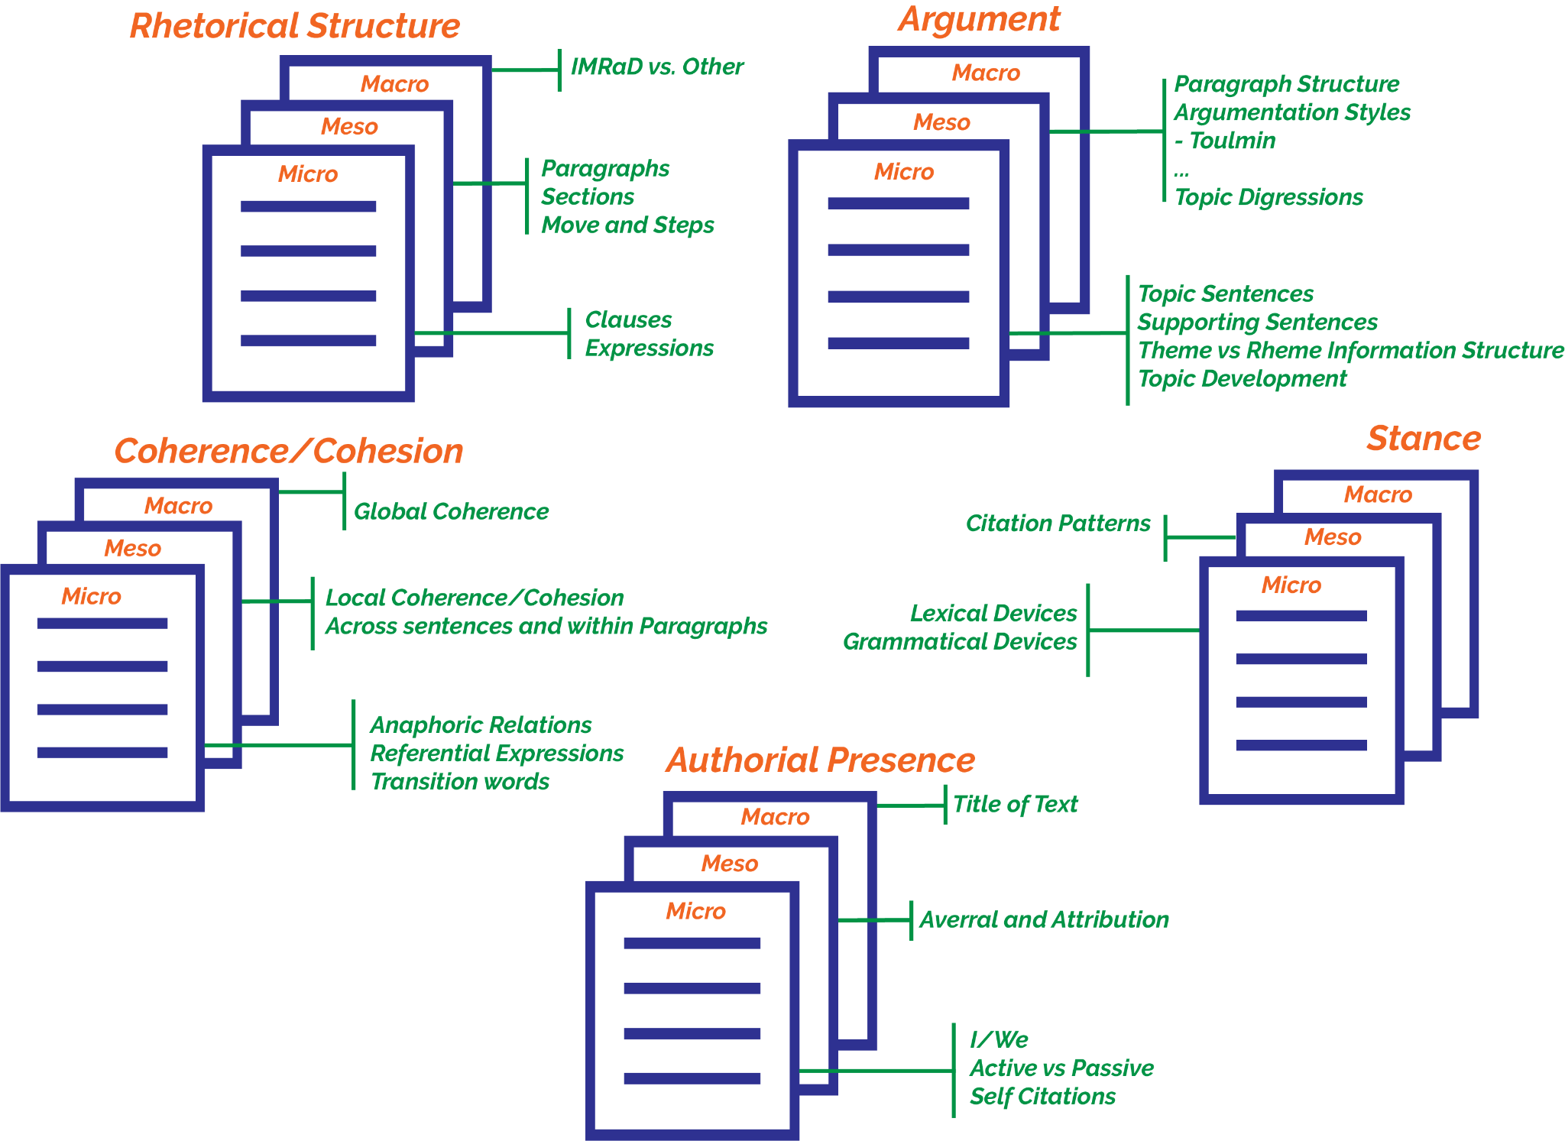
Figure 1: Five Feature Model

Institutional Description
The project unites three universities from the three Baltic countries: Estonia, Latvia, and Lithuania. The project was initiated by researchers situated in the University of Tartu, Estonia - one of the oldest universities in Eastern-Europe (est. 1632) and also the largest university in Estonia. Teaching of academic writing has been more methodologically developed in Tartu for about 15 years, the process being related to the establishment of a writing center within the university language center. Before that time, teaching of academic writing was mostly based on the individual practices and preferences of the teachers, and focused mainly on the surface issues of the text, e.g. on the formal requirements, language and orthography and correct use of references.
The establishment of a writing center gave a new perspective to teaching academic writing by bringing the text’s deeper level questions (e.g., forming arguments and expressing them clearly) into the focus. However, it appeared that the teaching of writing took a rather Anglo-American approach to writing, which is usually described as being problem- and data-based and following linearity of thought (Clyne, 1987; Duszak, 1997; Rienecker & Stray Jörgensen, 2017). At the same time, it grew apparent that we are lacking an agreement, or even an understanding about what is and how to describe Estonia’s own writing tradition. In discussions with our Latvian and Lithuanian colleagues, a similar problem was often raised. So, our project became to unite three universities that share a somewhat similar institutional context and that all seek their own voice in the teaching of and talking about their academic writing.
An even larger issue to be addressed was whether we can even talk about an Anglo-American writing tradition versus the traditions that might prescribe the writing of our Baltic languages and cultures. In order to understand our own writing it would make more sense to investigate these through the existence of our own texts rather than a comparison to other “tradition” -- whatever these may be.

Key Theorists
The most important theoretical frameworks in the context of our project are i) contrastive rhetoric, ii) genre theory, and iii) discourse analysis.

i) Robert Kaplan (1966) and the idea of contrastive rhetoric that aims to capture different cultural thought patterns. We depart from the further development of his ideas under the notion of Intercultural Rhetoric by Ulla Connor and colleagues (Connor, 1996; Connor et al., 2008). This line of writing research focuses on how different cultures and different languages affect the way we communicate our ideas in text.
We are aware of the critique surrounding contrastive rhetoric, we also embed our investigations following the ideas of critical contrastive rhetoric (Kubota & Lehner, 2004). We use this framework primarily due to the extensive amount of research it has generated about writing in other languages, despite these often being from the contrastive perspective. It provides us a way into other languages and tests and challenges the assumptions which are being brought out by these studies.
In addition, a key concept in contrastive rhetoric, as developed in the works of Hinds, 1987; MacKenzie, 2015; McCool, 2009; Qi & Liu, 2007; Salski & Dolgikh, 2018 - namely reader responsibility vs. writer responsibility - has been the main basis of selecting the five features into the feature model.

ii) Genre theory and modelling

Under this train of thought, the project has been strongly influenced by the research tradition called English for Academic Purposes, especially by John Swales and his works on rhetorical structure and genre analysis, more specifically his move-and-step analyses (Swales, 1990, 2004; Moreno & Swales, 2018). His ideas provide an analytic approach that aims to determine the functions of different text parts (Connor et al., 2008; Moreno & Swales, 2018). Based on Swales, the importance of top-down perspective in data analysis is also stressed in our work. In addition, Swales’s (1997) metaphor of English as Tyrannosaurus rex in academic writing aptly describes the problems we aim to overcome with our project.

More recently, the work of Bazerman (2018), and Donahue (2008, 2018), and Donahue and Lillis (2014) which raise the notion of modelling writing.

iii) The framework of discourse analysis as developed by Ken Hyland (2004), and his metadiscourse model (Hyland, 2005). In our project, we focus especially on these metadiscourse markers that have the function to express the writer’s stance towards the ideas and arguments that she expresses in the discourse.

In addition, we apply the research methods introduced by Douglas Biber et al. (2007), that is, the importance of combining Discourse Analysis framework with corpus-based empirical linguistics. Biber et al. (2007) have also emphasized that units of analysis will emerge during the data analysis process itself - this relates to bottom-up perspective in our project.

Glossary
Some items in the Glossary of terms have been presented in a paper for consideration, and have not been altered, a few more terms have been included for this IRC workshop.

Writing tradition: The term Writing tradition is used in a broad sense to stand for shared conventions of writing in a specific context. A writing tradition is located within larger cultures defined by physical or linguistic boundaries, but can also be distinguished in smaller cultures, such as those defined in disciplines, e.g., chemistry, or humanities. A tradition can be characterized by a number of features. For a more thorough elaboration on the term see the chapter entitled: Literature review: conflicting traditions and/or cultures
Feature: In this paper, feature is a means for describing a writing tradition. As such, we refer to the model (see figure 1) for investigating writing traditions as a feature model. Every feature in the model describes and consists of a whole range of concepts relevant to this particular feature. These concepts are operationalized as linguistic devices that may be grammatical, lexical, constructional, etc.
Sub-feature: Sub-features are features which can manifest themselves across the five identified features, and across the three different text levels (Macro, Meso and Micro level)
Macro-level: Means the largest textual unit of analysis, i.e., the complete text.
Meso-level: Refers to sections and paragraphs as the textual unit of analysis.
Micro-level: Refers to the sentence or word unit of analysis.
Argument: Using language to present ideas and to present evidence to support or reject those ideas, by following the several components that identify argumentation in text, e.g., premise, claim, warrant, or attack.

Rhetorical structure: Stands for the structure of the text with a special focus on the function that the text carries, including the macro-level units as expressed in IMRaD and other similar structures, or on the specific sections in the text (such as introductions or abstracts) at the meso-level.

Stance: Refers to the author’s personal opinion or attitude, encoded in the text they produce

Authorial presence: “the degree of visibility and authoritativeness writers are prepared to project in their texts for personal support of their statements when expressing their attitudes, judgements and assessments” (Dontcheva-Navrátilová, 2013, p. 10).

Coherence: Understood as an umbrella term that includes relational coherence and referential coherence, and that generally refers to the continuity of the propositional content and concepts referred to, that is necessary for a text to be meaningful.

References
Bazerman, C. (2018). What Does a Model Model? And for Whom? Educational Psychologist, 53(4), 301–318. https://doi.org/10.1080/00461520.2018.1496022
Biber, D., Connor, U., & Upton, T. (2007). Discourse on the Move. Using Corpus Analysis to Describe Discourse Structure. https://doi.org/10.1075/scl.28
Clyne, M. (1987). Discourse structures and discourse expectations: Implications for Anglo-German academic communication in English. Discourse across Cultures: Strategies in World Englishes, s 73, 83.
Connor, U. (1996). Contrastive Rhetoric: Cross-Cultural Aspects of Second Language Writing. Cambridge University Press.
Connor, U., Nagelhout, E., & Rozycki, W. V. (Eds.). (2008). Contrastive rhetoric: Reaching to intercultural rhetoric. John Benjamins Pub. https://doi.org/10.1075/pbns.169
Donahue, C. (2008). Cross-Cultural Analysis of Student Writing: Beyond Discourses of Difference. Written Communication, 25(3), 319–352. https://doi.org/10.1177/0741088308319515
Donahue, C., & Lillis, T. (2014). 4 Models of writing and text production. In J. Eva-Maria & D. Perrin (Eds.), Handbook of Writing and Text Production. De Gruyter Mouton.
Donahue, C. (2018). Rhetorical and Linguistic Flexibility. In X. You (Ed.), Transnational Writing Education (1st ed., pp. 21–40). Routledge. https://doi.org/10.4324/9781351205955-2
Dontcheva-Navrátilová, O. (2013). Authorial presence in academic discourse: Functions of author-reference pronouns. Linguistica Pragnesia, 23(1), 9–30.
Duszak, A. (1997). (Re)orientation strategies in academic discourse. In Schreiben in den Wissenschaften: 63–74 (p. 12). Peter Lang.
Hinds, J. (1987). Reader versus writer responsibility: A new typology. In Writing across languages: Analysis of L2 text (pp. 141–152). Addison-Wesley.
Hyland, K. (2004). Disciplinary discourses: Social interactions in academic writing (Michigan classics ed). University of Michigan Press.
Hyland, K. (2005). Stance and engagement: A model of interaction in academic discourse. Discourse Studies, 7(2), 173–192. https://doi.org/10.1177/1461445605050365
Kaplan, R. B. (1966). Cultural thought patterns in inter-cultural education. 1980, 399–418. https://doi.org/10.1111/j.1467-1770.1966.tb00804.x
Kubota, R., & Lehner, A. (2004). Toward critical contrastive rhetoric. Journal of Second Language Writing, 13(1), 7–27. https://doi.org/10.1016/j.jslw.2004.04.003
MacKenzie, I. (2015). Rethinking Reader and Writer Responsibility in Academic English. Applied Linguistics Review, 6(1), 1–21. https://doi.org/10.1515/applirev-2015-0001
McCool, M. (2009). Writing around the world: A guide to writing across cultures. Continuum.
Moreno, A. I., & Swales, J. M. (2018). Strengthening move analysis methodology towards bridging the function-form gap. English for Specific Purposes, 50, 40–63. https://doi.org/10.1016/j.esp.2017.11.006
Qi, X., & Liu, L. (2007). Differences between Reader/Writer Responsible Languages Reflected in EFL Learners’ Writing. Intercultural Communication Studies, 16(3), 148–159.
Rienecker, L., & Stray Jörgensen, P. (2017). The Good Paper. A handbook for writing papers in higher education (2nd ed.). Samfundslitteratur.
Salski, Ł., & Dolgikh, O. (2018). Reader Versus Writer Responsibility Revisited: A Polish-Russian Contrastive Approach. In University Writing in Central and Eastern Europe: Tradition, Transition, and Innovation ((Eds.) Mădălina Chitez, Claudia Ioana Doroholschi, Otto Kruse, Łukasz Salski, Dumitru Tucan, Vol. 29, pp. 89–102). Springer International Publishing.
Swales, J. (1990). Genre analysis: English in academic and research settings. Cambridge University Press.
Swales, J. (2004). Research genres: Explorations and applications. Cambridge University Press. https://doi.org/10.1017/CBO9781139524827
Swales, J. M. (1997). English as Tyrannosaurus rex. World Englishes, 16(3), 373–382. https://doi.org/10.1111/1467-971X.00071

