Dr. Katja Thieme
University of British Columbia—Vancouver, Canada

Proposal
Literary studies are often seen as a discipline without method. Research articles in literature do not have method sections, nor do they list what type of evidence has been included in a particular project or how exactly evidentiary materials have been analyzed. Among literary scholars, there is a powerful assumption that this kind of knowledge—which materials to look at and what to do with them—goes with the territory: it is both too obvious to speak about and too hidden to be fully known (Fahnestock and Secor; MacDonald; Wilder and Wolfe; Wilder; Banting; Fee). Because of implicitness of questions of method and definition, writing in literary studies is difficult to teach and often relies on students’ abilities to infer their own strategies for reading and writing (Herrington). And yet, like all disciplinary discourses, writing in literary studies does have its own range of analytical methods, its particular ways of dealing with evidentiary materials, its sense of the validity of certain questions, and its own rhetorical structures of presenting all that to a scholarly readership. US American scholars in writing and discourse studies, including Susan Peck MacDonald and Laura Wilder, have begun the work of identifying specific discursive practices that characterize published scholarship in literary studies.
Scholarship on Canadian literary studies points out how much the field of Canadian literary studies favours the values of social justice as it makes decisions about research questions and methods (Banting). Expanding on this work, this project asks: what are common language practices when presenting key concepts and methods in Canadian literary scholarship? What difficulties do these practices pose for student writers? And how could literature instructors empower student writers by teaching the methodological conventions not only of the discipline of literary studies generally, but Canadian literary studies more particularly? I analyze a textual corpus of recent research articles from Canadian Literature and Studies in Canadian Literature in order to clarify typical discursive patterns that are used when introducing key concepts and using (often hidden and unnamed) methods of literary scholarship. On the basis of these findings, one can ask: how can teaching in literary studies be improved in order to demystify the practices of the discipline?

Draft Text
[As delivered at a Canadian literature conference—as a result I speak in my capacity as someone who also studies and teaches literature. In its manuscript version the project will be geared more toward a writing and discourse studies audience. The conference paper represents the current stage of the project: theoretical framing has been set up, first version of the corpus has been built, preliminary coding has started but not been carried through yet.]

Providing Evidence in Scholarship on Canadian Literature
Literary studies are often seen as a discipline without method. Research articles in literature do not usually have method sections; rarely do they describe a systematic practice of collecting evidence; and they also do not tend to name or discuss distinct procedures of analyzing their evidence. Among literary scholars, there is an assumption that this kind of knowledge—which materials to look at and what to do with them while you’re looking at them—goes with the territory: it is both too obvious and habituated to speak about and too hidden and personal to be fully known. The status of literary studies as being without named methods has been discussed by a variety of authors; in the tradition of rhetorical and language studies in the US such authors include Jeanne Fahnestock & Marie Secor (1991), Susan Peck MacDonald (1994), and Laura Wilder (2012). From a Canadian perspective, Heather Murray has described the dominant process of becoming a literary scholar as learning through mimesis, meaning that an instructor might perform a close reading of a passage in the hopes that students will not only discern the motivations and techniques underlying this reading but also know how to translate the right elements of this oral performance into their written work. More recently, Sarah Banting has written about literary scholarship’s “elegant silence about its own rules” and likened the teaching of literary scholarship to a game of “I’m going camping” where only the game leader knows by which rules certain items are to be ruled in or out of the game (p. 4).
Because of this implicitness of questions of method and evidence, writing in literary studies is difficult to teach and—to an unfair degree—relies on students’ abilities to infer their own strategies for reading and writing (Herrington, 1988). And yet, like all disciplinary discourses, writing in literary studies does have its own range of analytical methods, its particular ways of dealing with evidentiary materials, its sense of the validity of certain questions, and its own rhetorical structures of presenting all that to a scholarly readership. In this project, I speak from my perspective as both a teacher of literary courses and a researcher in writing studies. I proceed from the assumption that as teachers of literature we must become more aware of the detailed genre conventions we value in our own professional writing; I share this assumption with Gerald Graff who argues that as we teach writing about literature we should attempt to bridge the gap between on the one hand the discussions that happen in our undergraduate classrooms and on the other hand current scholarly practice (including the conflicts which drive it). As a proponent of genre-based pedagogy, I suggest we carefully study literary scholarship in order first to better understand its genre conventions and second to teach them through manageable tasks so our students can appropriate these as they design their own projects and write their own papers for our classes.
You might ask at this point: why should our goal be that students in our courses learn to write like literary scholars? You might suggest that we should rather want to teach students how to write in more public or more popular or more creative genres instead. My response to that is twofold. One half of my response is that if we have more public or more popular or more creative genres in mind for our courses, then we must also teach those genres in a careful and conscious way throughout the course—providing models for writing such a genre, analyzing those models, letting students practice before they get graded on the final version. Before we do that, however, we need to consider this second half of the response to the question of why should we want to teach our students to write like literary scholars. In her book Rhetorical Strategies and Genre Conventions in Literary Studies, Laura Wilder writes incisively about her observations of first-year literature classrooms, her interviews with instructors, and her survey of students who were taking those classes. One of the key findings of her study is the “profound hesitancy” of these instructors to introduce literary studies as a discipline (65). This profound hesitancy takes the form of instructors not wanting to use disciplinary terms and questions when they’re discussing literature, trying to preserve their classrooms as “a space for ‘direct’ engagement with domain knowledge unfettered by disciplinary rhetorical practices and methods” (p. 65). Wilder here puts “direct” in quotation marks because despite instructors’ classroom performance of non-disciplinarity, when it comes to assessing and grading students, instructors insist on disciplinary practices—practices, we might add, which they have not explicitly mentioned, taught or scaffolded in their course but expect their students to produce. As another example, in an ethnographic study of an introductory literature course, A.J. Herrington noticed that the higher graded papers were the ones that performed the more disciplinary analyses of literary meaning, technique and dissonance; however, the instructor in that course was unaware how much these evaluations were “related to discipline-specific rhetorical practices” (Wilder p. 78). Clearly, we can teach more effectively if we are more aware of what we want students to learn.
Researchers in rhetorical genre theory have produced a great deal of work about what rhetorical practices of specific disciplines are and how they might be better explained and practiced in classrooms. My work in this project builds on the premise that it is published scholarship that should provide us with some of the clues we need to develop better instruction for the genres we use for assessing students in literature courses. [SLIDE, corpus & questions.] And so this is a corpus-based project where I am looking at published scholarship in search for language strategies that can be translated into student writing; specifically, I’m analyzing the first articles in each issue of Canadian Literature and Studies in Canadian Literature from 2012 to 2014. I’m at the beginning of this project—working with corpus text always takes a period of groping around before a more settled method of analysis emerges—and so in this presentation, I limit myself to how my project relates to analyses that have already been conducted on writing in literary studies. In its fuller version, this project asks: what are the language practices when writers present key concepts and evidentiary materials in Canadian literary scholarship; what are the difficulties student writers face in presenting literary evidence in their course assignments; and how can differences between the professional practices and student difficulties be harmonized through explicit teaching of the language and methodological conventions of the discipline?
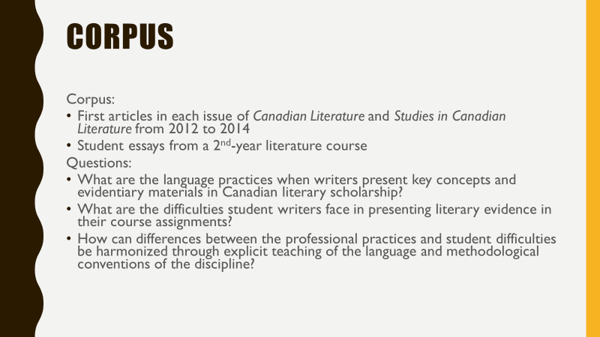
In the past 20 years, scholars in writing and discourse studies have already produced a range of interesting findings about the specific discursive practices that characterize published scholarship in literary studies. In a path-breaking 1991 chapter, Jeanne Fahnestock and Marie Secor have identified a set of rhetorical commonplaces or, as they call it, special topoi, that structure literary arguments [Slide: topoi table]. In their analysis of a corpus of 20 articles published from 1978 to 1982, they found the following five dominant topoi: 1) appearance/reality, 2) ubiquity, 3) paradox, 4) contemptus mundi, 5) paradigm. Following up on Fahnestock & Secor 10 years later, Laura Wilder found that the topoi had shifted in that decade and now also include 6) context, 7) mistaken critic, 8) social justice. Other scholars, too, have continued to develop this kind of topos analysis. For instance, in his topos study, James E. Warren asked 9 literature instructors to process a set of poems out loud and by doing so produce on-the-spot suggestions for conference-style arguments. His study illustrates how, as they build conceptual layers around the poems, individual scholars can diverge quite widely in their arguments. Thus while talking about the same poems they’re not talking very much with each other. This is a pattern that’s also noticeable in the published scholarship I’m looking at, where in Canadian literary studies there is not the overt and central display of shared conversation that’s common in social science disciplines (operates visibly through long parenthetical references—SLIDE, psychology introductions).
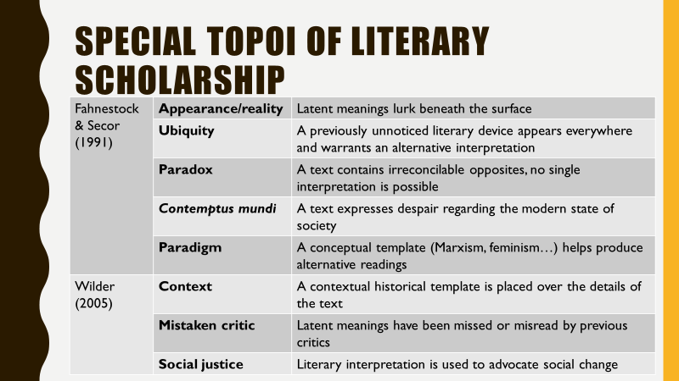
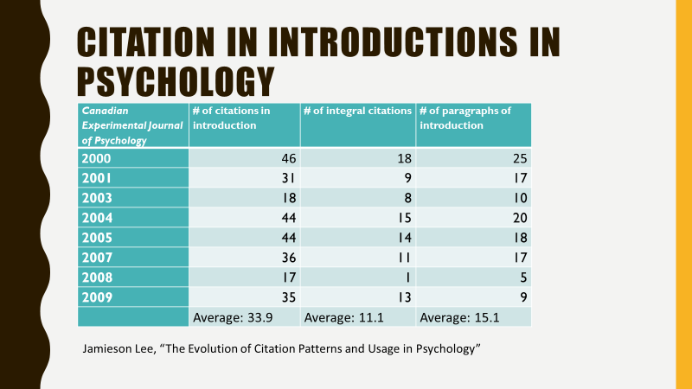
While my study deviates from this topos-focused way of looking at literary scholarship, I want to repeat here some important observations from these studies. One key observation is that in comparison to other disciplines, literary scholarship is not premised on the idea of knowledge building or knowledge accumulation. Another way of putting this is that knowledge in literary studies is not as communally and collaboratively constructed as in other disciplines—as a result of that, there’s also not that central knowledge that we can hold onto and present to newcomers as well as outsiders of the discipline. Literary scholars work mostly individually and rather than build knowledge constructs together through citation and repeated definitions they showcase rhetorical and stylistic skill as a way of celebrating and performing the field’s values (Warren p. 203). As Fahnestock & Secor put it, literary scholarship is not persuasive because its evidence is representative but because it tries to address the concerns of its intended audience through carefully crafted writing. In rhetoric, this style of presentation is called epideictic [Slide—epideictic]. Using Aristotle’s tripartite distinction, rhetoricians argue that literary scholarship is only sometimes forensic (judging the right and wrong of past actions), and rarely deliberative (convincing an audience of a present need to act in a certain way). For the most part it is epideictic in that it ceremonially establishes and affirms current values, or, we might add, criticizes and thus casts out values that do not belong to its disciplinary practices.
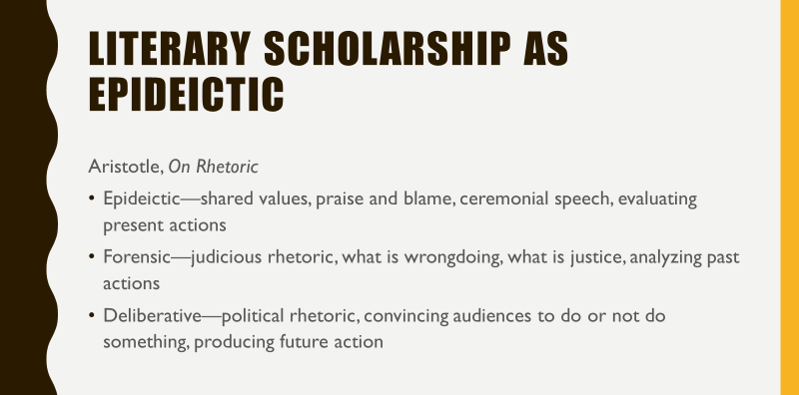
A key difficulty for novice writers, then, is to understand what those shared values are, and what one does with them in relation to a set of literary texts. This process of figuring out the central values of literary analysis is more difficult than one might imagine. It is also surprisingly tricky to grasp these central goals when reading literary scholarship because much of our literary research today has been reconfigured into something more like cultural studies by active incorporation of select theories from other disciplines, and that means that central values of literary scholarship are (a) rarely literary values (it’s hard to see why we’re investigating literature while thinking about these values), and (b) these values are deeply implied rather than explicitly stated (in a course I taught called “Canadian literature” students kept assuming [from the title] that the question of “what makes Canadian literature Canadian?” was the central question of the course, while the key questions used in analyses and lectures I provided were not mentioned in the course documents that framed the students’ work.) In a project on learning outcomes in a coordinated arts program Kathryn Grafton and her collaborators have found that in syllabi the program’s multidisciplinary and academic writing goals were stated and assessed, the literary studies outcomes were not at all stated but nevertheless assessed.
In an analysis presented at the 2013 Congress, Sarah Banting highlighted the paradoxical way in which Canadian literary scholarship pursues values that aren’t related to its scholarly practice. Some of these values are social and environmental justice, decolonization, and critique of neoliberalism and patriarchal structures. These kinds of broad, social values aren’t the disciplinary values we see, for instance, in method discussions in the social sciences: discussions about what type of data goes with what research questions, what amount of data is too small or just right for providing a good evidentiary basis, how do findings differ between different methods of analyses, and how to make sense of and interpret those findings. This kind of step-by-step presentation of disciplinary thinking is non-existent in our publications and therefore not visible to our students. For us literary scholars, the method sections in social science articles might feel like tedious and redundant reading. Consider, though, how much they reveal to novice writers about how social scientists develop (or claim to develop) their research projects and which scholarly values they follow as they choose research questions and produce and interpret evidence. Consider how much novice writers can learn from these method sections about taking practical steps, making decisions in their own smaller-scale course projects.
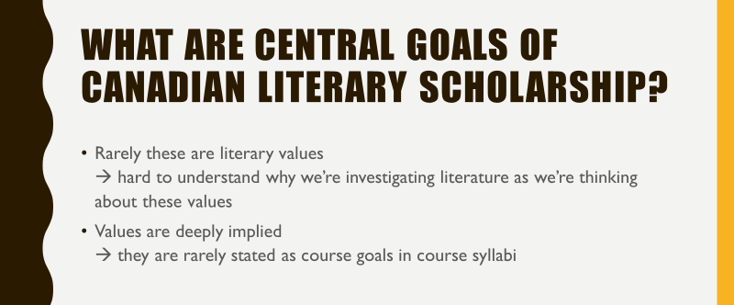
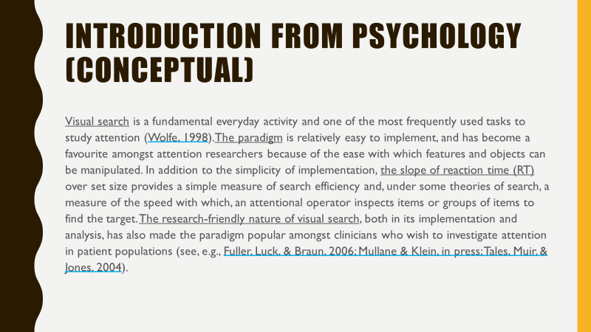
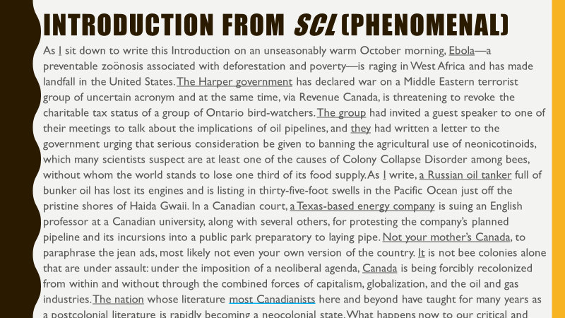Points to make on introduction from SCL (Pamela Banting) slide:
- Concept-driven style (Susan Peck MacDonald)—shared, collaboratively developed concepts
- Phenomenal style (the author, the person experiencing something, another author saying, arguing)
analytical, abstract concepts come from the author’s reading
how to teach students where abstractions come from if they’re not referenced? How to help them develop the right kinds of abstraction?
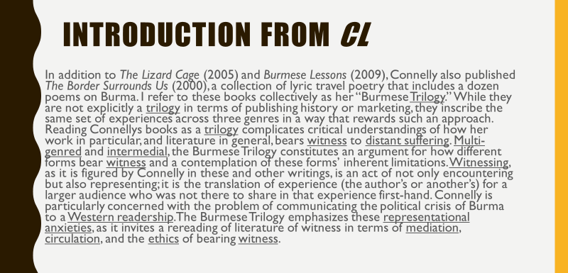
Points to make on introduction from CL (Hannah McGregor) slide:
- Critical terms are visible, and receive definitional attention—but they’re not immediately recognizable as critical terms with a research history because they’re not extensively referenced
- Definition that’s provided appears single-authored—the way in which it ties to previous conversations is obscured
- Think about including point about elitism of English degrees, of not seeing ourselves as helping the students who don’t naturally get our discourse
- Talk about this being necessary to be considered in processes of curriculum design—as we think about how to address declining enrolments we need to think about disciplinarity

Institutional Description
I work at the University of British Columbia, Vancouver (Canada) in a cross-appointed position. It’s crossed three ways between (1) the Department of English (where my tenure file is held), (2) Arts Studies in Research and Writing (a small unit of mostly contingent faculty who teach courses that fulfill the first-year writing requirement for Faculty of Arts students), and (3) Vantage College (a first-year program for international students who, with integrated language support, are completing UBC credits which can qualify them to become full time UBC students). My position is tenure-track and tenure and promotion are assessed on the basis of educational leadership. This project is positioned at the intersection of these institutional forces. Teaching first-year international students in some of my courses and second- to fourth-year English minor and major students (in classes that also have a good portion of students from other Arts programs), I have become highly aware of all the assumptions that teachers who have been trained in English literature departments make when we teach literature. As someone who also teaches research writing to students across humanities and social science disciplines, I have noticed how tricky it is to use published literary scholarship as aspirational models for students in literary courses. Unlike other disciplines, the contours of literary projects are rarely laid out in an explicit way, the way materials and methods were chosen and employed are hardly discussed. As someone whose work is assessed for its educational leadership, I’m trying to investigate these questions with an eye to pedagogy: how can I use corpus analysis of literary scholarship to make recommendations for course design and classroom teaching?

Key Theorists
Susan Peck MacDonald
- Epistemic/concept-driven style of research writing—shared, collaboratively developed concepts
- Phenomenal style—authors/characters/historical persons experiencing or thinking something, other author saying, arguing something (integral citations)

